- IDEALFUEL -

Lignin as a feedstock for renewable marine fuels

GRANT AGREEMENT No. 883753

HORIZON 2020 PROGRAMME - TOPIC LC-SC3-RES-23-2019
“Development of next generation biofuel and alternative renewable fuel technologies for aviation and shipping”

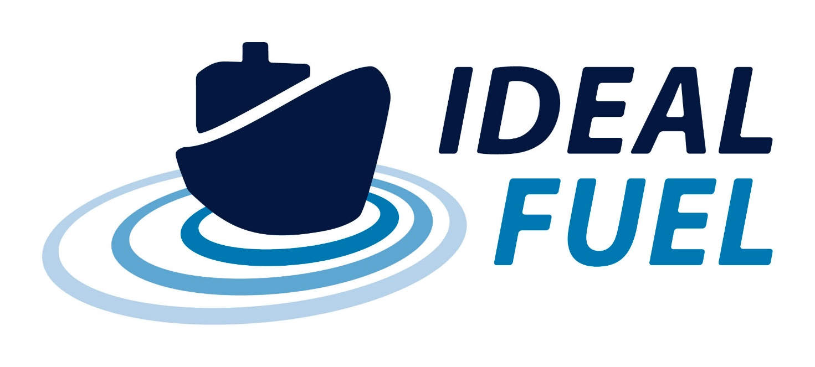

Deliverable Report
D8.3 – Project Management Plan – 1st update

History of changes

Version | Date | Changes | Pages
V1 | 01-09-2021 | Update to publishable summary and introduction (section 1) | 4 + 6
V1 | 01-09-2021 | Update to Figure 1-2 (Gantt Chart): due date of D6.1 updated from M18 to M25 | 9
V1 | 01-09-2021 | Update to Table 1-1 (General assembly members and deputies): names of GA members | 11
V1 | 01-09-2021 | Update to Table 1-3 (Work Package Leaders and deputies): names of WP leaders | 13
V1 | 01-09-2021 | Update to Sect. 1.2.6:  Table 1-4 (Sounding Board members): names of confirmed members added | 15
V1 | 01-09-2021 | Update to Sect 2.2 (Internal Project Monitoring):  - Deadline for internal reporting  - Update to Table 2-1 (Project progress monitoring: tentative GA meeting schedule): dates and location of meetings | 17
V1 | 01-09-2021 | Update to Sect. 3.2 (Critical Risks and Risk mitigation): added reference to D8.2 | 23
V1 | 01-09-2021 | Update to Table 4-2 (List of Deliverables): due date of D6.1 updated from M18 to M25 | 27

Deliverable No. | IDEALFUEL D8.3
Related WP | WP8
Deliverable Title | Project Management Plan (Project Handbook – 1st update)
Deliverable Date | 30-09-2021
Deliverable Type | REPORT
Dissemination level | Confidential – consortium members only (CO)
Written By | Eva Bøgelund (UNR)  Irene Lamme (UNR) | 01-09-2021
Checked by | Roy Hermanns (TUE) – WP leader | 06-09-2021
Reviewed by | All partners | 24-09-2021
Approved by | Roy Hermanns (TUE) – Project Coordinator | 27-09-2021
Status | V1

  - Disclaimer/ Acknowledgment


Copyright ©, all rights reserved. This document or any part thereof may not be made public or disclosed, copied or otherwise reproduced or used in any form or by any means, without prior permission in writing from the IDEALFUEL Consortium. Neither the IDEALFUEL Consortium nor any of its members, their officers, employees or agents shall be liable or responsible, in negligence or otherwise, for any loss, damage or expense whatever sustained by any person as a result of the use, in any manner or form, of any knowledge, information or data contained in this document, or due to any inaccuracy, omission or error therein contained.

All Intellectual Property Rights, know-how and information provided by and/or arising from this document, such as designs, documentation, as well as preparatory material in that regard, is and shall remain the exclusive property of the IDEALFUEL Consortium and any of its members or its licensors. Nothing contained in this document shall give, or shall be construed as giving, any right, title, ownership, interest, license or any other right in or to any IP, know-how and information.

This project has received funding from the European Union’s Horizon 2020 research and innovation programme under grant agreement No 883753. The information and views set out in this publication does not necessarily reflect the official opinion of the European Commission. Neither the European Union institutions and bodies nor any person acting on their behalf, may be held responsible for the use which may be made of the information contained therein.

Publishable summary
The EU H2020 project IDEALFUEL aims to develop an efficient and low-cost chemical pathway to convert lignocellulosic biomass into a Biogenic Heavy Fuel Oil (Bio-HFO) with ultra-low sulphur levels that can be used as drop-in fuel in the existing maritime fleet. This deliverable, D8.3, concerns the first update to the Project Management Plan (Project Handbook) for the IDEALFUEL project. The Handbook contains an overview of management bodies and documents needed in the day-to-day project practise. The document is based on the Description of the Action, the Grant Agreement, and the Consortium Agreement. Next to summarising the project structure, all procedures relevant to the project execution are described. These procedures are intended to improve decision making, progress monitoring, communication and management of changes, innovations, and risks. The procedures intend to assure a high quality and timely delivery of all deliverables in the IDEALFUEL project. There are no deviations from the description of this deliverable as given in Annex 1 of the Grant Agreement.

Contents
History of changes 2
1 Project Management Plan 6
1.1 Structure of Work Packages 6
1.2 Management Structure and Consortium Bodies 10
2 Management Procedures and Progress Monitoring 16
2.1 External Project Monitoring 16
2.2 Internal Project Monitoring 17
2.3 Management tools 18
2.4 Decision Making 20
2.5 Change Management 20
3 Risk Management 22
3.1 Risk Analysis 22
3.2 Critical Risks and Risk Mitigation 22
3.3 Role of the Partners and the Project Coordinator in Risk Management 24
4 Quality Assurance 25
4.1 Quality Assurance for Deliverables 25
4.2 Approval Procedure for Milestones 29
5 Communication 30
5.1 Acknowledgement of EU Funding 30
5.2 Early Information of Planned Dissemination 30
5.3 Internal Communication 31
6 Exchange of Material with non-EU Countries 32
7 Risk Register 33
Acknowledgement 34

Table of Figures
Figure 1-1 Work Package Structure 6
Figure 1-2 Gantt Chart 9
Figure 1-3 Management structure 10
Figure 2-1 Mett interface 19
Figure 2-2 EU-fin login interface 19
Figure 5-1 EU emblem 30

Tables
Table 1-1 General Assembly Members and Deputies 11
Table 1-2 Overview of composition, roles, responsibilities, and meeting schedules for the General Assembly and the Work Package Leader's Board 11
Table 1-3 Work Package Leaders and deputies 13
Table 1-4 Sounding Board members 15
Table 1-5 Innovation Management 15
Table 2-1 Project progress monitoring: tentative GA meeting schedule 17
Table 3-1 Identified risks and their mitigation measures 23
Table 4-1 Deliverable review process and timing 26
Table 4-2 List of Deliverables 27
Table 4-3 List of milestones 29

Project Management Plan
Deliverable D8.1 concerns the Project Management Plan (Project Handbook) for the IDEALFUEL project. The deliverable is part of Work Package (WP) 8 - Project management, administration, and technical coordination. In addition to D8.1, WP8 includes two updates to the Management Plan (D8.3 and D8.4 planned for M17 and M29, respectively) and a Risk and Mitigation Plan (D8.2, planned for M12). This is the first update to the Management Plan.
The Project Management Plan is based on Annex 1 of the Grant Agreement, more specific the “Description of the Action” (DoA) and further procedures proposed by the management team and discussed during the project Kick-off Meeting (28 May 2020). The document is meant to be a clear, sharp, comprehensive, and easily accessible guideline for the IDEALFUEL project partners.

Structure of Work Packages
This section describes how the tasks in the IDEALFUEL project, organised in Work Packages, are related to each other. Additionally, the IDEALFUEL management structure will be addressed.
Overall, the IDEALFUEL project activities are divided into eight Work Packages (WP). These WPs consist of 1 management WP, 1 WP concerning ethics requirements, 1 WP for dissemination, communication, and exploitation activities, and 5 technical WPs. An overview of the WP structure and interdependencies is presented in Figure 1-1.
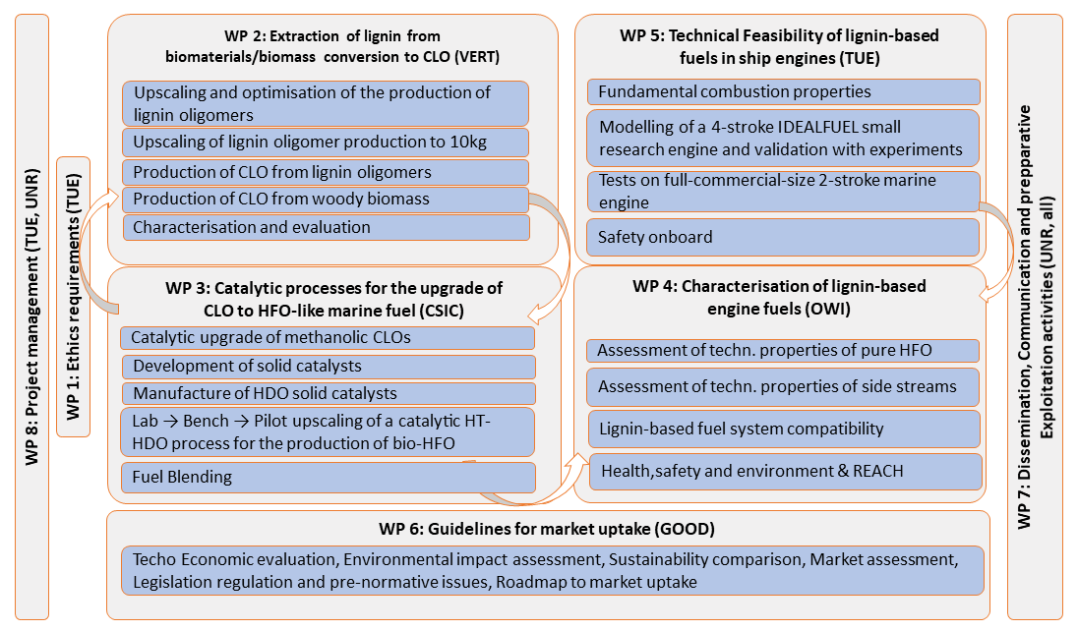
Figure 1-1 Work Package Structure

WP1 – Ethics requirements ensures compliance with the ethics requirements.
WP2 – Extraction of lignin from biomaterials aims to set up a production line and optimise the process for the production of oligomers.
WP3 – Catalytic processes for the upgrade of CLO to HFO-like marine fuels aims to develop, synthesize, and shape for piloting activities a robust solid catalyst, and determine optimal reaction process conditions therefor, for the hydrotreating of concentrated methanolic crude lignin oils into a biogenic fuel and to produce a sulphur-free CLO-based biofuel.
WP4 – Characterisation of lignin-based engine fuels aims to characterise and benchmark Bio-HFOs and the side-streams and evaluate their technical potential for other applications.
WP5 – Technical Feasibility of lignin-based fuels in ship engines aims to assess the technical feasibility of lignin-based fuels in ship engines.
WP6 – Guidelines for market uptake aims to evaluate technical and economic aspects such as efficiencies and costs compared to fossil fuels, sustainability and environmental impacts and to perform a market assessment and provide recommendations on standardization issues and legislative framework.
WP7 – Dissemination, Communication and preparative Exploitation activities aims to establish an appropriate and effective communication of the project results to relevant stakeholders, industries, suppliers and the fuels and ports community in general and to pave the way to exploitation of the IDEALFUEL results. Further, the Sounding Board setup and management is included in this WP.
WP8 – Project Management focuses on the efficient execution of the IDEALFUEL project, the maintenance of the Consortium Agreement and the Grant Agreement, and the protection of the intellectual property rights (IPR) of the consortium.
The Gantt chart in Figure 1-2 presents an overview of the schedule for each WPs and their (sub)tasks. The chart also includes the timing of deliverables and milestones.

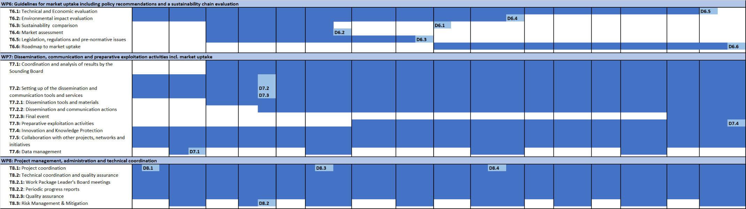
Figure 1-2 Gantt Chart

Management Structure and Consortium Bodies
The project coordination is based on a philosophy of management by objectives, in which delegation of responsibility, communication, trust and realistic objectives are the key of the management structure. Partners are requested to provide frequent feedback on their progress and any potential problems. The focus is on communication, cooperation, and shared responsibility. The overall goal is to identify problems early and undermine any negative effects efficiently and effectively before unwanted consequences become unavoidable. An overview of the management structure and the different Consortium Bodies is presented in Figure 1-3. The following sections will present each of the Consortium Bodies and their function.
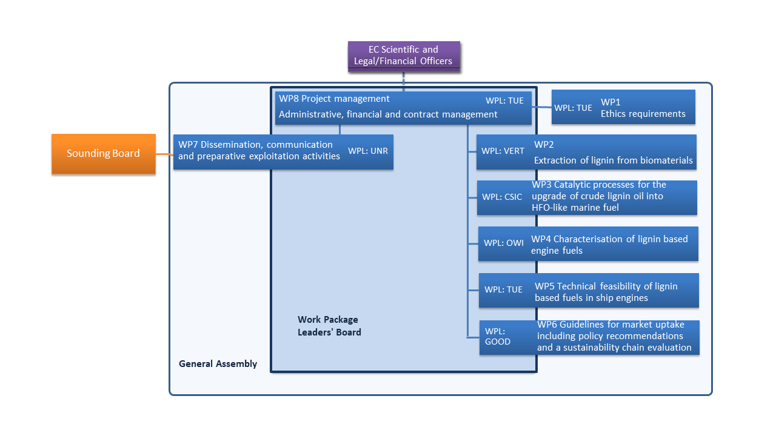
Figure 1-3 Management structure

General Assembly
The General Assembly (GA) is the ultimate decision-making body of the consortium. The GA will discuss and decide on overall project management, strategic management issues and contract amendments. Typical subjects for GA meetings are project status and evolution, review of resource status, major changes in the work plan including re-distribution of budget, major changes in dissemination and exploitation strategy, and cooperation with third parties and related projects. Furthermore, the GA will be an effective and efficient communication hub. The GA is composed of one representative of each consortium partner. Each of these will have one vote in the GA (see Table 1-1). More detailed voting mechanisms and detailed responsibilities can be found in the Consortium Agreement Section 6 – Governance structure. General Assembly meetings will be convened every 6 months. The meetings will be chaired by the Project Coordinator. A summary of GA functions is presented in Table 1-2.

Table 1-1 General Assembly Members and Deputies
No​ | Name​ | Short name​ | GA member​ | GA deputy​
1​ | Technische Universiteit Eindhoven | TUE​ | Roy Hermanns​ | ​Bart Somers
2​ | Vertoro B.V. | VERT​ | Michael Boot​ | ​Panos Kouris
3​ | Tec4Fuels | T4F​ | Klaus Lucka​ | ​Simon Eiden
4​ | Bloom Biorenewables Ltd | BLOOM​ | Remy Buser​ | ​Florent Héroguel
5​ | Uniresearch B.V. | UNR​ | Eva Bøgelund​ | ​Irene Lamme
6​ | Winterthur Gas & Diesel AG | WinGD​ | Beat von Rotz​ | ​Andreas Schmid
7​ | Formerly SeaNRG, is now GoodFuels B.V. #12
8​ | Thyssenkrupp Marine Systems GMBH | TKMS​ | Keno Leites​ | ​Tim Kullmann
9​ | OWI – Science for Fuels gGmbH | OWI​ | Wilfried Plum | ​Sangeetha Ramaswamy​
10​ | Agencia Estatal Consejo Superior De Investigaciones Cientificas | CSIC​ | Gonzalo Prieto​ | ​Marcelo Domine
11​ | Varo Energy Netherlands B.V. | VARO​ | Mark Wolthuis​ | ​Henk Wolthaus
12 | GoodFuels B.V. | GOOD​ | Olivia Morales Gonzalez | Felipe Ferrari
Table 1-2 Overview of composition, roles, responsibilities, and meeting schedules for the General Assembly and the Work Package Leader's Board
General Assembly (GA) | Structure | Work Package Leaders’ Board (WPLB)
One representative per partner | Members | All Work Package Leaders
Project Coordinator | Chair | Project Coordinator
Decision body and high-level steering of the project in terms of scientific goals, progress, finance, quality, dissemination and exploitation | Tasks | Keep track of monthly progress, preparation of changes to the project in terms of scientific goals, finances, quality, risk management, dissemination and exploitation
Every 6 months, additional meetings when needed | Meeting intervals | 1x per month (mostly teleconferences)
Chairperson, in writing no later than: 45 calendar days before, 15 for extraordinary meeting | Notice | Chairperson, in writing no later than: 15 calendar days before, 7 for extraordinary meeting
Chairperson distributes (WPLB prepares), 21 calendar days before, 10 for extraordinary meeting. Adding agenda items: 14 days before, 7 for extraordinary meeting, anonymously add item at meeting | Agenda | Chairperson prepares and distributes, 7 calendar days before. Adding agenda items: 2 days before
Chairperson, draft to all members within 10 days of meeting. Accepted: if no objection within 15 days of sending. Chairperson distributes accepted minutes to all members and coordinator | Minutes | Chairperson, draft to all members within 10 days of meeting. Accepted: if no objection within 15 days of sending. Chairperson distributes accepted minutes to all members and coordinator. Coordinator sends accepted minutes to GA members for information
2/3 members must be present/represented  2/3 majority vote (unanimous for new party) | Voting | 2/3 members must be present/represented  2/3 majority vote (unanimous for new party)

Work Package Leader’s Board
The Work Package Leader’s Board (WPLB) is the supervisory body for the project execution at an operational level. It is composed of the Work Package Leaders (or deputies) and the Project Coordinator and shall report to, and be accountable to, the General Assembly. Work Package Leaders will report on the research progress of their WP to the WPLB. Work Package Leader’s Board meetings will take place monthly by teleconferences. The following tasks will be carried out by the Work Package Leaders’ Board:
- Monitoring and control of the technical progress in the work packages, project schedule and deliverables,
- Assuring cooperation and integration between the Work Packages,
- Providing methodological and technical assistance to all Work Packages and tasks,
- Regular risk analysis and preparation of contingency plans, if required,
- Conducting periodic progress meetings on a monthly basis via teleconferences,
- Conducting meetings with the Sounding Board (2-4 meetings at least),
- Prepare changes which need decisions to be taken in the General Assembly.
A summary of WPLB functions is presented in Table 1-2.

Work Package Leaders
The Work Package Leaders (WPLs) will coordinate the activities related to their WP and will oversee and lead the technical developments, overall coherence, and technical implementation of the WP tasks (together with the Task Leader) to ensure that WP goals are met on time and within budget restrictions. The WPLs will coordinate and chair their own WP meetings. Each WPL has the following tasks:
- Maintaining monthly contact with the Task Leaders and coordination of the activities within the Work Package,
- Ensuring completion of Work Package activities and deliverables on time, within budget and of high quality,
- (In)formal reporting on Work Package progress, quality and risk status to the Project Coordinator and WPLB,
- Reviewing and approval of all formal Work Package deliverables,
- Managing of risks within the Work Package.
For Task Leaders a similar set of tasks as for work package leaders is valid, be it on a task level.
The names of the appointed WP Leaders (and deputies) have been presented at the Kick-off Meeting and are listed in Table 1-3.

Table 1-3 Work Package Leaders and deputies
WP No. | WP Title | Lead Beneficiary | WP Leader | WP deputy
WP1 | Ethics requirements | TUE | Roy Hermanns
WP2 | Extraction of lignin from biomaterials/ Biomass conversion to CLO | VERT | Panos Kouris | Michael Boot
WP3 | Catalytic processes for the upgrade of crude lignin oil into HFO-like marine fuel | CSIC | Marcelo Domine | Gonzalo Pietro
WP4 | Characterisation of lignin-based engine fuels | OWI | Sangeetha Ramaswamy | Nina Sittinger
WP5 | Technical feasibility of lignin based  fuels in ship engines | TUE | Bart Somers | Roy Hermanns
WP6 | Guidelines for market uptake including policy recommendations and a sustainability chain evaluation | GOOD | Olivia Morales Gonzalez | Roy Hermanns
WP7 | Dissemination, communication, and preparative exploitation activities incl. market uptake | UNR | Eva Bøgelund | Irene Lamme
WP8 | Project management, administration and technical coordination | TUE | Roy Hermanns | Jan-Paul Krugers

Project Coordinator
The designated Project Coordinator (PC) of the IDEALFUEL project is Roy Hermanns, Program Manager at Eindhoven University. The Project Coordinator’s most important task is to ensure completion of the work in time, within budget, and to a high quality. The PC is the primus inter pares and as such responsible for the overall project management, including coordination of the scientific and technical work plan, innovation management, and preparative exploitation activities. Of course, all consortium partners have their responsibility to perform the tasks they are assigned to in time, within budget, and to a high quality. The Project Coordinator is also the intermediary between the consortium partners and the EC Project Officers.
The following tasks will be carried out by the Project Coordinator:
- Overall technical coordination of the scientific and technical work plan,
- Maintaining contact with the EC (via the project officer),
- Notifying the project officer of developments that may require amendments of the Grant Agreement,
- Providing overviews of the work progress to the EC project officer,
- Final review and approval of deliverables submitted to the EC and material to be disseminated (together with the WP leaders),
- Chairing General Assembly, Work Package Leaders’ Board and Sounding Board meetings,
- Preparing and attending scheduled review meetings with the EC project officer.

Management Support Team
A Management Support Team (represented by UNR) will assist the Project Coordinator and Work Package Leaders’ Board with managerial, organisational and secretarial duties, administration and archiving work, such as:
- Support the Project Coordinator in the daily management of the project,
- Act as contact point for all partners and maintaining a high level of communication within the consortium,
- Organising and documenting project meetings such as General Assembly, Work Package Leaders’ Board, and Sounding Board meetings, including distributing documents before and after meetings,
- Managing deliverables and administrative documents, e.g. financial plans, (progress) reports and presentations,
- Producing and updating overviews of consortium expenses and deviations and keeping track of financial transactions between the EC and the consortium,
- Coordinate the preparation of the periodic management reports and the final report,
- Collect, check, and send to the EC the required cost statements, on basis of the scheduled plan, using the systems as provided by the EC.

Sounding Boards
A Sounding Board (SB) has been established to advise and help guide the process of defining the recommendations for implementation of the Bio-HFO developed within IDEALFUEL. The Sounding Board will be invited to 2 - 4 specific meetings/workshops to provide feedback on intermediate results, milestones, critical risks, and input from an end user/stakeholder perspective, like market developments. Consortium partner GOOD is responsible for coordinating the activities of the Sounding Board and analysing the results of the SB discussions.

The current members of the Sounding board are listed in Table 1-4:
Table 1-4 Sounding Board members
Organisation | Type of Organisation | Name | Email
City of Bremen/Port | Public admin / port | Jochen Kreß | jochen.kress@swh.bremen.de
International Maritime Organization (IMO) | Standardisation / regulatory | Bingbing Song | BSong@imo.org
Port of Rotterdam | Port | Peter Mollema | PW.Mollema@portofrotterdam.com
Maersk | Shipping | Maria Strandesen | maria.strandesen@maersk.com
Norden A/S | Shipping | Henrik Røjel | her@ds-norden.com
CONCAWE | NGO | Soler Alba | alba.soler@concawe.eu
Platform Duurzame Biobrandstoffe | NGO | Eric van der Heuvel | evdh@platformduurzamebiobrandstoffen.nl
Physikalisch-Technische Bundesanstalt (PTB) | Standardisation / Regulatory / research | Ravi Fernandes | ravi.fernandes@ptb.de
BICEPS Network | NGO | Coen Faber | coenfaber@purebirds.com
New members can be added to the Sounding Board upon unanimous approval of the General Assembly. The Coordinator will ensure that a non-disclosure agreement is executed between all Parties and each SB member. Together with the non-disclosure agreement the SB members will receive a brochure with more details on their role and the activities they will be invited to during the project.

Innovation Management Team
Innovation management is a process which requires an understanding of both market and technical problems, with a goal of successfully implementing appropriate creative ideas. Consortium partner TUE will lead as main innovation manager. Together with the other project’s innovation managers: GOOD, T4F, and VERT, with the support of UNR, TUE will undertake the innovation management in the IDEALFUEL project. In Table 1-5 the roles of each of the innovation management partners are identified.
Table 1-5 Innovation Management
Partners/Task | TUE | GOOD | T4F | VERT | UNR
Lead innovation team | R | S | S | S | S
Identification of results | R | I | I | S | S
Overview of intellectual property | R | I | I | S | S
Exploitation | S | S | S | R | S
Dissemination | S | S | S | S | R
R (responsible), S (support), I (information exchange)

Management Procedures and Progress Monitoring
In this chapter, all management procedures and tools for the general management and progress monitoring of the project will be addressed.

External Project Monitoring
The external project reporting covers all formal periodic reports (PR1: from M1-M18, PR2: from M19-M30, and PR3: from M31-M48) and continuous reports (deliverables and milestones). The content of these reports will be outlined in the following sections. Further details can be found in the Grant Agreement, Article 20 – Reporting.

Periodic Reporting
The periodic report (technical and financial report) must be submitted by the PC to the EC within 60 days following the end of the reporting period. The periodic report is being prepared based on the input of all partners and must contain:
- A technical report including:
- a summary,
- an explanation of the work carried out during the reporting period,
- an overview of the progress towards the project objectives, justifying the deviations from the work expected under Annex 1 of the Grant Agreement, if any,
- an overview of communication activities and updates to the plan for exploitation and dissemination of results, if any,
- answers to the ‘questionnaire’ in the context of the Horizon 2020 key performance indicators and the Horizon 2020 monitoring requirements.
- A financial report consisting of structured forms from the online grant management system, including:
- individual financial statements (Annex 4 to the GA) for each beneficiary,
- an explanation of the use of resources and the information on subcontracting and in-kind contributions provided by third parties, from each beneficiary during the reporting period,
- a periodic summary financial statement including the request for interim payment.
In addition to the periodic reports, the PC must submit the Final Report within 60 days following the end of the last reporting period.

Continuous Reporting: Deliverables and Milestones
The Project Coordinator must submit the Deliverables and Milestones identified in Annex 1 of the Grant Agreement in accordance with the timing and conditions set out therein. More information on the monitoring, preparation, quality review, and submission of Deliverables and Milestones can be found in Section 4 – Quality Assurance.

Internal Project Monitoring
General Assembly meetings will be held on a regular basis to facilitate the progress monitoring. The consortium has established the following GA meeting calendar to supervise the progress of the activities:
Table 2-1 Project progress monitoring: tentative GA meeting schedule
Meeting | Month | Date | Participants | (Proposed) host | (Proposed) location | Status
GA 1:  Kick -off | 1 | 28 May 2020 | All partners and EC officer | TUE | Online | Realised
GA 2 | 7 | 10-11 Nov 2020 | Partner representatives and EC officer (invited) | BLOOM | Online | Realised
GA 3 | 12 | 20-21 April 2021 | Partner representatives and EC officer (invited) | CSIC | Online | Realised
GA 4 & Periodic Review 1 | 18  (or later) | Jan 2022 | All partners and EC officer | TUE | Brussels (BE)
GA 5 | 26 | June / July 2022 | Partner representatives and EC officer (invited) | VERT | Eindhoven (NL)
GA 6 & Periodic Review 2 | 30  (or later) | Jan 2023 | All partners and EC officer | TUE | Brussels (BE)
GA 7 | 38 | June / July 2023 | Partner representatives and EC officer (invited) | OWI / T4F | Herzogenrath, (DE)
GA 8 | 43 | Nov / Dec 2023 | Partner representatives and EC officer (invited) | WinGD | Winterthur (CH)
Final Event | 48 | April 2024 | Partner representatives and EC officer (invited) | TUE | Eindhoven (NL)
GA 9 & Periodic Review 3 | 48  (or later) | April 2024 (or later) | All partners and EC officer | TUE | Brussels (BE)
In addition to the GA meetings, all consortium partners are requested to complete a short internal progress report every 6 months. This report should indicate any problems regarding meeting deadlines, completing the work as planned, and budgets. The purpose of the internal progress report is to set up and maintain an ‘early-warning’ system (for possible technical and financial risks) via clear, simple, and transparent procedures. The partners will have three weeks to complete the internal report. The Project Coordinator and Management Support Team will evaluate the internal report and present the progress status to the WPLB and decide on corrective actions if needed. Reporting will involve:
- Progress made in the partner’s work in specific WPs,
- Deviations from the DoA (if any),
- Status of Deliverables,
- Status of Milestones,
- Financial report (via EU-fin, see section 2.2.3): a simple overview (per partner) of the costs and Person Months (PMs) spent in the reporting period, including detailed justifications of “other costs”. Deviations from the estimated budget in Annex 2 of the Grant Agreement should also be reported.
Furthermore, WP Leaders will be requested to provide a brief report on the major achievements, (novel) risks, and problems encountered (critical or not critical) in the WP during the reporting period. When relevant or deemed necessary, the internal progress reports will be discussed during GA meetings.
In addition, the status of risks as identified in the risk management table (Table 1.3.5 of Annex 1 of the GA) will be evaluated at each General Assembly meeting. This evaluation should indicate whether risks are properly addressed or whether actions are needed (more details in Section 3 – Risk Management); if necessary extra risks (unforeseen during the proposal preparation) will be added and monitored.

Management tools
The following sections will introduce the management tools that will be used for internal project monitoring and reporting. Consortium partner UNR will setup and prepare the tools.

Mett
The management tool Mett will be used as platform for the consortium partners to exchange and archive documents. Special pages are dedicated to the different documents of the project (contracts, deliverables, periodic reports, contact list, meetings, etc). An impression of the Mett interface is presented in Figure 2-1.
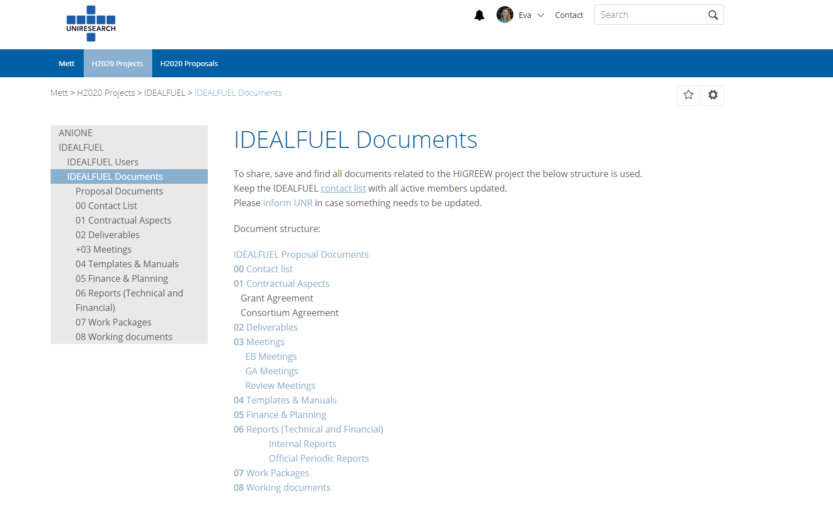
Figure 2-1 Mett interface

EU-fin
At the beginning of the project, a financial planning will be prepared (by UNR) in EU-fin. In this planning, the total project costs for each reporting period will be divided among the different WPs and budget categories, according to the estimated budget prepared during the proposal preparation (Annex 2 of the Grant Agreement). Every 6 months the consortium partners will be asked to report on project costs. Guidelines on how to use EU-fin will be distributed to all partners by UNR before the first reporting period (after M6, Oct 2020). It should be noted that the financial reporting must be in EURO. Expenses made in other currencies must be converted to EURO using the exchange rate of the day the expense is made. The EU-fin system login interface is shown in Figure 2-2.
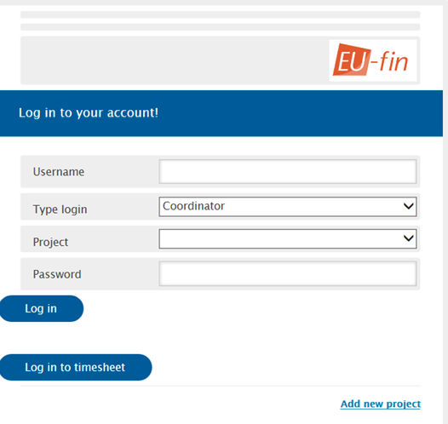
Figure 2-2 EU-fin login interface
The EU-fin tool allows the Project Coordinator and management support team to automatically generate cost reports which compare the actual project expenses with the estimated budget per beneficiary, WP, task, etc. Other functionalities include creating charts for comparing deliverables planned vs. actual, budget planned vs. budget spent, etc. The information in EU-fin will be used as input for the official periodic reports (after M18, after M30, and after M48).

Decision Making
The project will be governed by the Grant Agreement signed with the European Commission and the Consortium Agreement (CA) signed among the partners. The CA covers all issues necessary for the proper execution of the project such as the responsibilities (including Project Coordinator, WPLB, Innovation Management, and individual Parties), liabilities, voting rules, joint-ownership, background knowledge, intellectual property rights, knowledge management, grant distribution, rules for publishing information, conflict resolution, admission of new partners, etc.
The voting rules and quorum for the General Assembly are:
- The GA shall not deliberate and decide validly unless two-thirds (2/3) of its members are present or represented (quorum).
- Each member of the GA present or represented in the meeting shall have one vote.
- Decisions shall be taken by two-thirds (2/3) of the votes with exception of decisions concerning the entry of a new Party, any amendment to the Grant Agreement or the exclusion of a Party in which cases the votes have to be unanimous.

Change Management
IDEALFUEL is a collaborative project, involving 11 partners, so a shift in the 48 months’ planning or a change in the budget may happen. Such shifts are not uncommon for a project of this size and duration but these changes shouldn’t come as a surprise. Therefore, the project management team (Project Coordinator and management support team) and the entire consortium are committed to maintain open and transparent communication throughout the project lifetime.

Changes in Budget
Each consortium partner is requested to:
- Report immediately, as soon as the possibility of a budget modification is considered, to the Project Coordinator, the WP leaders, and the management support team (UNR),
- Provide a financial report every 6 months that clearly reports on the expenditures and financial planning.
The Project Coordinator, together with the WP leaders and the project management team, will evaluate the situation and propose scenarios and possible solutions for the change in budget. The Project Coordinator and the management support team will inform the Project Officer accordingly for further discussion and alignment.
Below a list of the most common situations in which changes to the budget may occur:
- Budget shift at partner level (only one partner involved, the total costs are not changing): some budget needs to be shifted from one WP to another or from one category to another (e.g. from travel to ‘other direct costs’) in principle no amendment to the Grant Agreement will be necessary, but this should be discussed with the Project Officer. Convincing justification will need to be provided.
- Budget shift between partners in principle no amendment to the Grant Agreement will be necessary, but this should be discussed with the Project Officer. Convincing justification will need to be provided.
- Changes in subcontracting/new subcontracting An amendment to the Grant Agreement is (probably) necessary. Partners should inform the Project Coordinator, WP leaders, and management support team as soon as possible and provide convincing justification. The project management team will contact the Project Officer.

Changes in Personnel or Roles
A project contact list is available on Mett. The list is updated and maintained by UNR with inputs from all consortium partners. Changes in personnel need to be communicated to the project management team (this project is dealing with confidential research information and in case someone leaves the team it is important to remove his/her access to the project document database).
Furthermore:
- Changes at Grant Agreement and WPL/WPLB level need to be presented and discussed during the General Assembly and WPLB meetings,
- In case of change of the Project Coordinator, an Amendment to the Grant Agreement will be required.

Changes in Technical Content and Timing
Each change related to the technical content and timing of the project needs to be reported to the Project Officer (via the Project Coordinator). Minor re-planning and re-alignment of activities may be implemented but in case of changes in the scope/objectives of a specific WP an Amendment to the Grant Agreement will be required. Partners are requested to immediately report possible changes to WP activities and planning to the WP Leader of the WP in question. The WPL will evaluate the situation and inform the Project Coordinator and management support team.

Risk Management
As part of the overall management plan for the IDEALFUEL project, this chapter describes the risk management plan. It identifies conditions that may put the project at risk and provides guidance for managing these. It also provides methods for the risk management process and establishes roles and responsibilities of all participants in this process.

Risk Analysis
Since the probability of failure in research and innovation projects is considerable, risk factors in the IDEALFUEL work plan should be analysed on a regular basis. Therefore, WP8 contains the Deliverable 8.2 which is dedicated to the Risk and Mitigation Plan. D8.2 will include a detailed risk management plan and will aim to identify possible risks that may hamper the project outcomes or in broader sense the market introduction of the IDEALFUEL project. The Risk and Mitigation Plan will be updated throughput the project.
Risks are approached according to the steps which together form the “circle” of risk management:
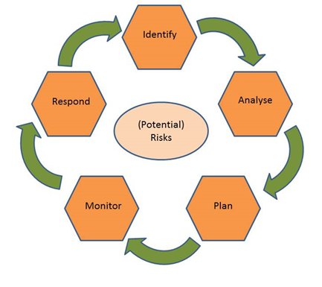
- Identify In this step, risks are identified, with the moments at which they could occur and the specific symptoms of the risks.
- Analyse Here, the risk is analysed further, looking also into the potential effects and consequences of the risk.
- Plan In this step, plans are developed for management of the specific risk, as well as contingency plans.
- Monitor The actual status of the risk is monitored, using e.g. the risk symptoms as identified in the first step.
- Respond The specific risk management plan is put into action, when the monitoring step has shown the need for this. Actions are taken here to prevent the risk from happening full force or to avoid undesired consequences of the risk.
The risk management circle formed by these five steps will continuously be performed during the project.

Critical Risks and Risk Mitigation
In Table 3-1, an overview is presented of the most important risks and potential mitigation strategies as listed in section 1.3.5 of the Grant Agreement Annex 1 (part A). Other risks may materialise and will be reported during the internal and periodic project reporting moments, as described above. Risk management is documented in D8.2 (submitted in M12).
Table 3-1 Identified risks and their mitigation measures
Risk No. | Description of risk | WP Number | Proposed risk-mitigation measures
1 | No suitable, large scale reactor available, or delayed, e.g. due to breakdown or other unforeseen factors | WP1 | Outsource to third-party biorefineries that have suitable equipment, e.g. Attis Innovations (USA) or Sekab (SE).
2 | CLO process do not scale up properly due to unforeseen factor | WP2 | In the project 2 routes will be tested, i.e. route #1 Vertoro and route #2 Bloom, if one of them does not scale properly the other process will act as a backup facility
3 | Lack of fuel availability for WP4 and 5 | WP2, WP3, WP4, WP5 | Surrogate fuels can be used, blending with HFO for the large-scale engine testing to test the effect of only a few percent of Bio-HFO on the engine performance.
4 | Producing Bio-HFO is of insufficient quality as marine fuel. | WP2, WP3, WP4, WP5 | Good quality of Bio-HFO is absolutely required. Numerous technical solutions are available to improve fuel quality, however, might prove too costly. Combination of further conditioning and additivation may be considered if too much offspec oil is produced.
5 | Technical issues delay pilot-scale production of optimized HDO catalyst, with a potential effect on further project tasks. | WP3, WP4, WP5 | Resort to commercially available catalysts, e.g. Co-MoOx/Al2O3 as fallback option. Even if not ad-hoc developed for optimal performance on CLO feeds, they would enable, after carbidization activation, the HDO process upscaling to be carried out, likely at the expenses of the yield to the final biofuel.
6 | Final upgraded Bio-HFO fuel not fully meeting the specs listed as a target (see WP2 description). | WP3, WP4, WP5 | Fuel formulation and blending recipes with conventional HFO can be adapted to avoid propagation of this risk to WP5.
7 | Unexpected high emissions, in particular NOx, HC during transient conditions | WP5 | More efforts needs to be implemented to analyse the fuel and ignition timing of this fuel. The consortium has key research facilities available to assess this in more detail if required
8 | Single cylinder buildup delays | WP5 | The results of the 2-stroke engine will become available later but this has virtually no impact on other partners. Other (external) facilities are available to do this testing if needed.
9 | Management - Loss of key staff / Project partners in the IDEALFUEL project | WP1, WP2, WP3, WP4, WP5, WP6, WP7 | There is enough complementary planned into the experience of the project partners to cover such loss.
10 | Regulation – Current legislation not adapted for use of Bio-HFO, resulting in uncertainty on mission limits, permit requirements etc. | WP6 | Get an overview of all legal issues and start communication actions with relevant stakeholders to overcome them. One key stakeholder IMO is in our sounding board.

Role of the Partners and the Project Coordinator in Risk Management
The monitoring of risks, and the reporting of new, yet unidentified risks, will be a task of everyone involved in IDEALFUEL. The General Assembly assesses the possible occurrence of the risks and decides on the mitigation measures or, when required, a modification of the work plan.
The roles and responsibilities in risk management are:
- Task Leaders: will identify risks, develop mitigation strategies and contingency plans for their tasks and monitor risks. Report potential risk factors to their Work Package Leader.
- Work Package Leaders: will consolidate risks and develop mitigation strategies and contingency plans on WP level. WPLs will report potential risk factors to the Project Coordinator and to other WPLs via the WPLB.
- Project Coordinator: is responsible for the risk management of the whole project. Identifies risk, develops mitigation strategies and contingency plans, monitors risks and reports risk status in the periodic progress reports to the EC, including planned contingency measures.

Quality Assurance

Quality Assurance for Deliverables
The term “Deliverables” refers to the formal IDEALFUEL project Deliverables as described in the Grant Agreement Annex 1 (part A). An overview of all formal IDEALFUEL Deliverables is presented in Table 4-2. To ensure their quality, all Deliverables will undergo internal review before submission. This review is conducted by the Leader of the WP to which the Deliverable belongs, an expert from the consortium who is working in the WP but who is not directly involved in the writing of the Deliverable, and the Project Coordinator.
Each reviewer will use the standard review form (see Annex A of this document) to document his/her review findings. After reviewing, the reviewer sends his/her comments to the Deliverable authors. The author(s) revises the Deliverable according to the quality assurance review form within a maximum of seven days after receiving the review request. The WP Leader ensures that the requested updates/improvements are implemented by the author(s). The Project Coordinator performs the final review.
Once the Deliverable is approved by the Project Coordinator, the Project Coordinator/Management Team submits the Deliverable to the EC in electronic form (PDF) via the SyGMa portal. The project Management Team stores the submitted Deliverables on Mett (section Documents / 02 Deliverables / Final/Submitted / Dx.x /).
All Deliverables will show to have followed the Quality Assurance procedure by including in the Deliverable itself the review form and the names of the persons who have performed the quality review.
A template for Deliverables will be provided by UNR. The template will include the following sections which are mandatory for all technical Deliverables:
- Public executive summary,
- Core content: core technical development of Deliverable with clear descriptions of the work carried out, results, and discussions (based on the provided technical information),
- Risk table: overview and description of encountered risks (if any) and mitigation actions,
- Conclusions and recommendations for future work including foreseen risks/challenges.

Timeline for Review and Approval
The review and approval of Deliverables should recognise the following timeline and steps to ensure that all Deliverables are of high quality and submitted on time:
Table 4-1 Deliverable review process and timing
Submission Date | Action | Action by
D- XX | Check on timely planning and prepare for supporting actions as necessary | WP Leader with Authors
D-21 | Present full draft of Deliverable for quality review to Reviewer(s) | Author
D-14 | Comments returned to Author  (in case of major modifications following the first round of reviews, revisit review procedure and take measures as necessary) | Reviewer(s)
D-7 | Updated Deliverable to WP Leader for approval | Author
D-2 | Finalised Deliverable to Project Coordinator for approval | WP Leader
D | Submit Deliverable to EC | Project Coordinator

Table 4-2 presents an overview of project Deliverables and assigned reviewers.

Table 4-2 List of Deliverables
Deliverable No | Deliverable Title | WP No | Lead beneficiary | Type | Diss. level | Due date (month) | Reviewer
D1.1 | NEC - Req. No1 | 1 | TUE | Ethics | CO | 6 | UNR / ALL
D1.2 | NEC - Req. No2 | 1 | TUE | Ethics | CO | 6 | UNR / ALL
D2.1 | Report on the setup of the production line and the optimisation of the process for the production of oligomers | 2 | BLOOM | Report | CO | 8 | TUE
D2.2 | Report on the optimisation of the pre-treatment and lignin conversion in 300L reactor | 2 | BLOOM | Report | CO | 20 | TUE
D2.3 | Report on the optimisation of the BLOOM lignin oligomers-to-CLO (CLO Process #1) process in 300L reactor | 2 | VERT | Report | CO | 30 | BLOOM
D2.4 | Report on the optimisation of the VERTORO wood-to-CLO process (CLO Process #2) in 300L reactor | 2 | VERT | Report | CO | 36 | BLOOM
D2.5 | Scientific publication compiled from data from deliverable D2.1-D2.4 | 2 | TUE | Report | PU | 48 | BLOOM
D3.1 | Report disclosing optimal catalyst composition and reaction settings for the hydrotreating of CLO feeds into a marine biofuel with HFO-like specs | 3 | CSIC | Report | CO | 30 | TUE
D3.2 | Report on ton-scale pilot production of lignin-based HFO-like marine biofuel | 3 | VERT | Report | PU | 40 | CSIC
D3.3 | Report on Blending RECIPE | 3 | GOOD | Report | CO | 45 | T4F
D4.1 | Initial material data sheet with technical properties of the Bio-HFO and benchmark fuels | 4 | OWI | Report | CO | 24 | T4F
D4.2 | Initial Fuel system compatibility report | 4 | T4F | Report | CO | 24 | WinGD
D4.3 | Storage stability of Bio-HFO fuels | 4 | OWI | Report | PU | 42 | T4F
D4.4 | Report on the potential of side streams for technical applications | 4 | OWI | Report | CO | 42 | T4F
D4.5 | Final report on technical benchmarking of Bio-HFO for ship engines | 4 | T4F | Report | PU | 48 | TUE
D4.6 | Final Fuel-system compatibility | 4 | T4F | Report | PU | 48 | WinGD
D4.7 | Draft Safety Data Sheet for the most optimum Bio-HFO | 4 | OWI | Report | PU | 48 | TUE
D5.1 | Ignition & combustion behaviour of baseline fuels | 5 | TUE | Report | PU | 18 | WinGD
D5.2 | Ignition & combustion behaviour of Bio-HFO & CLO | 5 | TUE | Report | PU | 36 | WinGD
D5.3 | 4-Stoke research engine - Validation of the CFD models with experiments | 5 | TUE | Report | PU | 48 | WinGD
D5.4 | 2 Stroke engine – Spray and combustion behaviour | 5 | WinGD | Report | CO | 48 | TUE
D5.5 | Safety onboard | 5 | OWI | Report | CO | 48 | TKMS
D6.1 | Report on Sustainability comparison | 6 | GOOD | Report | PU | 25 | TUE
D6.2 | Market Assessment Report | 6 | GOOD | Report | PU | 18 | TUE
D6.3 | Legislation, regulations and pre-normative issues report | 6 | TUE | Report | PU | 24 | TKMS
D6.4 | Environmental Impact Assessment | 6 | TUE | Report | PU | 30 | VERT
D6.5 | Report on Techno-Economic assessment | 6 | GOOD | Report | CO | 46 | TUE
D6.6 | Integrated Roadmap to market uptake | 6 | GOOD | Report | PU | 48 | TUE
D7.1 | Data Management Plan | 7 | TUE | Open research Data Point | PU | 6 | UNR
D7.2 | Corporate Identity: Project website, Flyer, etc | 7 | UNR | Report | PU | 12 | TUE
D7.3 | Dissemination plan | 7 | UNR | Report | PU | 12 | TUE
D7.4 | Exploitation plan | 7 | VERT | Report | CO | 48 | TUE
D8.1 | Project Management Plan (Project handbook) | 8 | UNR | Report | CO | 2 | TUE / ALL
D8.2 | Risk and Mitigation Plan | 8 | TUE | Report | CO | 12 | UNR
D8.3 | Project Management Plan (Project handbook - 1st update) | 8 | UNR | Report | CO | 17 | TUE
D8.4 | Project Management Plan (Project handbook - 2nd update) | 8 | UNR | Report | CO | 29 | TUE

Approval Procedure for Milestones
WP Leaders are responsible for the achievement of WP related milestones. WP Leaders report to the WPLB if they think a Milestone has been achieved and the means of verification as reported in the DoA have be met. The Milestone will be discussed in the WPLB and presented at the following General Assembly. The partner responsible for the Milestone will provide a short report to describe the Milestone achievement (a template will be provided by UNR). When a Milestone has been achieved, the Project Coordinator/Management Team will report it to the EC. The IDEALFUEL Milestones are listed in Table 4-3.
Table 4-3 List of milestones
Ms No | Milestone title | WP No | Lead beneficiary | Due date (month) | Means of verification
MS1 | Lignin Oil Extraction (1kg-scale) | WP2 | BLOOM | 6 | Setup is ready and extracted lignin will be delivered to partners for further testing and will be documented in D2.1
MS2 | Benchscale / process development (10 kg-scale) | WP2 | BLOOM | 18 | Oligomers characterised. Properties of CLO from 10 kg/batch scale within ±5% of those obtained at 1kgscale. Documented in delivery (M6)
MS3 | Fuel Formulation / blending showing targeted specs | WP4 | OWI | 25 | Verify with targeted specs, documented in D4.1
MS4 | Catalyst HDO development | WP3 | CSIC | 28 | The delivery of said catalyst to Vertoro in amounts sufficient for upscaling activities (D3.1)
MS5 | 20-30 kg HDO treated CLO | WP3 | VERT | 30 | Setup is ready and biofuel is delivered to partners in amounts sufficient for R&D engine tests
MS6 | Combustion ignition performance | WP5 | TUE | 36 | Documented in deliverable D5.2
MS7 | Pilot scale production (300L) | WP2 | VERT | 42 | Setup is ready and biofuel is delivered to partners in amounts sufficient for commercial 2-stroke engine tests
MS8 | Fuel system alignment | WP4 | OWI | 42 | Initial test results available for storage stability & interaction of fuel with material, component and engine-oil (D4.2/D4.3)

Communication
Internal communication will be stimulated as much as possible by the Management Team and the GA members. Frequent teleconferences and meetings will be organised among partners.

Acknowledgement of EU Funding
From Article 29.4 of the Grant Agreement:
Unless the Agency requests or agrees otherwise or unless it is impossible, any dissemination of results (in any form, including electronic) must:

- display the EU emblem (see Figure 5-1) and
Figure 5-1 EU emblem
- include the following text:
“This project has received funding from the European Union’s Horizon 2020 research and innovation programme under grant agreement No 883753”
When displayed together with another logo, the EU emblem must have appropriate prominence. For the purposes of their obligations under this Article, the beneficiaries may use the EU emblem without first obtaining approval from the Agency. This does not however give them the right to exclusive use. Moreover, they may not appropriate the EU emblem or any similar trademark or logo, either by registration or by any other means.
From Article 29.5 of the GA:
Any dissemination of results must indicate that it reflects only the author's view and that the Agency is not responsible for any use that may be made of the information it contains.

Early Information of Planned Dissemination
From Article 8.4.1.1 of the Consortium Agreement:
During the Project and for a period of 1 year after the end of the Project, the dissemination of Results by one or several Parties including but not restricted to publications and presentations, shall be governed by the procedure of Article 29.1 of the Grant Agreement subject to the following provisions.
Prior notice of any planned publication shall be given to the other Parties at least 21 calendar days before the publication. Any objection to the planned publication shall be made in accordance with the Grant Agreement in writing to the Coordinator and to the Party or Parties proposing the dissemination within 21 calendar days after receipt of the notice. If no objection is made within the time limit stated above, the publication is permitted.

Protocol for Review of Publications
Below the main steps and responsibilities in the review process of documents for external publication are summarised:
- the author
  - communicates his/her intention to publish to the Consortium as soon as possible but no later than 21 calendar days before publication
  - is responsible for checking (when results are jointly owned) that all result owners are informed and are listed as co-authors
  - is responsible for making sure that documents do not contain process technology details or other protected IP
  - emails all Consortium partners and:
    - asks for permission to publish,
    - provides a copy of the documents for approval at least 21 calendar days before submitting.
- the Consortium partners:
  - have 21 calendar days to respond,
  - check that politically sensitive information is removed or appropriately phrased
- If Consortium partners do not respond within 21 calendar days, the publication is permitted
- All publications must include the EU emblem, acknowledgement of EU funding, and disclaimer (see Section 5.1 of this document)

Internal Communication
Some simple rules for internal emails:
- Start your message subject with: IDEALFUEL
- Use e-mail responsibly: do not overuse/spam
- Use Mett for sharing large documents
- Make clear what you expect from others (detail, timing, how to receive)
- Confidentiality: mark your messages if the info is confidential
Contact list:
- Contact list is maintained by UNR
- Partners are responsible for making sure that the correct contact information is with UNR
- Contact list can be found on Mett

Exchange of Material with non-EU Countries
The IDEALFUEL research involves partners from non-EU countries. Specifically, exchange of material between project partners BLOOM and WinGD (both located in Switzerland) and the other project partners require the import and export regulation to non-EU countries to be considered. The following procedure for exchange of material used for the IDEALFUEL project will be followed (documented in D1.1 – NEC Requirement No 1 and D1.2 – NEC Requirement No 2):
Procedure concerning the exchange of project-related material with non-EU countries between the IDEALFUEL partners:
- All partners will specify exactly what material they will be exchanging with WinGD and BLOOM during the IDEALFUEL project and inform the management team (log template will be provided).
- Partners wishing to exchange material with WinGD or BLOOM must contact their own legal and security officers, with the aim to get information on national legislation concerning export to non-EU countries.
- All necessary documents (security certificates, transportation certificates, safety data sheets, etc.) will be acquired by the partner wishing to exchange material with WinGD or BLOOM.
- The documents will be sent to the management team who will provide them to INEA.

Risk Register
No risks linked to D8.3 have been identified.
Risk No. | What is the risk | Probability of risk occurrence¹ | Effect of risk¹ | Solutions to overcome the risk
WP8 | N/A
¹⁾ Probability risk will occur: 1 = high, 2 = medium, 3 = Low

Acknowledgement
The author(s) would like to thank the partners in the project for their valuable comments on previous drafts and for performing the review.
Project partners:
# | Partner short name | Partner Full Name
1 | TUE | Technische Universiteit Eindhoven
2 | VERT | Vertoro BV
3 | T4F | Tec4Fuels
4 | BLOOM | Bloom Biorenewables Ltd
5 | UNR | Uniresearch B.V.
6 | WinGD | Winterthur Gas & Diesel AG
 |  | (Formerly SeaNRG, is now GOODFUELS #12)
8 | TKMS | Thyssenkrupp Marine Systems GMBH
9 | OWI | OWI – Science for Fuels gGmbH
10 | CSIC | Agencia Estatal Consejo Superior De Investigaciones Cientificas
11 | VARO | Varo Energy Netherlands BV
12 | GOOD | GoodFuels B.V.

This project has received funding from the European Union’s Horizon 2020 research and innovation programme under grant agreement No 883753

