EUROPEAN COMMISSION

HORIZON 2020 PROGRAMME - TOPIC H2020-LC-BAT-2019

Solid state sUlfide Based LI-MEtal batteries for EV applications

GRANT AGREEMENT No. 875028

**SUBLIME**

SUBLIME – Deliverable Report

D1.1 – Project Handbook

|  |  |  |
| --- | --- | --- |
| **Deliverable No.** | SUBLIME D1.1 |  |
| **Related WP** | WP1 |  |
| **Deliverable Title** | Project Handbook |  |
| **Deliverable Date** | 2020-08-31 |  |
| **Deliverable Type** | REPORT |  |
| **Dissemination level** | Confidential – member only (CO) |  |
| **Written By** | Diederick Spee (UNR) | 2020-05-27 |
| **Checked by** | Kathrin Metselaar (UNR) |  |
| **Reviewed by (if applicable)** | All partners |  |
| **Approved by** |  |  |
| **Status** | Draft 2.0 |  |

Disclaimer/ Acknowledgment

Copyright ©, all rights reserved. This document or any part thereof may not be made public or disclosed, copied or otherwise reproduced or used in any form or by any means, without prior permission in writing from the SUBLIME Consortium. Neither the SUBLIME Consortium nor any of its members, their officers, employees or agents shall be liable or responsible, in negligence or otherwise, for any loss, damage or expense whatever sustained by any person as a result of the use, in any manner or form, of any knowledge, information or data contained in this document, or due to any inaccuracy, omission or error therein contained.

All Intellectual Property Rights, know-how and information provided by and/or arising from this document, such as designs, documentation, as well as preparatory material in that regard, is and shall remain the exclusive property of the SUBLIME Consortium and any of its members or its licensors. Nothing contained in this document shall give, or shall be construed as giving, any right, title, ownership, interest, license or any other right in or to any IP, know-how and information.

This project has received funding from the European Union’s Horizon 2020 research and innovation programme under grant agreement No 875028. The information and views set out in this publication does not necessarily reflect the official opinion of the European Commission. Neither the European Union institutions and bodies nor any person acting on their behalf, may be held responsible for the use which may be made of the information contained therein.

Document information

Additional author(s) and contributing partners

|  |  |
| --- | --- |
| Name | Organisation |
|  |  |
|  |  |
|  |  |
|  |  |
|  |  |

Document Change Log

|  |  |  |
| --- | --- | --- |
| Name | Date | Comments |
| V0.1 | 27/05/2020 | Draft version |
| V0.2 | 08/06/2020 | Internal review (by UNR) |
| V0.3 | 15/06/2020 | Review by FEV |
| V1.0 |  |  |
|  |  |  |

Document Distribution Log

|  |  |  |
| --- | --- | --- |
| Name | Organisation | Distributed to |
| V0.1 |  |  |
| V0.2 |  |  |
| V0.3 |  |  |
| V1.0 |  |  |
|  |  |  |

Verification and approval

|  |  |  |
| --- | --- | --- |
| Name | Name | Date |
|  |  |  |
|  |  |  |
|  |  |  |
|  |  |  |
|  |  |  |

**Summary**

This handbook is meant as a guideline for the SUBLIME project. It contains all information about the project, necessary in daily practice. The document is based on the Annex I to the Grant Agreement, the “Description of Action”. It is meant to be clear, sharp, comprehensive and easily accessible.

After summarizing the project structure, all procedures relevant in the project are described. These procedures are intended to ease decision making, progress monitoring, communication and management of changes, innovations and risks. They furthermore intend to assure good quality of all deliverables in the SUBLIME project.

**Contents**

1 Purpose of the Document 7

1.1 Document Structure 7

1.2 Deviations from original Description in the Grant Agreement Annex 1 Part A 7

**1.2.1** Description of work related to deliverable in GA Annex 1 – Part A 7

**1.2.2** Time deviations from original planning in GA Annex 1 – Part A 7

**1.2.3** Content deviations from original plan in GA Annex 1 – Part A 7

2 Introduction to SUBLIME 7

2.1 SUBLIME Project structure 7

2.2 SUBLIME Work packages (WP) 7

2.2.1 WP structure 8

2.2.2 WP timing 9

2.3 Management and consortium bodies 11

2.3.1 Organizational structure 11

2.3.2 Project Coordinator 11

2.3.3 Project management support team 12

2.3.4 General assembly (GA) 12

2.3.5 WP leaders board 12

2.3.6 WP leaders 12

2.3.7 Stakeholder group 14

3 Management plan 14

3.1 Progress monitoring 14

Internal project monitoring 15

2.1.1 Management tools 15

Mett 16

EU-fin 16

3.2 Decision making 17

3.3 Change management 18

3.3.1 Changes in budget 18

3.3.2 Changes in personnel 18

3.3.3 Changes in technical content and timing 19

3.4 Innovation management 19

4 Risk management 21

4.1 Risk Analysis 21

4.2 Critical risks and risk mitigation 21

4.3 Role of the partners and the coordinator in risk management 22

5 Quality Assurance 24

5.1 Review Process for project deliverables and reports 24

5.2 Quality assurance procedure 24

5.2.1 Quality management responsibilities 24

5.2.2 General quality management procedure 28

5.3 Approval process of Milestones 29

6 Communication, confidentiality and IP ownership 31

6.1 Decision and voting rules 31

6.2 IPR 31

6.3 Transfer of results 31

6.4 Dissemination of results 32

6.5 Acknowledgment of EU funding 32

6.6 Early information of planned dissemination 33

7 Acknowledgement 34

8 Appendix A – Quality Assurance review form 35

# Purpose of the Document

## Document Structure

In Section 2 the SUBLIME project structure is introduced, followed by section 3 on the management aspects, procedures and tools for general management of the project, followed by Risk management (4), Quality assurance (5) and Communication (6).

## Deviations from original Description in the Grant Agreement Annex 1 Part A

### Description of work related to deliverable in GA Annex 1 – Part A

The objective of this handbook is to provide an overview of all relevant management aspects.

### Time deviations from original planning in GA Annex 1 – Part A

There are no deviations with respect to timing of this deliverable

### Content deviations from original plan in GA Annex 1 – Part A

There are no deviations from the Annex 1 – Part A with respect to the content.

# Introduction to SUBLIME

## SUBLIME Project structure

Here it is described how the tasks in the SUBLIME project, organized in work packages, are dependent on each other and how they are related timewise. Also, the management structure addressed.

## SUBLIME Work packages (WP)

The SUBLIME strategy is implemented in 8 WPs consisting of 1 management WP, 6 technical WP’s, including one on defining the specifications and a supporting WP for dissemination, exploitation & communication.

**WP1 – Project management and technical coordination** ensures the execution of the project in compliance with the Rights and Obligations as set out in the H2020 Grant Agreement (GA No. 875028) and project’s Consortium Agreement.

**WP2 – Battery Electric Vehicle (BEV) Requirements and specifications** intends to define at the start of the project, the KPIs (i.e. energy density, cell impedance/power, cyclability) and design targets (technical and cost related) to be fulfilled by the cells for battery electric vehicles.

**WP3 – Materials Optimization and Scale up**’sobjective of this WP is to develop and optimize the materials to be used in the cell in WP4 and WP6.

**WP4 – Lab electrode & cell preparation** ‘s main objective is to process, assess and optimize the cell components to develop sulfide-based cells (up to 40 mAh).

**WP5 – Battery cell design, pre-industrial scale up and manufacturing** aims at defining the safety conditions for the scaling up of electrodes, solid electrolyte layer (SEL), cell assembly and also for cell shipments. The final 10Ah prototype cells will be designed in agreement with specifications defined in WP2. The process for electrode manufacturing as well as solid electrolyte layer will be up scaled and 10Ah prototypes will be manufactured to reach TRL5.

**WP6 – Testing & Aging at multi-level cell, safety and Sustainability & Cost Assessment** deals with

evaluation of the electrochemical and electrical performances of cells after and before aging. (>500 cycles at 80%DoD). The safety behavior will be evaluated on the complete cells. A recycling concept will be developed and an LCA carried out.

**WP7 – Multiscale Mechanistic Modelling** The main objectives of this work package are to drive the iterative development of SUBLIME material and cell sulfide solid state battery technology through physics based multiscale physics based modelling approach according to the guidelines of European Material Modelling Council (EMMC) and Review of Modelling of Materials (RoMM).

**WP8 – Dissemination, exploitation strategy & business plans** will focus on carrying out effective communication and dissemination activities for SUBLIME, engaging both scientific and technical audiences, as well as stakeholders and citizens.

### WP structure

In figure 1.1 below, all relations between all WP’s and the tasks they include, are shown schematically. The PERT diagram shows the main relationships and interactions among work packages and corresponding tasks.

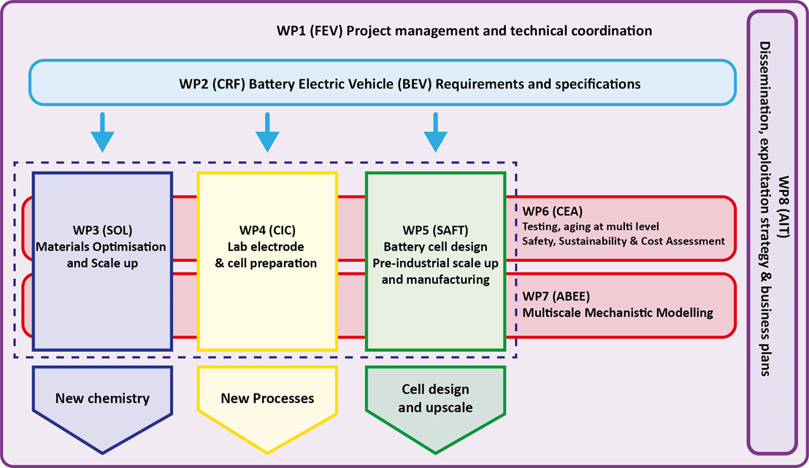

**Fig. 1.1 Work package structure.**

### WP timing

In the Gantt chart on the next page, the timing of all the WP’s and the tasks they include is shown. For each WP and each task, the appointed leader (identified with an “L”) and involved partners (identified with an “P”) are identified

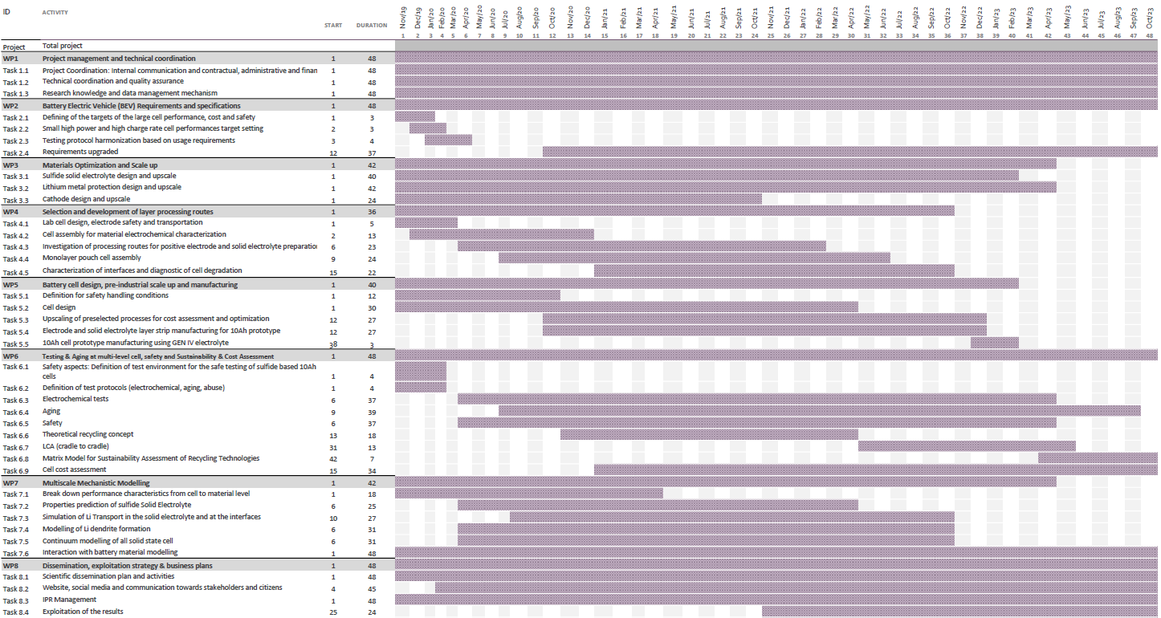

## Management and consortium bodies

### Organizational structure

The management structure of the SUBLIME project is depicted in figure 1.2 below.

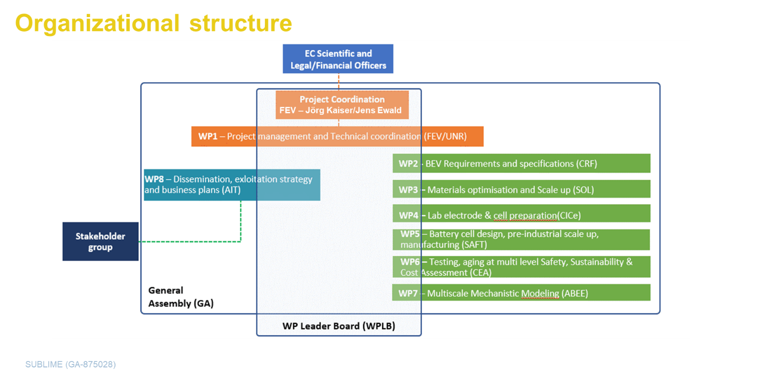

**Fig. 1.2 Management structure.**

### Project Coordinator

**Project Coordinator**

The project coordinator’s most important task is to ensure *completion of the work* *in time, within budget, and to a high quality*. The coordinator is the *primus inter pares* and as such responsible for the overall project management, including coordination of the scientific and technical work plan, innovation management and preparative exploitation activities. Of course, all partners have their responsibility to perform the tasks they are assign to *in time, within budget, and to a high quality*.

The designated **Coordinators** of SUBLIME are Dr. Jens Ewald and Jörg Kaiser, both FEV. Jens Ewald is currently active as coordinator of the HIFI-Elements project (H2020 GV07-2017) and active in the field of next generation powertrains and electric vehicle development and especially focused on transferring research results into industry.). Jörg Kaiser is expert on battery cell development. The following tasks will be carried out by the project coordinators:

* Overall technical coordination of the scientific and technical work plan;
* Maintaining contact with the EC (project, legal and financial officers);
* Maintain regular contact to the work package leaders to track and monitor technical progress
* Notifying the project officer of developments that may require amendments of the Grant Agreement;
* Providing overviews of the work progress to the EC (project officer);
* Final review and approval of deliverables submitted to the EC and material to be disseminated (together with the leader of the Dissemination, Communication and Exploitation work package);
* Chairing General Assembly, Work Package Leaders Board and Stakeholder Group meetings;
* Preparing and attending scheduled review meetings with the project officer.

### Project management support team

A **project management support team** (represented by **UNR**) will support the consortium, project coordinator, the General Assembly and Work Package Leaders Board with managerial, organisational and secretarial duties, administration and archiving work, such as:

* Support the consortium and project coordinator in the daily management of the project;
* Act as contact point for all partners and maintaining a high level of communication within the consortium;
* Organising and documenting project meetings, like General Assembly, and Work Package Leaders Board, including distributing documents before and after meetings;
* Managing deliverables and administrative documents, e.g. financial plans, (progress) reports etc.;
* Producing and updating overviews of consortium expenses and deviations and keeping track of financial transactions between the EC and the consortium;
* Coordinate the preparation of the periodic management reports and the final report;
* Collect, check and send to the EC the required cost statements, on the basis of the scheduled plan using the systems as provided by the EC.

### General assembly (GA)

For high-level decision-making, **a General Assembly (GA)**, composed of one representative from each partner will be established at the start of the project. Meeting at 6 month intervals, the GA will discuss and decide on: project status and evolution, review of resource status, major changes in the work plan including re-distribution of budget, major changes in dissemination and exploitation strategy, co-operation with third parties and related projects and issues that require contract amendments.

### WP leaders board

The **WP Leaders Board** **(WPLB)** comprises of the project coordinator and the work package leaders. Meeting will be scheduled monthly/bi-monthly via teleconferences. The following tasks will be carried out by the WPLB:

* Monitoring and control of the technical progress in the work packages, project schedule and deliverables;
* Assuring cooperation and integration between the work packages;
* Providing methodological and technical assistance to all work packages and tasks;
* Regular risk analysis and preparation of contingency plans, if required;
* Conducting periodic progress meetings on a bi-monthly basis via teleconferences;
* Prepare changes which need decisions to be taken in the General Assembly.

### WP leaders

The research work has been divided into logical parts for which work package leaders and task leaders have been assigned to co-ordinate the activities within that specific work package and tasks. The **work package leaders (WPLs)** will coordinate and chair their own work package meetings. Work package leaders deal with the technical developments and overall coherence and technical implementation of the project output in their specific WP with the following duties:

* Maintaining monthly contact with the task leaders and coordination of the activities within the work package;
* Ensuring completion of work package activities and deliverables on time, within budget and of high quality;
* (In)formal reporting on work package progress, quality and risk status to the coordinator and Work Package Leaders Board;
* Reviewing and approval of all formal work package deliverables;
* Managing of risks within the work package;

For **task leaders** a similar set of tasks, as for the WPLs is valid, albeit on a task level.

|  |  |  |  |  |  |
| --- | --- | --- | --- | --- | --- |
| WP | WP Title | Wp leader | Wp leader  (Person) | Start month | End month |
| WP1 | Project management and technical coordination | FEV | Jens Ewald | 1 | 48 |
| WP2 | Battery Electric Vehicle requirements and specifications | CRF | Mauro Francesco Sgroi | 1 | 48 |
| WP3 | Materials optimization and scale up | SOL | Marc David Braida | 1 | 42 |
| WP4 | Lab electrode and cell preparation | CIC | Frederic Aguesse | 1 | 36 |
| WP5 | Battery cell design pre-industrial scale up and manufacturing | SAFT | Christian Jordy | 1 | 40 |
| WP6 | Testing, aging at multilevel. Safety, sustainability & cost assessment | CEA | Vincent Remi | 1 | 48 |
| WP7 | Multiscale Mechanistic model | ABEE | Satya Panchireddy | 6 | 48 |
| WP8 | Dissemination, exploitation strategy & business plans | AIT | Marcus Jahn | 1 | 48 |

**Table 1.1 Work package leaders.**

### Stakeholder group

It is the aim to establish a **Stakeholder group (SG)**, comprising key representatives from policymakers and industry, to advise and help guide the process of defining the recommendations for implementation of the results developed within the SUBLIME project: Thanks to their expertise, professional knowledge and bird’s eye view, the members of the stakeholder group will play an important part in contributing to the success of the SUBLIME project, helping to provide full commitment to the recommendations developed. SG members will be identified during the project kick-off meeting. The purpose of this group is to increase the probability of wide market acceptance of the materials and processes developed and with that a better market penetration. Furthermore, SG could advice in overcoming potential obstacles by challenging the project on relevant safety, health and other issues which need to be answered and might be not taken into account from the beginning.

# Management plan

In this chapter all procedures and tools for general management of the project are addressed.

## Progress monitoring

Progress meetings will be held on a regular basis to facilitate the progress monitoring. The consortium has established the following meeting calendar to supervise the progress of the activities:

|  |  |  |  |  |
| --- | --- | --- | --- | --- |
| **Date** | **What meeting** | **Host** | **Where** | **Contribution / Explanation** |
| May 2020 | General Assembly | FEV | Online | Kick Off meeting |
| Nov 2020 | General Assembly | FEV | Aachen/Brehna (Leipzig), Germany |  |
| May 2021 | General Assembly | CEA | Grenoble | Test facilities visit |
| Oct 2021 | Review Meeting | ABEE | Brussels |  |
| General Assembly | ABEE | Brussels |  |
| May 2022 | General Assembly | CICE |  |  |
| Nov 2022 | General Assembly | CRF | Turin |  |
| April 2023 | Review Meeting | SOL | Brussels | Combi with GA? |
| May 2023 | General Assembly | ABEE | Brussels | INCLU Review meeting? |
| Nov 2023 | General Assembly | AIT |  |  |
| April 2024 | Final Event |  |  |  |
| April 2024 | Review Meeting | SOL | Brussels | Combi with GA? |
| May 2021 | F2F WPLB |  |  | Every year? Combine with GA |
| May 2022 | F2F WPLB |  |  | Every year? Combine with GA |
| May 2023 | F2F WPLB |  |  | Every year? Combine with GA |
| July 2020 | Online WPLB | UNR | Online | Every other month or every month? |

**Table 2.1. Project progress monitoring: tentative meetings schedule**

### Internal project monitoring

Progress internal monitoring and reporting will be realized via specific management tools (more information in following sub-sections). Uniresearch is setting up and preparing the necessary platforms, together with FEV they will ensure regular check moments for the project.

With intervals of max 6 months, all partners are requested to complete a short internal progress report. The partners will be asked to indicate any problem regarding meeting deadlines, completing the work as planned and budgets. The idea is to set up and maintain an ‘early-warning’ system (for possible technical and financial risks) via clear, simple and transparent procedures. In particular:

* Technical report: a simple .doc template will be provided by UNR, each partner will have to report on the activities undertaken during the specific period.
* Possible deviation from the DoA.
* Participation at meetings.
* Contribution to milestones/deliverables.
* Risks/problems encountered, or which may raise in short future.
* Attention points.
* Financial report (via EU-fin, see following sub-sections): a simple overview (per WP) of the costs and PMs spent in the specific period, including short clarification. Deviation from Annex I with respect to the planned budget should also be reported.

Furthermore, each WP leader may be requested to provide a brief management report on the major achievements, risks and problems encountered (critical or not critical). In case of critical problems/risks, potential remedies need to be identified. The status of risks as identified in the risk management table (Table 3.2b of DoA-Part A), will be reported, indicating whether properly addressed or whether actions are needed to be taken (see separate section on risk management); if necessary extra risks (unforeseen during the proposal preparation) will be added and monitored.

Each partner will need to give an estimation, at the time of the internal reporting moment, of the project-related expenditures. This will help the management team to early identify possible over-/under-spending and – hopefully - avoid financial risks.

The progress reports will be discussed during GA meetings.

Further, progresses and activities towards the preparation of Deliverables and Milestones will be monitored (more information about monitoring, preparation and submission of deliverables and milestones are reported in Chapter 4 – Quality Assurance).

In particular, milestones – as control points in the project - can help to chart progress. Milestones either correspond to the completion of a key deliverable, or are intermediary points so that, if problems have arisen, corrective measures can be taken, or are critical decision point in the project where, for example, the consortium must decide which of several technologies to adopt for further development.

### 2.1.1 Management tools

The organisational structure composed of a Project Coordinator (FEV) assisted by a project management support team (UNR), an GA for a regular assessment of the progress and as the ultimate decision body in the project, has proven its appropriateness and adequacy in numerous EU funded projects. The management method and procedures applied by partner UNR for planning, monitoring and control of the progress of the research are derived from the methods and procedures used by multinationals for managing large research and development programmes.

### Mett

The management tool [Mett](https://uniresearch.mett.nl/) will be used as platform for the partners in order to communicate among partners, exchange documents, check planning and deliverables/milestones status.

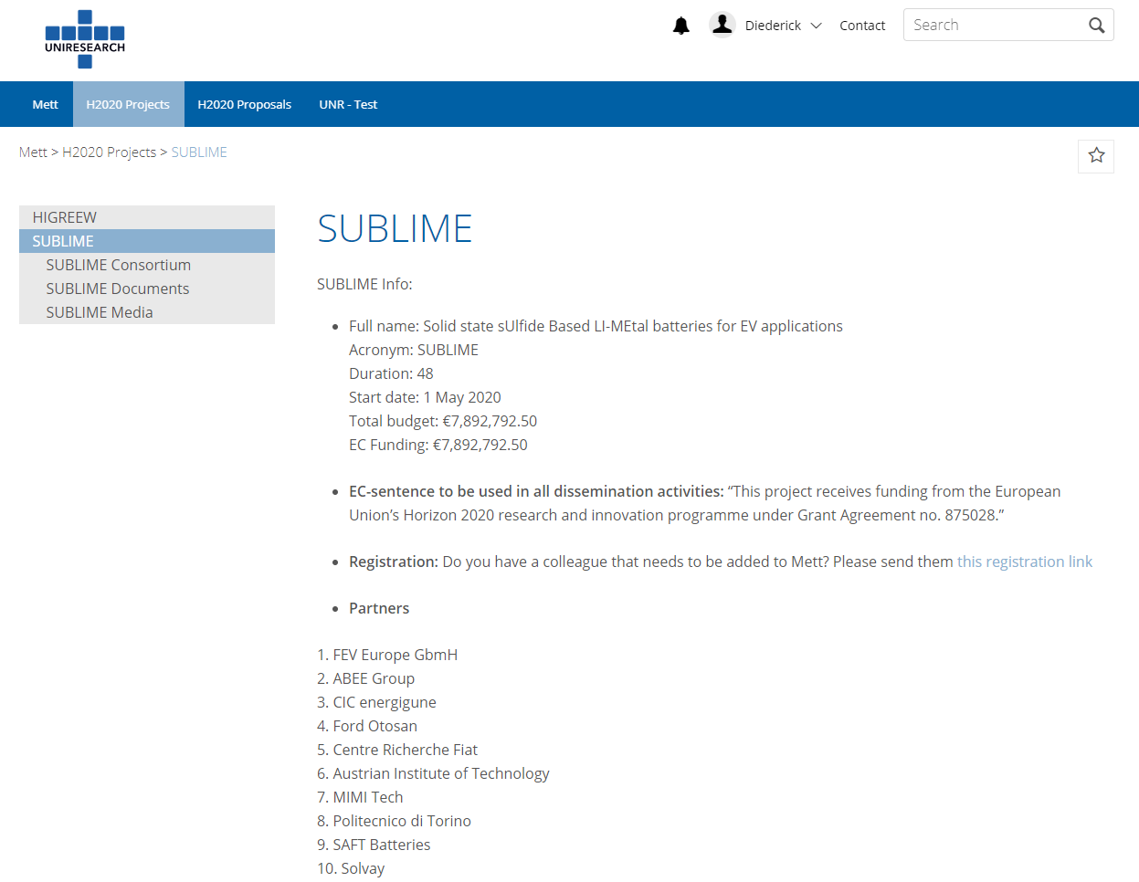

Special pages, with different functionalities, are dedicated to the different aspects of the project (document upload and exchange, video and photos’, contact list and consortium members).

### EU-fin

An e-mail is sent every max 6 months with the link to the project reporting tool “EU-fin”. All the partners have to report on project costs. In EU-fin, at the beginning of the project, a financial planning will be prepared (by UNR). In there the total project costs for each period will be divided among the different WPs (according to the budget file prepared during the proposal preparation) and categories.

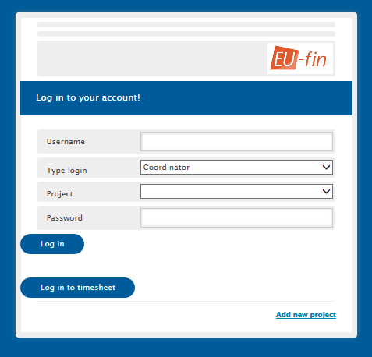

The figure above shows the login to report in the EU-fin system. This tool allows the project manager and coordinator to generate automatically cost reports comparing the actual expenses versus the budget per beneficiary, WP, activity, etc. Other functionalities are creating charts for comparing deliverables planned vs. actual, budget planned vs. actual, etc.

Below are reported just few examples of possible graphs and statistics which can be prepared, such as PMs spent per WP and /or per partner; budget spent in comparison with planned (also at WP and partner level). Information will be used to complete the official periodic reports (after M18, M36 and M48).

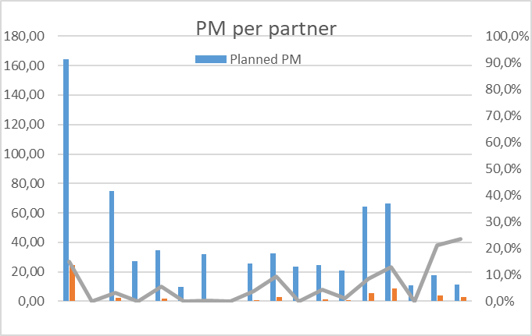

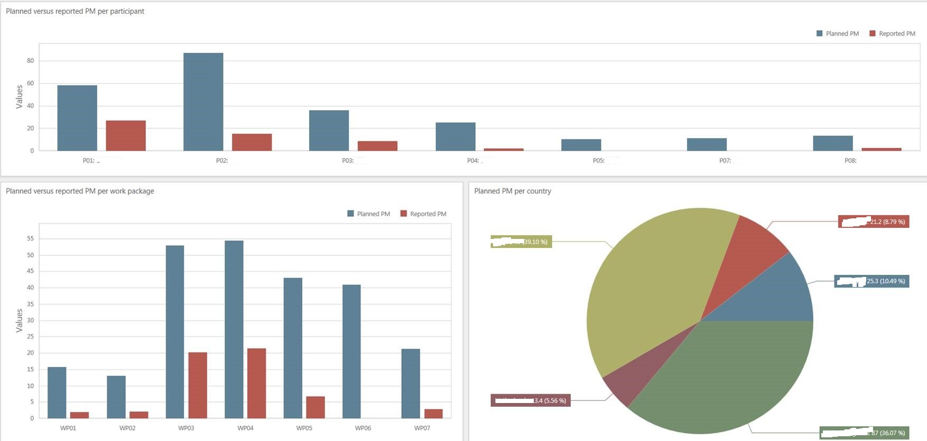

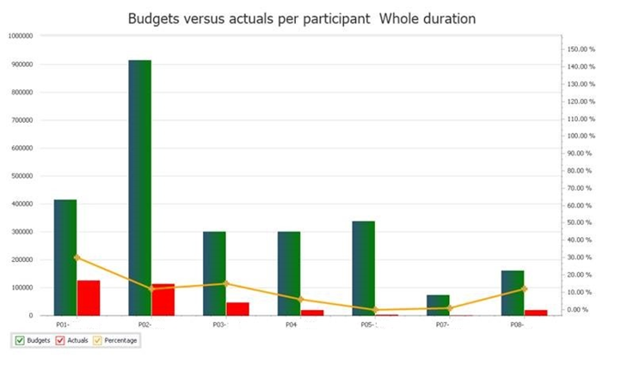

## Decision making

The project will be governed by the Grant Agreement signed with the European Commission and the Consortium Agreement (CA) signed among the partners, both before the project’s official launch. The CA, based on DESCA model, will cover all the relevant issues necessary for the proper execution of the project such as the responsibilities (Project Coordinator, Work Package Leaders Board, Exploitation Manager and individual parties), liabilities, voting rules, patent rules, joint-ownership, background knowledge, intellectual property rights, knowledge management, grant distribution, rules for publishing information, conflict resolution, admission of new partners, etc.

The voting rules and quorum for the General Assembly are:

* The General Assembly shall not deliberate and decide validly unless two-thirds (2/3) of its Members are present or represented (quorum);
* Each Member of the General Assembly present or represented in the meeting shall have one vote.
* Decisions shall be taken by a majority of two-thirds (2/3) of the votes with exception of decisions concerning the entry of a new Party, in which case the votes have to be unanimous.

## Change management

In a collaborative project, involving 15 partners (from 8 different European countries), 48 months of planning and a significant budget, changes may happen. This is quite normal but there should not be a surprise at the end of an official period (or of the project). Therefore, the project management team and the entire consortium is committed to maintain an open and transparent communication system. Nevertheless the ‘Rules of the Game’ are clearly reported below.

### Changes in budget

Each partner is requested to:

* Report immediately, as soon as the possibility of a budget modification is considered, to the coordinator.
* Provide the financial report each 6 months and clearly report on the expenditures and financial planning.

The coordinator together with the project management team will evaluate the situation, propose scenarios and possible solutions and inform accordingly the project officer for further discussion and alignment.

Below a list of the most common situations which may raise:

* Budget shift at partner level (only one partner involved, the total costs are not changing): some budget needs to be shifted from one WP to another or from one category to another (ex. From travel to ‘other direct costs’) 🡪 in principle no amendment to the Grant Agreement will be necessary but this should be discussed with the project officer and the Commission. Anyway, convincing justification for this shift should be provided.
* Budget shift between different partners 🡪 this may request an amendment of the Grant Agreement and it should be carefully analysed by the GA and – finally – by the Commission. Supporting documents need to be provided.

### Changes in personnel

A project contact list is available on Mett and maintained updated by UNR with inputs from all partners. It is normal new personnel/PhD students/collaborators join or leave the project team within four years’ time. However, changes need to be communicated immediately and anyway to the management team (this project is dealing with confidential research information and in case someone leaves the team it is important to remove his/her access to the project document database).

* Changes at GA level need to be presented and discussed during the meetings.
* In case of change of the coordinator an Amendment to the Grant Agreement will be necessary.
* Partners are requested to report immediately changes to the management team.

### Changes in technical content and timing

Each change related to the technical content and timing needs to be reported to the project officer (via the project coordinator).

Minor re-planning and re-alignment of the activities may be implemented but in case of changes in the scope/objectives of a specific WP an Amendment to the Grant Agreement will be necessary.

Partners are requested to report immediately possible changes at specific task to the WP leader who will evaluate the situation and inform the management team.

## Innovation management

Innovation management aims at promoting awareness of world-wide IP and expertise in the field of solid-state batteries, to enlarge the EU knowhow in the field and in particular LiM, while IPR management aims at protecting the exploitable results coming out of SUBLIME. Innovation management is a process, which requires an understanding of both the market and the technical possibilities, with an aim to successfully implement appropriate creative ideas. With good innovation management it should allow a consortium to respond quickly and thoroughly to both internal and external opportunities. This means the consortium must be able to develop an awareness of market needs and have the flexibility to adapt their product or service to meet these needs. AIT and ABEE will lead the task (8.1.1) and align activities with S-BAT cluster and other battery initiatives to identify potential synergies.

The strategy to capture and manage innovation is based on the following pillars:

* A careful worldwide patent search to identify any prior disclosures, complementary IPR or other relevant data assessing novelty and patentability.
* Peer review of the knowledge or technology both, within the consortium and (under the terms of a concluded confidential agreement) from key opinion leaders in the relevant field assessing novelty and inventiveness.
* Development of the content and claims of the patent application along with on-going reviews of any other work in the same or similar fields to ensure uniqueness and maximum breadth of coverage;
* Periodic review of patent application by the consortium to ensure relevance, value and commitment.
* Where appropriate filling a full patent application and pursuit to grant of the patent.
* Align activities with other S-BAT projects to identify potential synergies.
* Search for additional funding possibilities to ensure the continuation of SUBLIME project after its ending.
* Organize F2F meetings between the SUBLIME partners for coordinating plans, R&D progress and networking.
* Organize regular telecalls between the core teams of the project to share intermediate results, awareness towards EC, and identify concrete collaboration and testing opportunities.

# Risk management

As part of the overall management plan for the SUBLIME project, this document describes the risk management plan. It identifies conditions that may put the project at risk and provides guidance for managing these. It also provides methods and establishes roles and responsibilities of all participants in the risk management process.

## Risk Analysis

Since the probability of failure in Research and Innovation projects is considerable, risk factors in the SUBLIME work plan should be analysed on a regular basis. Therefore, WP1 contains the task 1.3 that is dedicated to a risk management plan, which will be kept up to date continuously during the entire project.

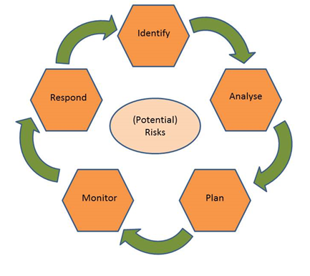Risks are approached according to the steps which together form the “circle” of risk management:

* Identify 🡪 In this step, risks are identified, with the moments at which they could occur and the specific symptoms of the risks.
* Analyse 🡪 Here, the risk is analysed further, looking also into the potential effects and consequences of the risk.
* Plan 🡪 In this step, plans are developed for management of the specific risk, as well as contingency plans.
* Monitor 🡪 The actual status of the risk is monitored, using e.g. the risk symptoms as identified in the first step.
* Respond 🡪 The specific risk management plan is put into action, when the monitoring step has shown the need for this. Actions are taken here to prevent the risk from happening full force or to avoid undesired consequences of the risk.

The risk management circle formed by these five steps will continuously be performed during the running time of the project.

## Critical risks and risk mitigation

In this section we will present a lean analysis of the major risks that could make the project fail. The strategy is based on the determination of major project achievements, or milestones, as described in section 3.2.5. of the DoA. The consortium has determined what the major factors are that could prevent the SUBLIME project from reaching the milestones. In table 3.1, an overview is presented of the most important risks and potential mitigation strategies (as presented in the DoA, other risks may be materialised and will be reported during the internal project reporting moments, as described in a section above).

|  |  |  |  |
| --- | --- | --- | --- |
| **No.** | **Description of risk** | **WP** | **Proposed risk-mitigation measures** |
| 1 | Delivery of sufficient sulfide SSE | WP3 | In case of insufficient amount of sulfide electrolyte, the electrode process and cell capacity and number of cells will be adjusted consequently |
| 2 | Reaching the right performances of SSE --> conductivity < 1mS/cm for upscaled sulphide | WP3 | If the targeted conductivity is not reached, the cell design will be adapted to minimize the cell resistance, and cell energy density will be consequently reduced |
| 3 | Development of appropriate LiM coating technology | WP4 | In case, LiM coating technology is performing enough, Li free electrode concept will be developed in this project and coating issues will be easier to overcome. |
| 4 | Optimisation of the interface to reach the requested targets --> 450Wh/kg and 1200Wh/l? | WP4 | In case the interface resistance is not low enough, the surface area of interface will be increased by decreasing the loading of electrode with a reduced cell energy density |
| 5 | Battery cell swelling | WP5 | In case the cell design is not adapted enough to the high swelling of LiM anode, laboratory high pressure system will be used |
| 4 | Sulfide electrolyte reacts with humidity traces in dry room forming H2S | WP5 | If H2S formation rate is too high, the electrodes and solid electrolyte layer will have to be manufactured in glove box or in dry rooms with dew points -80°C. Cells with capacity lower than 1Ah will be produced |
| 6 | Delivery of required materials for prototype manufacturing--> please give a target | WP3/5 | In case of insufficient amount of active material, the electrode process, cell capacity and number of cells will be adjusted consequently |
| 7 | Accuracy and predictability of the developed models | WP7 | In case the model is not accurate and predictive enough for the sulfide electrolyte design, more experimental tests will be necessary which will delay the delivery of material for the 40 mAh high power cell prototype. In this case, the performance will be demonstrated in smaller 2 mAh cell. |
| 8 | Produce large 10 Ah cells | WP5 | If 10Ah could not be achieved for upscaling issues, SUBLIME will target 5Ah cells |
| 9 | Delivery of enough small cells for preliminarily evaluation | WP4/6 | If not, the number of experiments will be reduced; specific test will be designed to characterize at the same time calendar and cycle life |

**Table 3.1. Possible identified risks and their mitigation measures.**

## Role of the partners and the coordinator in risk management

The monitoring of these risks, and the reporting of new, as yet unidentified risks, will actually be a task of everyone involved in SUBLIME. In the end it is the responsibility of the General Assembly to assess the possible occurrence of the risks, and to decide on the mitigation measures or, eventually, a modification of the work plan.

During the execution of the SUBLIME project frequent Work package leader Board meetings will be held to monitor progress, stimulate interactions between respective work packages, seek for feedback and exchange lessons learned, and to respect timely delivery of intermediate results, project deliverables and milestones.

The prevention of problems, avoidance of deviations from the project work plan, and mitigation of any risk arising as well as enhancement of the project success is an important task of project management in general.

The management work plan and the common internet platform “Mett” will spell out roles and responsibilities for proper execution of the SUBLIME Project and will distinguish between:

* Persons responsible for deliverables: who will identify risk, develop mitigation strategies and contingency plans for their tasks and monitor risk. They report potential risk factors to their Work Package Leader.
* Work package leaders, who will consolidate risk and develop mitigation strategies and contingency plans on work package level. They report potential risk factors to the Project coordinator and other WP Leaders.
* Project coordinator, who is responsible for the risk management of the whole project. He/she identifies risk, develops mitigation strategies and contingency plans, monitors risk and reports risk status in the periodic progress reports to the EU, including planned contingency measures.

In the end all partners are responsible for dealing with the risk factors and actions as sketched in the contingency plan.

# Quality Assurance

## Review Process for project deliverables and reports

The term “Deliverables” refers to the formal SUBLIME Project deliverables as described in the Grant Agreement No. 875028; the term “Reports” refers not only to the compulsory reports for the Commission but – more in general - also to other publications and exposures of SUBLIME activities to third parties.

Also, content on the project website can be considered a report; with the notion that all information presented at the website has to be PUBLIC, the website host is responsible for quality and sanity checks on information that is to be published at the SUBLIME website.

For confidential deliverable(s) a short Publishable summary can be offered on the website.

An overview of all formal SUBLIME deliverables is presented in Annex A.

An overview of all other SUBLIME exhibitions and presentations will be included in the SUBLIME Dissemination plan. This plan will be regularly updated with initiatives from the consortium and/or individual partners that intend to deliver SUBLIME related publications, presentations and similar. (Updates of) This plan will be discussed and agreed upon at SUBLIME General Assembly Meetings.

All deliverables have to undergo a quality assessment. The rules for quality assessment are laid out in next sections.

## Quality assurance procedure

To ensure their quality all SUBLIME deliverables will be reviewed internally before delivery to the Commission or to publishing bodies.

### Quality management responsibilities

The Project Coordinators, Jens Ewald & Jörg Kaiser (both FEV), together with the project management support team (UNR) guard the Quality Assurance Procedure. They supervise the overall assessment of project deliverables by dedicated reviewers. Authors remain responsible for timely delivery of (drafts of) deliverables during this process, while the project support team is responsible only for uploading of final project products to the EU portal and informing the Project Officer. This is especially important in case of delays in delivery dates of formal deliverables.

Each work package leader is quality manager for his/her own work package and for the deliverables developed within concerned work package. The WP leader may assign internal reviewers to review a deliverable draft, preferably a staff member working in that work package who is not one of the deliverable authors (given the low staff number, this may not always be possible).

Further, for quality assurance purposes, each deliverable – once approved by the WP leader – will be reviewed by other partners (not directly involved in the task performed). Below we report a list of the technical deliverables and proposed reviewers.

|  |  |  |  |  |  |  |  |
| --- | --- | --- | --- | --- | --- | --- | --- |
| Del | Title | WP | Lead | Reviewer | Level | M | EC date |
| D1.1 | Project Handbook | 1 | UNR | ABEE/FEV | CO | 3 | jul-20 |
| D2.1 | Report on specifications, performances and cost requirements for the large cell | 2 | CRF | CEA/POLITO | CO | 3 | jul-20 |
| D2.2 | Report on specifications and performances requirements for small cells | 2 | CRF | TNO/UMICORE | CO | 4 | aug-20 |
| D4.1 | Protocol for sulfide-based material handling and transportation | 4 | SAFT | AIT/CICe | CO | 5 | sep-20 |
| D6.1 | Report on the safe handling & testing protocol and cell testing protocols (electrochemical, aging, abuse) | 6 | CEA | ABEE/SAFT | CO | 5 | sep-20 |
| D2.3 | Report on test protocols for small and large cells | 2 | FO | CICe/POLITO | CO | 6 | okt-20 |
| D8.1 | Dissemination and communication strategy and plan | 8 | UNR | AIT/FEV | PU | 6 | okt-20 |
| D1.2 | Initial Risk Management plan | 1 | FEV | ABEE/SOL | CO | 8 | dec-20 |
| D1.3 | Initial Data management plan | 1 | FEV | AIT/ABEE | CO | 8 | dec-20 |
| D3.1 | Report on delivery of 100g sulfide for WP4 | 3 | CEA | CICe/SAFT | CO | 12 | apr-21 |
| D5.1 | Definition of safety conditions for material and electrodes scaling-up and shipments | 5 | IST | UMICORE/SOL | CO | 12 | apr-21 |
| D4.2 | Report on interface stability using optimized materials | 4 | CIC | TNO/AIT | CO | 14 | jun-21 |
| D3.2 | Report on delivery of 1kg batches for WP4 & WP5 | 3 | SOL | CICe/SAFT | CO | 18 | okt-21 |
| D4.3 | Report on formulation and process at lab scale | 4 | IST | CEA/AIT | CO | 22 | feb-22 |
| D3.4 | Report on the protective strategies on Lithium metal | 3 | SOL | POLITO/IST | CO | 24 | apr-22 |
| D3.5 | Report on delivery of optimized cathode for Primary pathway | 3 | UMC | CICe/SAFT | CO | 24 | apr-22 |
| D8.2 | Interim IPR report and exploitation strategy and business plan | 8 | FEV | AIT/ABEE | PU | 24 | apr-22 |
| D4.4 | Report on layer processing towards upscaling | 4 | AIT | ABEE/CICe | CO | 28 | aug-22 |
| D5.2 | Prototype cell design | 5 | SAFT | CICe/ABEE | CO | 30 | okt-22 |
| D6.3 | Report on possible recycling path including a flow sheet and mass balance calculation | 6 | MIM | UMICORE/SAFT | PU | 30 | okt-22 |
| D7.1 | Properties prediction of sulfide Solid Electrolyte | 7 | CIC | SOL/CICe | CO | 30 | okt-22 |
| D4.5 | Report on monolayer pouch cell assembly | 4 | IST | CICe/AIT | PU | 32 | dec-22 |
| D3.3 | Report on delivery of 10 kg batches for WP5 | 3 | SOL | CICe/SAFT | CO | 34 | feb-23 |
| D3.7 | Report on delivery of lithium metal foil for Primary pathway | 3 | SOL | CICe/SAFT | CO | 34 | feb-23 |
| D5.3 | Results of the process upscaling benchmarking for positive electrode and solid electrolyte layer | 5 | IST | CICe/ABEE | CO | 34 | feb-23 |
| D4.6 | Report on solid-to-solid interface characterization | 4 | CIC | CEA/TNO | CO | 36 | apr-23 |
| D7.2 | Mechanism of Li Transport and dendrite formation in all solid battery | 7 | ABEE | TNO/CICe | CO | 36 | apr-23 |
| D3.6 | Report on delivery of optimized cathode for Secondary pathway | 3 | UMC | CICe/SAFT | CO | 40 | aug-23 |
| D3.8 | Report on delivery of optimized lithium metal foil for Secondary Pathway | 3 | SOL | ABEE/SAFT | CO | 40 | aug-23 |
| D5.4 | 10Ah cell prototypes manufacturing | 5 | SAFT | CICe/ABEE | CO | 40 | aug-23 |
| D6.4 | Report on LCA including listed data set | 6 | MIM | ABEE/SAFT | PU | 42 | okt-23 |
| D7.3 | Report on the prediction of electrochemical performance and degradation behaviour | 7 | POL | CICe/TNO | CO | 42 | okt-23 |
| D1.4 | Final Risk Management plan | 1 | FEV | ABEE/SOL | CO | 46 | feb-24 |
| D6.2 | Report on electrochemical, Aging and safety tests | 6 | CEA | POLITO/SAFT | CO | 47 | mrt-24 |
| D1.5 | Final Data management plan | 1 | FEV | AIT/ABEE | CO | 48 | apr-24 |
| D2.4 | Upgraded requirements and targets for 2030 | 2 | CRF | UMICORE/SAFT | PU | 48 | apr-24 |
| D6.5 | Matrix model for sustainability assessment | 6 | MIM | CEA/SAFT | PU | 48 | apr-24 |
| D6.6 | Cell cost assessment | 6 | CIC | IST/SAFT | CO | 48 | apr-24 |
| D7.4 | Report on the interaction with the battery modelling community | 7 | ABEE | CICe/TNO | PU | 48 | apr-24 |
| D8.3 | Final IPR report and exploitation strategy after SUBLIME – Roadmap to 2030 | 8 | ABEE | AIT/FEV | CO | 48 | apr-24 |
| D8.4 | Final report, summary of published documents | 8 | UNR | ABEE/AIT | PU | 48 | apr-24 |

Table 4.1 – Deliverables appointed internal reviews

### General quality management procedure

The quality management procedure recognizes the following timeline and steps to submit the deliverable in time:

|  |  |  |  |
| --- | --- | --- | --- |
| **Submission Date** | **Action** | **Action by** | **Example dates D1.1** |
| **D-28** | Present draft of deliverable for quality review to WP Leader & incorporate any changes from WPL into the final draft for review by Reviewers | Main Author | 3 July |
| **D-21** | Present final draft of deliverable for quality review to Reviewers | Main Author | 10 July |
| **D-14** | Provide review report with recommendations to Main Author and in copy to WP Leader | Quality Reviewers | 17 July |
| **D-10** | In case of serious modifications following from first review, revisit the review procedure in order to take appropriate measures as necessary | WPL, Authors and Reviewers | 21 July |
| **D-7** | Present final version to project coordinator & incorporate any changes requested by coordinator into the final draft before sending a CLEAN copy to UNR | Main Author | 24 July |
| **D-3** | Present final version to UNR | Main Author | 28 July |
| **D** | Submit deliverable to the Commission | UNR | 31ST July 2020 |

Table 4.2 Time plan for quality management

All final deliverables are to show to have followed the effective quality management through filled out review forms by the reviewers (attached as appendix A to this document).

Due date (D) is the day at which deliverable has to be forwarded externally, be it the project officer or other bodies. Formal due dates for SUBLIME deliverables are the last day of the month specified in the SUBLIME deliverables table.

The author(s) of the deliverable shall use the latest deliverable template (can be found on the SUBLIME Mett, section Templates and Logos for creating the deliverable.

The WP leader takes to the initiative to contact the GA members earlier if she/he fears that a part of the deliverable is critical.

The WP leader responsible for a deliverable assigns reviewer(s) for the deliverable four weeks before the deliverables’ due date. The reviewer is independent from the authors and ideally is from at least one other SUBLIME consortium partner, ideally one of the WP participants. In case of a large or key deliverable, the WP leader may assign multiple independent reviewers (see table 4.1).

The internal review shall be completed no later than one week after the review request.

The reviewer uses a standard review form (reported in Appendix A of this document) to document his/her review findings. The review form is maintained throughout this procedure until submission of the deliverable. It will remain stored in the SUBLIME project place for archive purposes.

The reviewer reviews the deliverable and sends his/her completed comments to the WP leader and to the authors of the deliverable. The possible results of the review process are:

ACCEPT: The deliverable is acceptable in its current form and the SUBLIME coordinator should submit it to the Commission.

ACCEPT with REVISION: The deliverable is in principle acceptable. However, some minor changes are needed. The author(s) should revise the deliverable. No further WP internal reviewing is required.

REVISE: The deliverable is not acceptable in its current form. The author(s) proceed for improvement.

The author(s) revise the deliverable according to the review result within a maximum of five days after receiving the request for quality improvement and inform the WP leader which will request a new review preferably by the same reviewer.

The WP leader checks the review and ensures that requested improvements are implemented by the author(s).

When the deliverable is accepted, the WP leader informs the Project Management Team.

The Project Management Team checks the deliverable and the review form. He/she may issue a request for further improvement to the author(s) and the WP leader. This procedure makes it highly likely that the twofold improved deliverable is ready for submission. If not, the author(s) must implement the final corrections as requested immediately.

Once the review and approved procedure is completed, the Project Coordinator then submits the deliverable to the Commission in electronic form (PDF) via the SyGMa portal. The Management Team stores the PDF of submitted deliverables on the SUBLIME Mett (section Documents / SUBMITTED DELIVERABLES / Dx.x /).

The final version of the deliverable must be submitted to the Commission as close as possible to the due date. Therefore, reviewing and revising must be performed as early and as fast as possible in case multiple review-revise cycles are necessary.

## Approval process of Milestones

WP leaders are responsible for the achievement of WP related milestones. WP leaders report to the General Assembly if they think a milestone has been achieved and the means of verification as reported in SyGMa should be met. It will then be discussed, after which the Management team can report to the Commission.

Below the table reporting the project Milestones

|  |  |  |  |  |  |
| --- | --- | --- | --- | --- | --- |
| **Milestone number** | **Milestone name** | **Lead partner** | **Related WPs** | **Estimated date** | **Means of verification** |
| MS01 | Requirements regarding performances, cost and safety | CRF | WP2 | M4 | D2.1 report |
| MS02 | Protocol for safe handling and testing defined | CEA | WP6 | M5 | D6.1 report |
| MS03 | Lab-scale cell ready (capacity of about 1-2 mAh, 10 mm of diameter cell) | CIC | WP4 | M14 | D4.2 report |
| MS04 | Pouch cells (up to 40 mAh) assembled | IST | WP4 | M32 | D4.6 report |
| MS05 | Recycling path defined | MIM | WP6 | M30 | D6.3 report |
| MS06 | Delivery of 50 kg sulfide electrolyte (GENIV) & cathode material  layer & 30m of Li metal (Primary Pathway) | SOL & UMC | WP3 | M34 | Reception of materials and Li metal at IST and SAFT |
| MS07 | Delivery of 100g optimized sulfide electrolyte (GENVI) & cathode material  layer & 50cm of Li metal (Secondary Pathway ) | CEA, UMC & SOL | WP3 | M40 | Reception of materials and Li metal at CIC |
| MS08 | 10 Ah cell delivery | SAFT | WP5 | M40 | Picture of cells will be sent to the coordinator when received by the partner (CEA) |
| MS09 | Availability of the Multiphysics model | POL | WP7 | M42 | D7.3 report |
| MS10 | Formulation & process for positive electrode and SEL for WP5 | IST | WP4 | M22 | D4.3 |

Table 4.3 List of milestones.

# Communication, confidentiality and IP ownership

Internal communication will be stimulated as much as possible by the management team and the EB members. Frequent teleconferences and meetings will be organised among partners.

The partners concluded a Consortium Agreement (CA), in which all relevant issues necessary for the proper execution of the project are described in detail.

Below a summary of few articles related to decisions, communication and confidentiality.

## Decision and voting rules

*Article 6.2.3.1 of the CA*

Each Consortium Body shall not deliberate and decide validly unless two-thirds (2/3) of its Members are present or represented (quorum). If the quorum is not reached, the chairperson of the Consortium Body shall convene another ordinary meeting within 15 calendar days. If in this meeting the quorum is not reached once more, the chairperson shall convene an extraordinary meeting which shall be entitled to decide even if less than the quorum of Members is present or represented.

## IPR

*Article 8.1 of the CA*

Results are owned by the Party that generates them.

*Article 8.2 of the CA*

Joint ownership is governed by Grant Agreement Article 26.2 with the following additions:

Once the Results have been generated, the joint owners concerned must agree on the conditions of use and Exploitation of the Results in a joint ownership agreement. The joint ownership agreement shall be established between the joint owners concerned as soon as necessary, and in any event before any Exploitation.

Unless otherwise agreed:

− each of the joint owners shall be entitled to use their jointly owned Results for non-commercial research activities on a royalty-free basis, and without requiring the prior consent of the other joint owner(s), and

− each of the joint owners shall be entitled to otherwise Exploit the jointly owned Results and to grant non-exclusive licenses to third parties (without any right to sub-license), if the other joint owners are given:

(a) at least 45 calendar days advance notice; and

(b) Fair and Reasonable Conditions compensation.

In case the Results are jointly generated by a Party and Umicore, each of the joint owners shall be entitled to use their jointly owned Results on a royalty-free basis and without requiring the prior consent of the other joint owner(s) only for Internal Research Activities.

## Export to non-EU countries

Part B of the GA states that SUBLIME will not export neither hardware nor software to non-EU countries that could be classified as dual-use item 3A001.e.1.b.: “‘Secondary cells’ having an ‘energy density’ exceeding 350 Wh/kg”. And in case we were to export them, SUBLIME will pay particular attention to the compliance with the Second Regulatory Review on Nanomaterials COM/2012/0572 during the project.

Moreover

* any activities involving dual-use items or dangerous materials and substances will comply with applicable EU, national and international law;
* if any dual-use items listed in Annex I of Regulation No 428/2009 will be exported from the EU, copies of any export or transfer licence will be provided to INEA before the beginning of the activity

**Procedure concerning the export of software during SUBLIME**

The export regulation to non-EU countries has an effect on the collaboration with the SUBLIME partner Ford Otosan (Turkey). During the first Work Package Leaders Board meeting (WPLB01) the following procedure was agreed:

1. All partners will specify what exactly they will be sharing with Ford Otosan during SUBLIME and inform the management team.
2. The next step will be that the partner wishing to share information with Ford Otosan contacts their own legal and security officers, with the aim to get information on national legislation concerning export to non-EU countries.
3. All necessary documents (security certificates, transportation certificates, safety data sheets, etc.) will be acquired by the partner wishing to share information or export software to Ford Otosan.
4. The documents will be sent to the management team who will provide them to INEA.

No hardware shall be exported to Turkey unless otherwise agreed.

## Transfer of results

*Article 8.3.1 of the CA*

Each Party may transfer ownership of its own Results to any of its Affiliated Entities without the need to give a prior notice to the other Parties, provided that the PARTY ensures that its obligations under Articles 26.2, 26.4, 27, 28, 29, 30 and 31 of the Grant Agreement also apply to the new owner and that this owner has the obligation to pass them on in any subsequent transfer.

In case of jointly owned Results, the other Parties hereby consent to such transfer of ownership for the following parties:

**Assignor Affiliate/Assignee**

FEV Europe GmbH FEV Group GmbH

Rhodia Operations SAS Solvay SA

As long as the other Parties are not informed of such a transfer the original owner of the Results shall remain the correct Party to request and get access rights granted from

*Article 8.3.2 of the CA*

Each Party may identify specific third parties it intends to transfer the ownership of its Results to in Attachment 3 to this Consortium Agreement. The other Parties hereby waive their right to prior notice and their right to object to a transfer to listed third parties according to the Grant Agreement Article 30.1. During the implementation of the Project, any Party may add any further third party to Attachment 3 upon approval of the General Assembly within a reasonable period prior to a transfer to such further third party becoming effective.

*Article 8.3.3 of the CA*

The transferring Party shall, however, at the time of the transfer, inform the other Parties of such transfer and shall ensure that the rights of the other Parties will not be affected by such transfer.

*Article 8.3.4 of the CA*

The Parties recognize that in the framework of a merger or an acquisition of an important part of its assets, it may be impossible under applicable EU and national laws on mergers and acquisitions for a Party to give the full 45 calendar days prior notice for the transfer as foreseen in the Grant Agreement

*Article 8.3.5 of the CA*

The obligations above apply only for as long as other Parties still have - or still may request - Access Rights to the Results.

## Dissemination of results

*Article 8.4.2.1 of the CA*

During the Project and for a period of 1 year after the end of the Project, the dissemination of own and jointly owned Results by one or several Parties including but not restricted to publications and presentations, shall be governed by the procedure of Article 29.1 of the Grant Agreement subject to the following provisions. Prior notice of any planned publication shall be given to the other Parties at least 45 calendar days before the publication. Any objection to the planned publication shall be made in accordance with the Grant Agreement in writing to the Coordinator and to the Party or Parties proposing the dissemination within 30 calendar days after receipt of the notice. If no objection is made within the time limit stated above, the publication is permitted

## Acknowledgment of EU funding

*Article 29.4 of the GA*

For communications activities:

“This project has received funding from the European Union’s Horizon 2020 research and innovation programme under Grant Agreement No 875613.”

For patents:

"The project leading to this application has received funding from the European Union’s Horizon 2020 research and innovation programme under grant agreement No 875028."

For standardisation activities:

“Results incorporated in this standard received funding from the European Union’s Horizon 2020 research and innovation programme under grant agreement No 875028”.

For infrastructure, equipment and major results:

"This [infrastructure][equipment][result] is part of a project that has received funding from the European Union’s Horizon 2020 research and innovation programme under grant agreement No 875028."



In addition, the emblem of the European Commission should be displayed.

## Early information of planned dissemination

Please note:

Dissemination activities must be planned well in advance to allow for proper quality review and security assessment

All partners need to be informed well in advance (45 days prior) to formal publication (apart from the formal SUBLIME deliverable) this holds for publications in journals, presentations at conferences and contributions to proceedings, and the like.

# Acknowledgement

The author(s) would like to thank the partners in the project for their valuable comments on previous drafts and for performing the review.

**Project partners:**

|  |  |  |
| --- | --- | --- |
| **#** | **Participant organisation name** | **Short** |
| 1 | FEV Europe GmbH | FEV |
| 2 | ABEE Group | ABEE |
| 3 | CICe energigune | CIC |
| 4 | FORD Otomotiv Sanayi A.S | FORD |
| 5 | Centro Ricerche FIAT S.C.p.A. | CRF |
| 6 | Austrian Institute of Technology GmbH | AIT |
| 7 | MIMITech GmbH | MIM |
| 8 | Politecnico di Torino | POL |
| 9 | SAFT Batteries | SAFT |
| 10 | SOLVAY – Rhodia Operations | SOL |
| 11 | TNO Holst centre | TNO |
| 12 | Fraunhofer IST | IST |
| 13 | Commissariat à L’Energie Atomique et aux Energies Alternatives | CEA |
| 14 | UMICORE | UMC |
| 15 | Uniresearch BV | UNR |

|  |  |
| --- | --- |
| http://elastic.studioh2o.nl/image.php/userdata/image/ec_1.gif?width=150&height=150&image=/userdata/image/ec_1.gif | *This project has received funding from the European Union’s Horizon 2020 research and innovation programme under Grant Agreement no. 875028.* |

# Appendix A – Quality Assurance review form

The following questions should be answered by all reviewers (WP Leader, peer reviewer 1, peer reviewer 2 and the technical coordinator) as part of the Quality Assurance Procedure. Questions answered with NO should be motivated. The author will then make an updated version of the Deliverable. When all reviewers have answered all questions with YES, only then the Deliverable can be submitted to the EC.

NOTE: For public documents this Quality Assurance part will be removed before publication.

|  |  |  |  |  |
| --- | --- | --- | --- | --- |
| Question | WP Leader | Peer reviewer 1 | Peer reviewer 2 | Technical Coordinator |
|  | Jens Ewald | Noshin Omar | Joerg Kaiser | Jens Ewald |
| 1. Do you accept this deliverable as it is? | Yes | Yes / No (motivate) | Yes / No (motivate) | Yes / No (motivate) |
| 1. Is the deliverable completely ready (or are any changes required)? | Yes | Yes / No (motivate) | Yes / No (motivate) | Yes / No (motivate) |
| 1. Does this deliverable correspond to the DoW? | Yes | Yes / No (motivate) | Yes / No (motivate) | Yes / No (motivate) |
| 1. Is the Deliverable in line with the SUBLIME objectives? | Yes | Yes / No (motivate) | Yes / No (motivate) | Yes / No (motivate) |
| 1. WP Objectives? | Yes | Yes / No (motivate) | Yes / No (motivate) | Yes / No (motivate) |
| 1. Task Objectives? | Yes | Yes / No (motivate) | Yes / No (motivate) | Yes / No (motivate) |
| 1. Is the technical quality sufficient? | Yes | Yes / No (motivate) | Yes / No (motivate) | Yes / No (motivate) |