# Quality Assurance

## Quality assurance procedure for deliverables

The term “Deliverables” refers to the formal SAFELiMOVE Project Deliverables as described in the Grant Agreement No. 875189. An overview of all formal SAFELiMOVE deliverables is presented in Table 5. To ensure their quality all SAFELiMOVE deliverables will be reviewed internally before submission.

All technical deliverables should have:

* Public executive summary (1-2 pages)
* Core part of approx. 10-15 pages (depending on the kind of report): real content on the technical developments, with clear description what work was done, results and a discussion why certain decisions were taken, based on the provided technical information
* Risk table (if applicable) with real risks and an elaboration on the risks
* Conclusions and recommendations for future work

The authors should use the deliverable template as provided on Mett.

### General review procedure

The review procedure has the following timelines and steps to submit the deliverable in time:

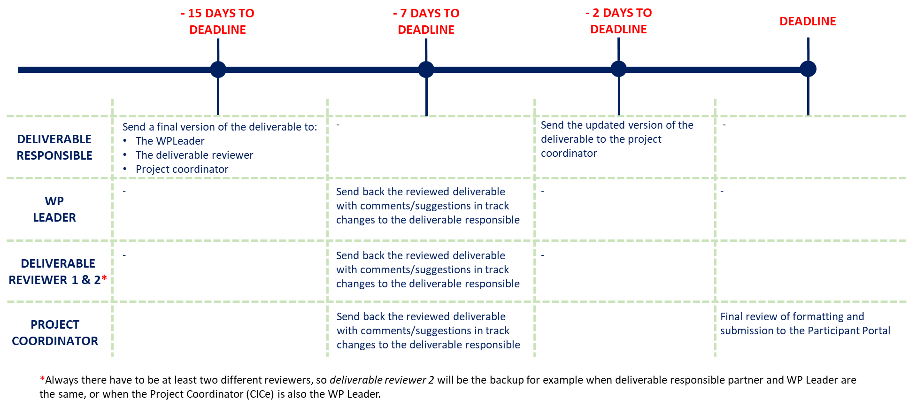

Figure 5 Overview of deliverable review process

All deliverables should show to have followed the procedure above by indicating in the deliverable itself the persons that have performed the quality review.

Each reviewer uses the standard review form (shown in Annex A of this document) to document his/her review findings. After reviewing, the reviewer sends his/her comments to the authors of the deliverable. The author(s) revises the deliverable according to the review result within a maximum of five days after receiving the request for quality improvement.

The Project Coordinator ensures that requested improvements are implemented by the author(s) and performs the final review. Once the deliverable is approved by the Project Coordinator, the Project Coordinator then submits the deliverable to the Commission in electronic form (PDF) via the SyGMa portal. The project management team stores the submitted deliverables on Mett (section Documents / SUBMITTED DELIVERABLES / Dx.x /).

Table 5 shows a list of the deliverables and proposed reviewers.

|  |
| --- |
| Table 5 Proposed reviewers for deliverables |