* IDEALFUEL -   
  Lignin as a feedstock for renewable marine fuels

GRANT AGREEMENT No. 883753

HORIZON 2020 PROGRAMME - TOPIC LC-SC3-RES-23-2019

“Development of next generation biofuel and alternative renewable fuel technologies for aviation and shipping”

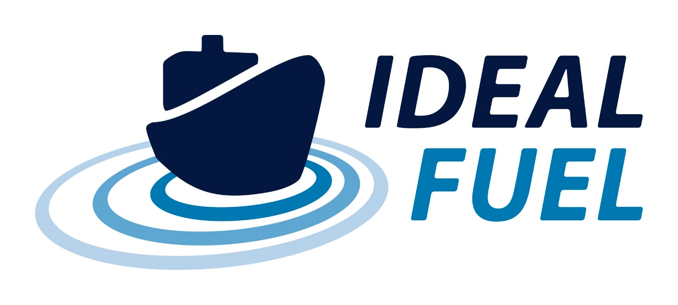

Milestone Report

M1 – Lignin Oil Extraction (1 kg-scale)

|  |  |  |
| --- | --- | --- |
| Milestone No. | IDEALFUEL MS01 |  |
| Related WP | WP2 |  |
| Milestone Title | Lignin Oil Extraction (1 kg-scale) |  |
| Milestone Date | 31-10-2020 |  |
| Written By | Florent Héroguel (BLOOM) | 27-20-2020 |
| Checked by | Name WP leader (VERT) | dd-mm-yyyy |
| Approved by | Project Coordinator | dd-mm-yyyy |
| Status | Draft 1.0 ~~/ Draft 2.0 / Final~~ | dd-mm-yyyy |

Disclaimer/ Acknowledgment

Copyright ©, all rights reserved. This document or any part thereof may not be made public or disclosed, copied or otherwise reproduced or used in any form or by any means, without prior permission in writing from the IDEALFUEL Consortium. Neither the IDEALFUEL Consortium nor any of its members, their officers, employees or agents shall be liable or responsible, in negligence or otherwise, for any loss, damage or expense whatever sustained by any person as a result of the use, in any manner or form, of any knowledge, information or data contained in this document, or due to any inaccuracy, omission or error therein contained.

All Intellectual Property Rights, know-how and information provided by and/or arising from this document, such as designs, documentation, as well as preparatory material in that regard, is and shall remain the exclusive property of the IDEALFUEL Consortium and any of its members or its licensors. Nothing contained in this document shall give, or shall be construed as giving, any right, title, ownership, interest, license or any other right in or to any IP, know-how and information.

This project has received funding from the European Union’s Horizon 2020 research and innovation programme under grant agreement No 883753. The information and views set out in this publication does not necessarily reflect the official opinion of the European Commission. Neither the European Union institutions and bodies nor any person acting on their behalf, may be held responsible for the use which may be made of the information contained therein.

**Publishable summary**

Please insert up to half a page of publishable summary which can be used for publication on the project website. The summary should shortly explain the background and means of achievement for the milestone.

While technical lignin are cheap and available in large quantities, their characteristics are not suitable for the development of high-performance marine fuels. Among others, these lignins suffer from low solubilities, large molecular weight, high sulfur content and are generally non-uniform in their chemical nature. One strategy consists in solvent fractionation of technical lignins to extract a high-quality fraction, which can be more suitable for fuels applications. A second strategy consists in the production of high-quality lignin from biomass with alternative bio-refining process. Within IDEALFUEL, the partners selected solvolysis and Aldehyde-Assisted Fractionation (AAF) as the most relevant technologies for the production of high-performance lignin for fuels applications.

The AAF biomass pretreatment technology has been recently developed at the Laboratory of Sustainable and Catalytic Processing at EPFL (Shuai L. et al., *Science* **2016**, 354, 329-333; Talebi Amiri et al., *Nature Protocols,* **2019**, 14, 921-954). This approach – based on a “stabilizing strategy” that prevents the condensation of the most recalcitrant fraction, lignin – is the first of its kind. This chemical process is regarded as a paradigm shift in the field of biomass upgrading, as it is the first method able to extract a lignin that can be converted to i) aromatic monomers and ii) highly soluble lignin oligomers. These two fractions have been shown to have high-value application in the replacement of petrochemicals.

BLOOM has performed Aldehyde-Assisted Fractionation (AAF) of beechwood at the 10 litres scale to produce stabilized lignin in the 100g-scale. Lignin has been isolated as a solid by precipitation and characterized by HSQC NMR which revealed low degree of condensation (high β-O-4 content). In a second step, AAF lignin depolymerization by hydrogenolsis under pressure at the 1 litre scale has been performed to produce lignin oligomers and mononers. Lignin oligomers have been isolated by precipitation and send to partners as a powder.

# Milestone Achievement

## 1.1 Title of Milestone

This document reports the achievement of IDEALFUEL Milestone MS01 concerning Lignin Oil Extraction (1 kg-scale).

## 1.2 Description of Milestone and means of verification

*Describe the milestone and the means of verification (list deviations from the DoA, if any).*

The milestone consists in the extraction of lignin oil at the 1 kg-scale. Means of verification are the ability of partners to perform extraction of lignin oil at the 1 kg-scale.

## 1.3 Comments on completion

*Describe how the milestone was achieved. i.e. references to (parts of) deliverables, input-output. Include images/graphics if relevant.*

Bloom has performed AAF of beechwood at the 10 litres scale to produce stabilized lignin. Lignin has been isolated as a solid by precipitation. In a second step, Bloom has performed lignin depolymerization by hydrogenolsis under pressure at the 1 litre scale to produce lignin oligomers and monomers. Lignin has been isolated by precipitation, characterized by HSQC NMR which revealed low degree of condensation (high β-O-4 content) and send to partners as a powder: 10 g were sent to CSIC on 21.08.2020 and 200 g were sent to Vertoro on 05.11.2020. Furthermore, the team has run preliminary tests on 100L and 250L reactors, which were successful. A dissemination video, available on the website, has been prepared by the Bloom team to illustrate the scale at which Bloom is currently operating. The details regarding production will compiled in a report and delivered at M8 according to D2.1: Report on the setup of the production line and the optimization of the process for the production of oligomers.

## 1.4 Other relevant information

|  |  |
| --- | --- |
| Lead beneficiary |  |
| Delivery date in DoA |  |
| Actual deliverable date |  |
| Achieved | Yes / No |
| Reference documents | Mention relevant documents (if any) |

# Risk Register

*Describe any risks related to the milestone e.g. related to the timing of linked activities*

|  |  |  |  |  |
| --- | --- | --- | --- | --- |
| Risk No. | What is the risk | Probability of risk occurrence1 | Effect of risk1 | Solutions to overcome the risk |
| WPx.x | Any risks related to this milestone? | Indicate the level | Indicate the level | Give a description how to overcome the risk / describe give possible solution(s) |
|  | COVID-related delays  Whole Switzerland was coming out of a full shutdown at the start of the project. With facilities running at 50% of their capacity, BLOOM has successfully done everything to maintain the indicated deadline. However, the recent case surge on October 22nd may trigger renewed measures that limit the activity on large reactors, where several co-workers are involved and proximity can not be avoided. | 1 | 1 | BLOOM takes all the measures to ensure that co-workers are safe, in their professional and private lives. Furthermore, all measures are in place in the working environment to ensure a minimal risk of contamination. Finally, all activities that do not require laboratory equipment are preformed from home- |

1) Probability risk will occur: 1 = high, 2 = medium, 3 = Low

|  |  |
| --- | --- |
| http://elastic.studioh2o.nl/image.php/userdata/image/ec_1.gif?width=150&height=150&image=/userdata/image/ec_1.gif | *This project has received funding from the European Union’s Horizon 2020 research and innovation programme under grant agreement No 883753* |