* IDEALFUEL -   
  Lignin as a feedstock for renewable marine fuels

GRANT AGREEMENT No. 883753

HORIZON 2020 PROGRAMME - TOPIC LC-SC3-RES-23-2019

“Development of next generation biofuel and alternative renewable fuel technologies for aviation and shipping”

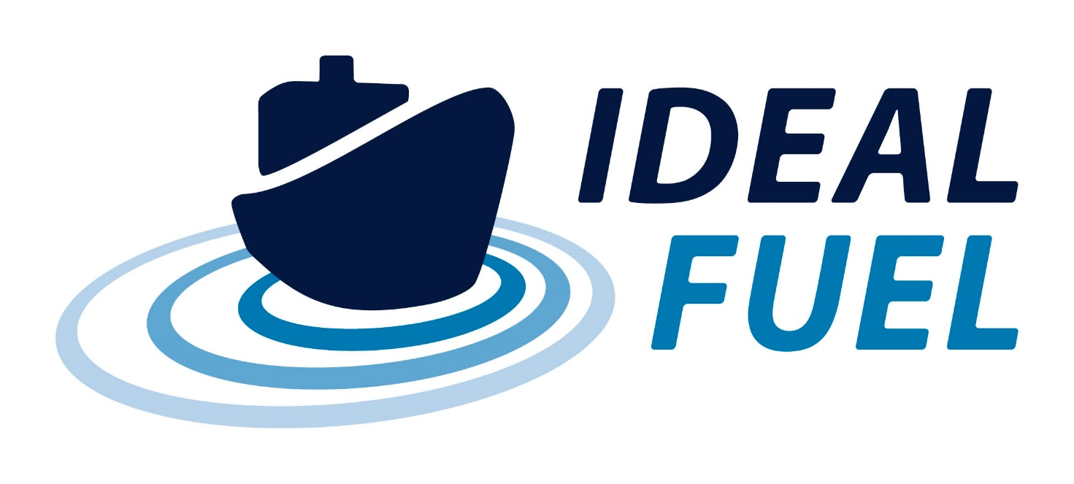

Deliverable Report

D8.2 – Risk and Mitigation Plan

|  |  |  |
| --- | --- | --- |
| Deliverable No. | IDEALFUEL D8.2 |  |
| Related WP | WP8 |  |
| Deliverable Title | Risk and Mitigation Plan |  |
| Deliverable Date | 30-04-2021 |  |
| Deliverable Type | REPORT |  |
| Dissemination level | Confidential – consortium members only (CO) |  |
| Written By | Roy Hermanns (TUE) | 16-04-2021 |
| Checked by | Eva Bøgelund (UNR) | 28-04-2021 |
| Reviewed by | All partners | xx-xx-2021 |
| Approved by | Roy Hermanns (TUE) – Project Coordinator | xx-xx-2021 |
| Status | Final |  |

Disclaimer/ Acknowledgment

Copyright ©, all rights reserved. This document or any part thereof may not be made public or disclosed, copied or otherwise reproduced or used in any form or by any means, without prior permission in writing from the IDEALFUEL Consortium. Neither the IDEALFUEL Consortium nor any of its members, their officers, employees or agents shall be liable or responsible, in negligence or otherwise, for any loss, damage or expense whatever sustained by any person as a result of the use, in any manner or form, of any knowledge, information or data contained in this document, or due to any inaccuracy, omission or error therein contained.

All Intellectual Property Rights, know-how and information provided by and/or arising from this document, such as designs, documentation, as well as preparatory material in that regard, is and shall remain the exclusive property of the IDEALFUEL Consortium and any of its members or its licensors. Nothing contained in this document shall give, or shall be construed as giving, any right, title, ownership, interest, license or any other right in or to any IP, know-how and information.

This project has received funding from the European Union’s Horizon 2020 research and innovation programme under grant agreement No 883753. The information and views set out in this publication does not necessarily reflect the official opinion of the European Commission. Neither the European Union institutions and bodies nor any person acting on their behalf, may be held responsible for the use which may be made of the information contained therein.

**Publishable summary**

The EU H2020 project IDEALFUEL aims to develop an efficient and low-cost chemical pathway to convert lignocellulosic biomass into a Biogenic Heavy Fuel Oil (Bio-HFO) with ultra-low sulphur levels that can be used as drop-in fuel in the existing maritime fleet. This deliverable D8.2 describes the Risk and Mitigation Plan (RMP) for the IDEALFUEL project. The RMP defines how risks associated with the IDEALFUEL project will be identified, analysed, and managed. It outlines how risk management activities will be performed, recorded, and monitored throughout the lifetime of the project.

Risk identification will involve all consortium members and will include an evaluation of external factors that might hamper or endanger the main goal of the project being the introduction of Bio-HFO to the market. Careful attention will be given to external factors like legislation, financial feasibility (economics), public acceptance etc.

All risks will be assessed on Impact and Probability, and the combination of both is called “the effect”. It will determine which risks will need a mitigation planning. For this purpose, a Risk Management Tool has been made in Excel.

This deliverable is an extension of the risks identified in the Description of the Action of the Grant Agreement. The updated Risk Management Tool is presented and discussed. A Risk Log is defined listing the risks with the highest perceived impact and probability.

Contents

1 Introduction 5

1.1 Scope 5

1.2 Objectives of the Risk and Mitigation Plan 5

2 Risk Mitigation Procedures 6

2.1 Process 6

2.2 Risk Identification 6

2.3 Risk Analysis 6

2.4 Risk Response Planning 7

2.5 Risk Monitoring, Controlling and Reporting 7

3 Status of the Risk and Mitigation Assessment 8

3.1 Internal Risk Log 8

4 Conclusion 9

Acknowledgement 10

Appendix A – Internal Risks => IT IS BETTER LOOK in the EXCEL SHEET 11

Appendix B – External risks 15

Appendix C – Quality Assurance Review Form 16

**Error! Hyperlink reference not valid.Error! Hyperlink reference not valid.Error! Hyperlink reference not valid.Error! Hyperlink reference not valid.Error! Hyperlink reference not valid.Error! Hyperlink reference not valid.Error! Hyperlink reference not valid.Error! Hyperlink reference not valid.Error! Hyperlink reference not valid.Error! Hyperlink reference not valid.Error! Hyperlink reference not valid.Error! Hyperlink reference not valid.Error! Hyperlink reference not valid.Error! Hyperlink reference not valid.Error! Hyperlink reference not valid.Error! Hyperlink reference not valid.**

# Introduction

## Scope

The IDEALFUEL project, like all projects, will experience risks that can have an impact on or threaten the success of the project. Therefore, an effective Risk and Mitigation strategy is essential. The general context of Risk and Mitigation planning is the process of identifying and assessing specific risks and then developing actions to support opportunities and reduce threats to the overall project objectives. Some risks have already been identified at the proposal stage, whereas others will emerge during subsequent phases of the project. This document is delivered in the context of the IDEALFUEL project as a follow up deliverable and is envisioned as a dynamic, changing document, intended to support management decision making.

A risk is an event or condition that, if it occurs, could have a negative effect on the project’s objectives. Risk Management is the process of identifying, assessing, responding to, monitoring, and reporting risks. This Risk and Mitigation Plan (RMP) defines how risks associated with the IDEALFUEL project will be identified, analysed, and managed. It outlines how risk management activities will be performed, recorded, and monitored throughout the lifetime of the project and provides a tool for recording and prioritizing risks.

In the IDEALFUEL project risk management and its associated mitigation efforts is differentiated in two areas:

1. **Risks related to the projects research progress (Internal Risks).**  
   The risks grouped in this area range from technical risks which can be directly related to the project progress, e.g. management issues, Bio-HFO production, catalyst development, and combustion testing.
2. **Risks due to external factors (External Risks)**  
   The risks grouped in this area are risks that cannot be directly influenced by the IDEALFUEL consortium. Typically these risks could hamper market introduction of the Bio-HFO due for example to proposed policies, procedures, and standards.

Risk management includes up-front planning of how risks will be mitigated and managed once identified. Therefore, risk mitigation strategies and specific action plans are taken care off in the IDEALFUEL project via a dedicated task 8.3. Typically risk mitigation plans should characterize[1]:

* the root causes of risks that have been identified and quantified in earlier phases of the risk management process;
* Evaluate risk interactions and common causes;
* Identify alternative mitigation strategies, methods, and tools for each major risk;
* Assess and prioritize mitigation alternatives;
* Select and commit the resources required for specific risk mitigation alternatives;
* Communicate planning results to all project participants for implementation.

## Objectives of the Risk and Mitigation Plan

This report will not only focus on the identification of risks and mitigation that can hamper the project progress but also assess risks coming from the outside that can hamper in the future the market introduction of this Bio-HFO. The Risk and Mitigation Plan is created and managed by the coordinator TUE in the IDEALFUEL project and is monitored and updated on a regular basis throughout the lifetime of the project. The objectives of the Risk and Mitigation Plan (RMP) are to explore risk response strategies for the items identified in the qualitative and quantitative risk analysis. This plan proposes policies, procedures, goals, and responsibility standards for the introduction of Bio-HFO. Once thoroughly analysed the critical set of risks, a better position is established to determine the best course of action to mitigate those risks. This strategy will be used to develop a risk management and mitigation plan, which will be updated on a regular basis based on developing knowledge in the project IDEALFUEL. Active input from all consortium members in identifying and managing risks is required.

# Risk Mitigation Procedures

Best practices in this area require that the known and perceived risks will be prioritized according to the degree and likelihood of the disadvantageous results that are anticipated to take place. Followed by a thorough analyses and documentation of all such risks according to their levels of priority in a form known as the risk mitigation plan. After which, the development and integration of the corresponding risk mitigation strategies follows.

Generally three key questions can be posed for risk mitigation:

* What can be done and what options are available?
* What are the trade-offs in terms of all costs, benefits, and risks among the available options?
* What are the impacts of current decisions on future options?

An understanding of these three questions is essential to risk mitigation and risk management planning for market introduction of the marine Bio-HFO. *Question 1* addresses the available risk response options, which are presented in the following section. An understanding of *questions 2 and 3* is necessary for risk planning because they determine the impact of both the immediate mitigation decisions and the flexibility of risk mitigation and planning on future events.

## Process

TUE as coordinator is responsible for the RMP, and will work together with the consortium members in order to ensure that risks are actively identified, analysed, and managed throughout the life of the project. Risks will be identified as early as possible in the project so as to minimize their impact. The steps for accomplishing this are outlined in the following sections. As such the coordinator will act as the Risk Manager for this project.

## Risk Identification

Risk identification will involve the consortium members and will include an evaluation of external factors that might hamper or endanger the main goal of the project being the introduction of marine Bio-HFO to the market. Careful attention will be given to external factors like legislation, financial feasibility (economics), public acceptance etc.

An Excel based Risk Management Tool has been generated and will be kept up to date. The qualitative Risk Analysis as described below is part of the tool.

## Risk Analysis

All risks identified will be assessed to identify the possible effect on the project objective. Qualification (ranking) will be used to determine which risks are the top risks to pursue and respond to and which risks can be ignored.

The probability and impact of occurrence for each identified risk will be assessed by the Risk Manager, with input from the consortium members:

**Probability**

* High – Greater than 75% probability of occurrence
* Medium – Between 25% and 75% probability of occurrence
* Low – Below 25% probability of occurrence

**Impact**

|  |  |  |  |  |
| --- | --- | --- | --- | --- |
| **Impact** | **H** |  |  |  |
| **M** |  |  |  |
| **L** |  |  |  |
|  | **L** | **M** | **H** |
|  | **Probability** | | | |

* High – Risk that has the potential to greatly impact project objective
* Medium – Risk that has the potential to slightly impact the project objective
* Low – Risk that has relatively little impact on the project objective

Risks that fall within the RED and YELLOW zones will have risk response planning which may include a risk mitigation and a risk contingency plan.

Based on the qualitative risk analysis, the risks will be prioritized into a “Top 10 Risk List”.

## Risk Response Planning

Each major risk (those falling in the Red & Yellow zones) will be assigned to a consortium team member. For each major risk, one of the following approaches will be selected to address it:

* **Avoid** – eliminate the threat by eliminating the cause
* **Mitigate** – Identify ways to reduce the probability or the impact of the risk
* **Accept** – Nothing will be done
* **Transfer** – Make another party responsible for the risk (buy insurance, outsourcing, etc.)

For each risk that will be mitigated, the consortium members will identify ways to prevent the risk from occurring or reduce its impact or probability of occurring. For each major risk that is to be mitigated or that is accepted, a course of action will be outlined in the event that the risk does materialize in order to minimize its impact. This course of action should however be reasonably and within the overall scope of the project.

## Risk Monitoring, Controlling and Reporting

The level of risk will be tracked, monitored and reported throughout the project lifecycle. The identified risks and mitigation actions listed in the Risk Management Tool is divided into external and internal risk, which is shown in Appendix A and B respectively. Note that the Risk Management Tool will be updated regularly in the course of the project. A “Top 10 Risk Log” will be maintained by the Risk Manager (TUE) and is available for review by all consortium members and will be regularly discussed and updated together with the project partners. The Risk Log will be generated from the Risk Management Tool. Furthermore, it will be reported as a component of the project status reporting process.

# Status of the Risk and Mitigation Assessment

This Deliverable is an update of the identified Risk and Mitigations that have been provided in the proposal. As part of the RMP a risk management tool was developed. Together with the consortium partners, risks have been identified and their impact and probability estimated. This Deliverable will present an update of the assessment based on the work done and knowledge gathered during the last year.

In the grant agreement a total of 10 risks were identified and listed in table “1.3.5. WT5 Critical Implementation risks and mitigation actions”. These risks have been included in the overall Risk Management Tool (see Appendix A and B) which have been identified by “yes” in the last column (In GA).

A Risk Log is generated based on the Risk Management Tool. The Risk Log lists the identified risks ranking them based on their overall Effect. The risk with the highest potential effect on the IDEALFUEL objectives is given number 1. Section 3.1 will discuss the Risk Log and associated actions to mitigate them in more detail.

## Internal Risk Log

Based on the updated Risk Management Tool the Risk Log of the internal risks that can hamper the project progress has been generated. It basically ranks the risks with the highest Effect (Impact x Possibility) from high to low. The result is presented in table 1 below.

Table 1: Risk Log

|  |  |  |  |
| --- | --- | --- | --- |
| **Risk Rank** | **Risk Nr.** |  | **Effect** |
| 1 | GA3 | Lack of fuel availability for WP4 and 5 | 6 |
| 2 | GA5 | Technical issues delay pilot-scale production of optimized HDO catalyst, with a potential effect on further project tasks. | 6 |
| 3 | GA4 | Producing Bio-HFO is of insufficient quality as marine fuel. | 4 |
| 4 | GA6 | Final upgraded Bio-HFO fuel not fully meeting the specs listed as a target (see WP2 description). | 4 |
| 5 | GA7 | Unexpected high emissions, in particular NOx, HC during transient conditions | 4 |
| 6 | - | Underperforming partner | 4 |
| 7 | - | Impact COVID19 | 4 |
| 8 | GA1 | No suitable, large scale reactor available, or delayed, e.g. due to breakdown or other unforeseen factor | **3** |
| 9 | - | Loss of key staff in the IDEALFUEL project | **3** |
| 10 | - | Defaulting partner | **3** |

# Conclusion

This Risk and Mitigation Plan is delivered in the context of the IDEALFUEL project as a baseline deliverable, but is envisioned as a dynamic, changing document, intended to support management decision making and will be updated regularly. All consortium members are expected to participate activity in risk identification and mitigation.

# Acknowledgement

The author(s) would like to thank the partners in the project for their valuable comments on previous drafts and for performing the review.

**Project partners:**

|  |  |  |
| --- | --- | --- |
| # | Partner short name | Partner Full Name |
| 1 | TUE | Technische Universiteit Eindhoven |
| 2 | VERT | Vertoro BV |
| 3 | T4F | Tec4Fuels |
| 4 | BLOOM | Bloom Biorenewables Ltd |
| 5 | UNR | Uniresearch B.V. |
| 6 | WinGD | Winterthur Gas & Diesel AG |
|  |  | (Formerly SeaNRG, is now GOODFUELS #12) |
| 8 | TKMS | Thyssenkrupp Marine Systems GMBH |
| 9 | OWI | OWI – Science for Fuels gGmbH |
| 10 | CSIC | Agencia Estatal Consejo Superior De Investigaciones Cientificas |
| 11 | VARO | Varo Energy Netherlands BV |
| 12 | GOOD | GoodFuels B.V. |

|  |  |
| --- | --- |
| http://elastic.studioh2o.nl/image.php/userdata/image/ec_1.gif?width=150&height=150&image=/userdata/image/ec_1.gif | *This project has received funding from the European Union’s Horizon 2020 research and innovation programme under grant agreement No 883753* |

# Appendix A – Internal Risks => IT IS BETTER LOOK in the EXCEL SHEET

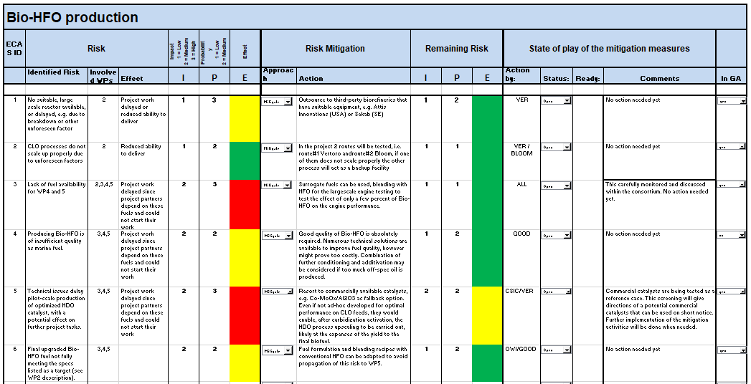

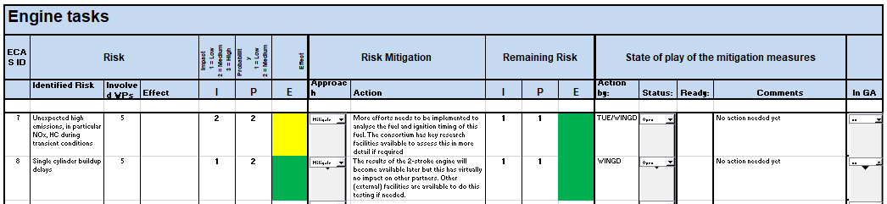

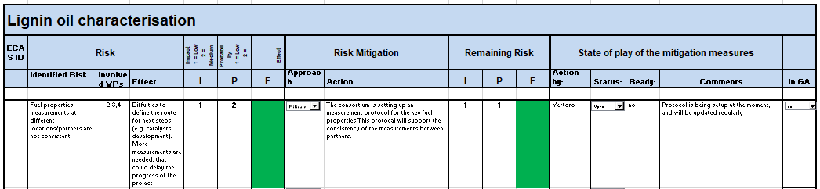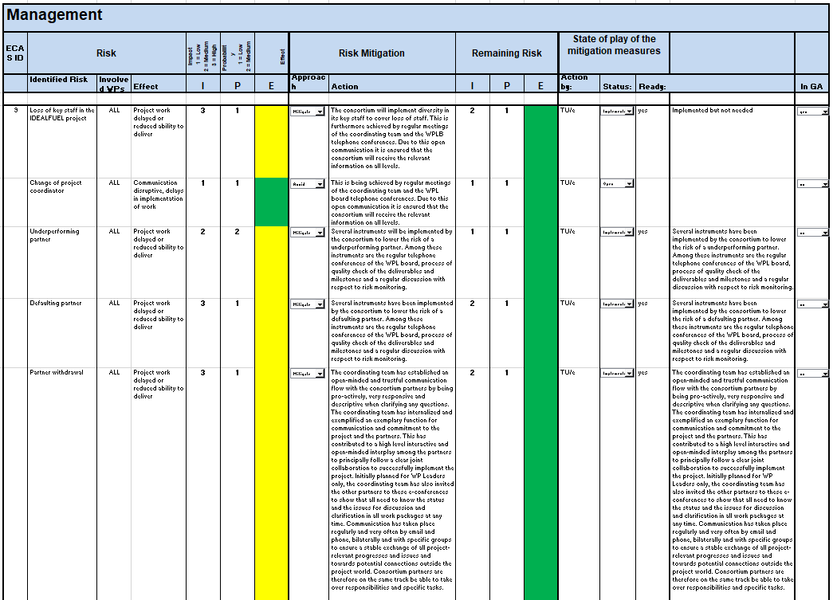

# Appendix B – External risks

# Appendix C – Quality Assurance Review Form

The following questions should be answered by all reviewers (WP Leader, reviewer, Project Coordinator) as part of the Quality Assurance procedure. Questions answered with NO should be motivated. The deliverable author will update the draft based on the comments. When all reviewers have answered all questions with YES, only then can the Deliverable be submitted to the EC.

NOTE: This Quality Assurance form will be removed from Deliverables with dissemination level “Public” before publication.

|  |  |  |  |
| --- | --- | --- | --- |
| Question | WP Leader | Reviewer | Project Coordinator |
|  | NAME (Organisation) | Eva Bogelund (UNR) | NAME (Organisation) |
| 1. Do you accept this Deliverable as it is? | Yes / No (elaborate) | Yes | Yes / No (elaborate) |
| 1. Is the Deliverable complete?  * All required chapters? * Use of relevant templates? | Yes / No (elaborate) | Yes | Yes / No (elaborate) |
| 1. Does the Deliverable correspond to the DoA?  * All relevant actions preformed and reported? | Yes / No (elaborate) | Yes | Yes / No (elaborate) |
| 1. Is the Deliverable in line with the IDEALFUEL objectives?  * WP objectives * Task Objectives | Yes / No (elaborate) | Yes | Yes / No (elaborate) |
| 1. Is the technical quality sufficient?  * Inputs and assumptions correct/clear? * Data, calculations, and motivations correct/clear? * Outputs and conclusions correct/clear? | Yes / No (elaborate) | Yes | Yes / No (elaborate) |
| 1. Is created and potential IP identified and are protection measures in place? | Yes / No (elaborate) | Yes | Yes / No (elaborate) |
| 1. Is the Risk Procedure followed and reported? | Yes / No (elaborate) | Yes | Yes / No (elaborate) |
| 1. Is the reporting quality sufficient?  * Clear language * Clear argumentation * Consistency * Structure | Yes / No (elaborate) | Yes | Yes / No (elaborate) |

1. The owner’s role in project Risk Management, National Academies Press, (2005). ISBN 0-309-54754-7