* IDEALFUEL -   
  Lignin as a feedstock for renewable marine fuels

GRANT AGREEMENT No. 883753

HORIZON 2020 PROGRAMME - TOPIC LC-SC3-RES-23-2019

“Development of next generation biofuel and alternative renewable fuel technologies for aviation and shipping”

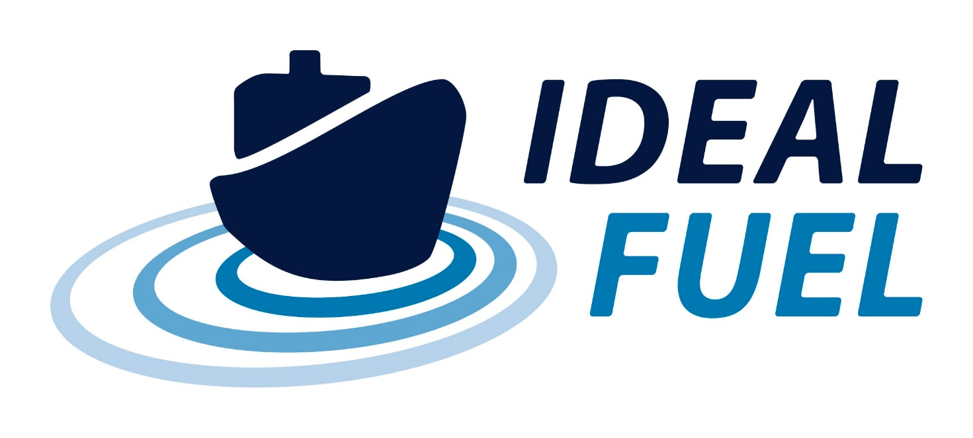

Deliverable Report

D7.3 – Dissemination Plan

|  |  |  |
| --- | --- | --- |
| Deliverable No. | IDEALFUEL D7.3 |  |
| Related WP | WP7 |  |
| Deliverable Title | Dissemination Plan |  |
| Deliverable Date | 30-04-2021 |  |
| Deliverable Type | REPORT |  |
| Dissemination level | Public (PU) |  |
| Written By | Eva Bøgelund (UNR) | 22-03-2021 |
| Checked by | All partners | dd-mm-yyyy |
| Reviewed by | All partners | dd-mm-yyyy |
| Approved by | Roy Hermanns (TUE) – Project Coordinator | dd-mm-yyyy |
| Status | Draft 1.0 | 22-03-2021 |

Disclaimer/ Acknowledgment

Copyright ©, all rights reserved. This document or any part thereof may not be made public or disclosed, copied or otherwise reproduced or used in any form or by any means, without prior permission in writing from the IDEALFUEL Consortium. Neither the IDEALFUEL Consortium nor any of its members, their officers, employees or agents shall be liable or responsible, in negligence or otherwise, for any loss, damage or expense whatever sustained by any person as a result of the use, in any manner or form, of any knowledge, information or data contained in this document, or due to any inaccuracy, omission or error therein contained.

All Intellectual Property Rights, know-how and information provided by and/or arising from this document, such as designs, documentation, as well as preparatory material in that regard, is and shall remain the exclusive property of the IDEALFUEL Consortium and any of its members or its licensors. Nothing contained in this document shall give, or shall be construed as giving, any right, title, ownership, interest, license or any other right in or to any IP, know-how and information.

This project has received funding from the European Union’s Horizon 2020 research and innovation programme under grant agreement No 883753. The information and views set out in this publication does not necessarily reflect the official opinion of the European Commission. Neither the European Union institutions and bodies nor any person acting on their behalf, may be held responsible for the use which may be made of the information contained therein.

**Publishable summary**

The EU H2020 project IDEALFUEL aims to develop an efficient and low-cost chemical pathway to convert lignocellulosic biomass into a Biogenic Heavy Fuel Oil (Bio-HFO) with ultra-low sulphur levels that can be used as drop-in fuel in the existing maritime fleet. This deliverable, D7.3, concerns the Dissemination Plan for the IDEALFUEL project. The Dissemination Plan describes the implementation strategy for the dissemination of the IDEALFUEL project and aims to maximise the impact of the project results. The Dissemination Plan also describes the target audiences and means to reach these audiences in the most efficient way.

Contents

1 Introduction 5

1.1 Dissemination versus Exploitation 5

2 Dissemination Strategy and Tools 6

2.1 Dissemination Approach and Strategy 6

2.2 IDEALFUEL Objectives 7

2.3 Tools for dissemination 7

2.4 Quantification and timing of Dissemination Activities 8

2.5 Dissemination Contact Database 10

2.6 Monitoring of Dissemination activities 10

3 Dissemination Goals, Target Audiences, and Communication Channels 11

3.1 Dissemination to Internal Stakeholders 11

3.2 Dissemination to the Scientific Community 11

3.3 Dissemination to External Stakeholders 12

3.4 Dissemination to the General Public 13

3.5 Dissemination to Stimulate Exploitation 13

3.6 Feedback to the European Commission 13

4 Dissemination Rules and Organisation 14

4.1 Role of the Dissemination WP Leader and Project Coordinator 14

4.2 Role of the Project Partners 14

4.3 Rules for Dissemination and Publication 14

4.4 Dissemination Acknowledgement and Disclaimer 14

5 Dissemination achievements 15

6 Conclusion 17

7 Risk Register 18

Acknowledgement 19

Appendix A – Quality Assurance Review Form 20

**Table of Figures**

Figure 2.1 IDEALFUEL dissemination strategy 6

Figure 2.2 IDEALFUEL logo 7

**Tables**

Table 2.1 Quantification of IDEALFUEL Dissemination Activities 8

Table 5.1 Overview of IDEALFUEL dissemination activities M1-M12 15

Table 5.2 First schedule of conferences and exhibitions where IDEALFUEL results can be presented. 16

Table 5.3 First list of journals for publication of IDEALFUEL results 16

# Introduction

Deliverable D7.3 – Dissemination Plan, concerns the Dissemination Plan for the IDEALFUEL project. The document is the third deliverable of Work Package 7 – Dissemination, communication, and preparative exploitation activities incl. market uptake. The main objectives of WP7 are to ensure that the IDEALFUEL project activities and results are promoted to relevant target groups (stakeholders, end-users, interest groups, policymakers, industries) and to raise awareness of ongoing research and developments in the field of maritime biofuel.

Specifically, D7.3 will identify target audiences, optimised communication channels to reach these, and outline the dissemination activities during the IDEALFUEL project lifetime. It will also identify initial success indicators and describe dissemination management and monitoring processes.

The first plans for dissemination of the IDEALFUEL project are outlined in the Description of Action (DoA, Annex 1 to the Grant Agreement). The Dissemination Plan will be updated continuously throughout the project lifetime and will be evaluated and discussed at General Assembly meetings (approximately every 6 months).

## Dissemination versus Exploitation

It is important to distinguish between dissemination activities and exploitation activities. In its brochure “Making the Most of Your H2020 Project”[1], the European IPR Helpdesk defines Dissemination as the public disclosure of the results of the project by any appropriate means and in any medium. The objective of dissemination is defined as the transfer of knowledge with the aim to enable others to use the results in their own work. On the other hand, Exploitation is defined as the utilisation of results in further research activities or developments other than those covered by the project. The objective of Exploitation is the effective use of project results for commercial purposes such as creating and marketing a product or process but also for improving policies for example via standardisation activities, and for tackling economic and societal problems.

The major difference between Dissemination and Exploitation is that dissemination activities are carried out during the project lifetime while exploitation activities mainly take place at the end and after the completion of the project once project results have been obtained. However, if potentially exploitable project results are obtained before the end of the project, activities to exploit these can begin earlier.

This document concerns the dissemination of the IDEALFUEL project. The exploitation of project results and the path to market will be described in D7.4 – Exploitation Plan (expected in M48).

# Dissemination Strategy and Tools

The IDEALFUEL project is funded by public EU money, and the results and outputs of the project should therefore benefit the EU as a whole, for example by paving the way to exploitation of the project results towards European leadership in renewable fuel technologies. This includes making the project results known to the widest possible group of potential users and generally maximising the impact of the work carried out in the project as much as possible. The following sections will outline the overall project objectives to be disseminated, the dissemination approach and strategy, and describe the tools that will be used for communication.

## Dissemination Approach and Strategy

The aim of the dissemination activities in the IDEALFUEL project is to ensure the highest visibility and awareness of the project activities and maximise the potential impact of the project results. These efforts will not just be focused on the 48-month project duration but will also be directed at building continuity of the IDEALFUEL collaboration extending the project lifetime. With this main goal, the Dissemination Plan establishes the rules and guidelines on how IDEALFUEL will share its outcomes with the target groups and stakeholders. These activities will pave the way to exploitation and future market uptake of the project results (documented in D7.4).

The Dissemination Plan will elaborate the communication strategy outlined in the DoA and describe in more detail the targeted audiences (scientific community and network, stakeholders, industry, end-users, public) and how these audiences will be reached. The Dissemination Plan places emphasis on the dissemination of tangible results and the importance of tailoring the communication of these to the various audience groups for maximal impact. The Dissemination Plan is set up following the Commission Guidelines for Communicating EU Research*[2]*. The IDEALFUEL dissemination strategy is presented in Figure 2.1.

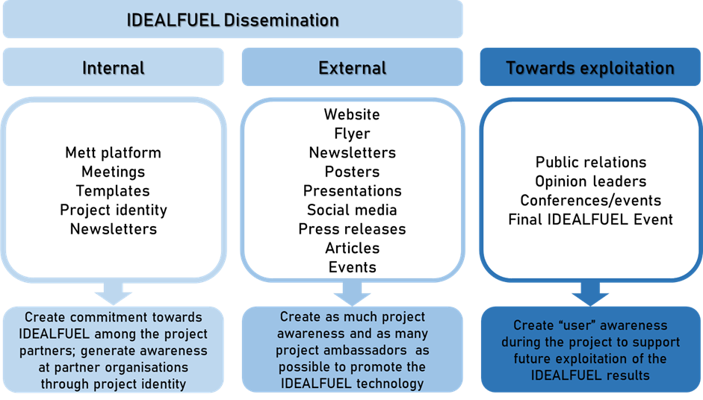

Figure 2.1 IDEALFUEL dissemination strategy

## IDEALFUEL Objectives

The overall goal of IDEALFUEL is to enable the utilisation of lignin from lignocellulosic biomass as maritime fuel in a sustainable manner. IDEALFUEL aims to develop an efficient and low-cost chemical pathway to convert lignocellulosic biomass into a Bio Heavy Fuel Oil (Bio-HFO) with ultra-low sulphur levels that can be used as drop-in fuel in the existing maritime fleet. IDEALFUEL will develop its technology and processes from the current lab-scale (TRL3) via bench-scale (TRL4) to pilot scale (TRL5) and will prove the performance and compatibility of the Bio-HFO over the whole blending range in maritime fuel systems and marine engines. IDEALFUEL will also carry out a Well to Propeller impact assessment and Life Cycle Analysis to check and proof the soundness of the environmental, society, and sustainability aspects of the developed technologies, processes, products, and logistics.

## Tools for dissemination

Several dissemination tools have been developed for the IDEALFUEL project. These include the project visual identity and project logo, the project public website, and several project templates (flyer, presentations, newsletters, deliverables, milestones). The work with these tools is documented in deliverables D7.2 – Corporate Identity. An overview of the tools is including in this document.

### Project Logo and Visual Identity

A graphical project identity has been designed for IDEALFUEL. The graphical identity includes the project logo, fonts, and colours. These elements will be incorporated in the design of all dissemination material related to the project. The purpose of the visual identity is to provide the project with consistent and easily recognisable dissemination material. The IDEALFUEL logo is presented in Figure 2.2.

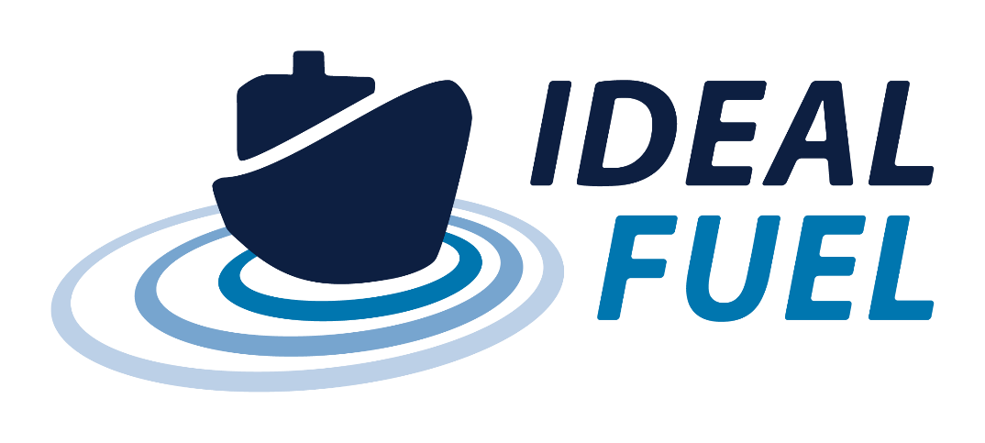

Figure 2.2 IDEALFUEL logo

### Templates

Standard templates for the dissemination of IDEALFUEL project results have been designed for presentations and posters (MS PowerPoint) and Deliverable and Milestone reports (MS Word). These templates include the project logo and project colour scheme. To ensure that IDEALFUEL project results are presented in a consistent way, project partners are encouraged to always use the project templates when disseminating project results both internally and externally. If needed, addition templates for specific dissemination activities will be developed as the project evolves.

### Website

The IDEALFUEL project website is the first point of contact for third parties interested in the project and its activities. The website was launched in September 2020 and is hosted at [www.IDEALFUEL.eu](http://www.IDEALFUEL.eu). The website is designed to provide an easily accessible overview of the project objectives, concepts, results, and consortium partners. The texts on the project website are updated regularly, with an expected average of at least 8 updates per year.

### Newsletter

Newsletters reporting on ongoing and archived project results and activities will be published roughly every half year throughout the project lifetime. The newsletters will be distributed to the contacts registered in the Dissemination Database (see section 2.5). Newsletters aim to communicate about the project to a wide audience and will therefore be written in general, non-scientific terms. For experts, the newsletters will provide links to the project technical reports where possible (i.e., if not containing confidential or otherwise protected information).

### Social media

The IDEALFUEL project results will be promoted on LinkedIn. The project page was launched in September 2020 and is hosted at [www.linkedin.com/company/idealfuel](https://www.linkedin.com/company/idealfuel). Posts on project results and achievements will be linked to the IDEALFUEL project partners’ social media pages. In this way, the existing communication structure of the project partners will be engaged. The posts will be designed to draw attention to the project activities via short texts and attractive visuals and will provide links for further reading were possible (e.g., news items on the project website or project reports). Texts will be posted on social media regularly, with an expected average of at least 1 post per month. Several tags will be used when texts are posted on social media including: #idealfuel, #biofuel, #lignin, #ships, #H2020, #INEA, #EUfunding, #research, #innovations.

### Sounding Board workshops

The Sounding Board of IDEALFUEL is comprised of key representatives from authorities, policymakers, shipping companies, fuels industry, and standardisation bodies. These experts will help guide the process of defining the recommendations for implementation of the Bio-HFO developed within IDEALFUEL. The Sounding Board will be invited to 2-4 specific workshops during the project lifetime and will provide feedback on intermediate results, milestones, critical risks, and input from an end user/stakeholder perspective. Via their networks, the Sounding Board members will act as information multipliers and help spread the project results in their respective areas of expertise. The Sounding Board members will also be engaged when drafting the exploitation plan for the project results (D7.4).

## Quantification and timing of Dissemination Activities

Table 2.1 presents an overview of IDEALFUEL dissemination activities and sets a basis for verifying whether the project dissemination objectives have been met. Monitoring will be done throughout the project and included in the official reporting at M18, M36 and M48.

Table 2.1 Quantification of IDEALFUEL Dissemination Activities

| **Targeted Audience** | **Objective** | **KPI** | **Comment** |
| --- | --- | --- | --- |
| **IDEALFUEL website** | | | |
| Policy makers, biofuel/maritime professionals, research community, industry, general public | Make target groups aware of the progress of IDEALFUEL, results and their availability. |  8 updates/year   1000 views/year | The IDEALFUEL website will strongly promote project developments providing downloadable explanatory information, press releases, videos, photographs, project flyer(s), etc. |
| **Meetings, workshops, conferences, exhibitions/trade fairs** | | | |
| Consortium members | Knowledge exchange |  2meetings/year  1 month | GA and WPLB meetings with IDEALFUEL Consortium |
| Sounding Board Members | Knowledge exchange |  1 workshops/year | Feedback on project development/results from external stakeholders |
| Maritime sector, biofuel community, research community, Standardisation Committee | Show results, receive feedback |  20 conferences/exhibitions | Key conferences: EUBCE – European Biomass Conference and Exhibition; RRB - International Conference on Renewable Resources & Biorefinery; GREENPORT |
| **Scientific publications** | | | |
| Researchers in biofuel technology and ship engine disciplines | Knowledge dissemination | > 5-10 peer reviewed publications (Open Access) | Key journals: Journal of the American Chemical Society; Nature Chemistry; Angewandte Chemie; Combustion and Flame; Energy and Fuels; ACS Catalysis. |
| **Electronic newsletter** | | | |
| General public, biofuel/maritime professional and stakeholders, industry | Keep interested parties informed of the project progress and results. |  7 newsletters (half-yearly) | The newsletter will also allow further extending the project’s dissemination contact database. |
| **Final Event** | | | |
| Consortium members, Sounding Board members, biofuel/maritime professionals and stakeholders, research community, industry, policy makers | Expand the results beyond the consortium; leverage the project results within the industry. |  50 attendees | A Final Event will demonstrate the project deliverables with the aim to gain industry recognition. |
| **Social Media (LinkedIn)** | | | |
| General public, biofuel/maritime professionals and stakeholders, industry, policy makers | Expand news of project development/results beyond the consortium |  1 update/month | Social media will strongly promote project developments amongst the industry stakeholders. |

The timing of the dissemination activities is crucial for an effective communication of the project results. In the first months of the project all the tools needed to perform optimal dissemination actions have been developed (including logo, website, templates). In the remainder of the project, the planned activities will be executed and monitored. The Work Package Leaders and the Project Coordinator will monitor the timeline of the planned project tasks and activities in order to optimise the timing of dissemination activities.

Future dissemination activities

* 2020 – 2024: Present results of research activities at (international) meetings, workshops, conferences, exhibitions/trade fairs, by newsletters and through the project’s website.
* 2020 – 2024: Availability of the project website, to keep results and findings directly accessible to the public. After 2024 the website will not be updated but kept alive for 5 years.
* 2024: Final Event

## Dissemination Contact Database

Project partner UNR will collect contact details of stakeholders and other interested parties in a “Dissemination Database”. Contacts and information will be added to the dissemination database throughout the project lifetime. The source of the contacts for dissemination purposes are the partners (e.g., their clients and collaborators), registrations on the IDEALFUEL website (via the [‘keep updated’ button](https://idealfuel.eu/subscribe-2/)), possible linked projects, and the Sounding Board. In the database, the following information will be collected (whenever possible) for each contact:

* Name
* Email address
* Organisation
* Marketing department
* Type of organisation (research institute, university, NGO, public entity/local authority, legislation/standardisation committee, EU Commission/project/country, shipping industry, fuel supplier, manufacture, other)
* Connection to IDEALFUEL (participant, stakeholder, EC, affiliated entity, client)

The dissemination database will be managed in compliance with the General Data Protection Regulation (GDPR). Project partners providing contact information for the Dissemination Database are responsible for ensuring that these contacts are correct and that contacts have agreed to receive information about the IDEALFUEL project.

## Monitoring of Dissemination activities

A complete overview of dissemination activities relating to the IDEALFUEL project will be kept by project partner UNR. This document will be updated throughout the project lifetime and will be used as the basis for reporting in the EC system (at M18, M30, and M48). Partners will be invited to report on planned and achieved dissemination activities to the WP7 Leader (UNR) and Project Coordinator on a regular basis. In addition, partners will be requested to report on planned and achieved dissemination activities every six months as part of the internal project progress monitoring. In addition to tracking dissemination activities, the number of visitors to the project website will also be monitored as part of the internal project progress reporting.

# Dissemination Goals, Target Audiences, and Communication Channels

The following paragraphs describe the internal and external dissemination target audiences, together with the channels that will be used to reach them. If more target audiences are identified during the project, they will be included in the communication strategy and future updates to this document.

## Dissemination to Internal Stakeholders

The internal stakeholders are the project Consortium partners. Project information is shared and exchanged between the project partners via monthly WP Leader Board meetings and half-yearly General Assembly (GA) meetings. The **goal** of the communication is to ensure that the project is progressing smoothly, meets its targets in terms of timelines and achievements, and that all project activities are documented properly. The main **channel** for communication to the internal stakeholders is email and the Mett platform where partners can access and share information.

In general, GA meetings will be conducted face-to-face (as soon as allowed by the Covid-19 pandemic situation) while WPLB meetings will be conducted via teleconference. After each WPLB and GA meeting, the meeting agenda, meeting minutes, and meeting list of participants will be distributed to the Consortium and uploaded to Mett.

## Dissemination to the Scientific Community

IDEALFUEL will disseminate its results and findings to the scientific community and other experts in the field of biofuels through presentations at workshops and conferences and through scientific journal publications. Dissemination of results to the scientific (research and academic) community will primarily be carried out by the project research partners (TUE, OWI, CSIC). The work carried out in IDEALFUEL will allow for significant progress in the field of sustainable biofuel technology for the maritime sector. Through the IDEALFUEL project, the Consortium research partners can showcase their recent technology development and share their scientific studies with the broader international maritime transport, fuel, and engine community. Visibility of the research partners in the IDEALFUEL project may also encourage new master and PhD students to join the field of biofuel technology.

### Goals

The main goal for dissemination of project results to the scientific community is to inform on the advances made in the framework of the IDEALFUEL project in the field of biofuel technology. In addition, this communication is intended to attract the interest of research teams and industries in the field to explore the potential for future collaborations. Also, collaboration and networking with other projects, networks, and initiatives will be investigated for mutually added value. These activities will allow the IDEALFUEL partners to learn from stakeholders and colleagues outside of the Consortium and discuss common issues and get feedback on the IDEALFUEL results.

### Channels

The channels for dissemination of IDEALFUEL project results aimed at the scientific community include, but are not limited to, the following:

* Publications on advances and results in (inter)nationally renowned peer-reviewed scientific and technical journals via (Open Access) scientific articles.
* Presentations of project results at (inter)national conferences.
* Networking at conferences, workshops, and other technology event to advertise the project’s results and identify related initiatives and projects to open new collaboration paths.
* Announcements of developments on the project website.
* Announcements of developments on the websites of the Consortium partners.
* Organisation of a Final Event at the end of the project to demonstrate the developed technology.

Based on the professional contacts of each of the IDEALFUEL research partners, and their association to relevant scientific networks, the impact of the disseminated IDEALFUEL results to the scientific community will be maximised.

## Dissemination to External Stakeholders

External stakeholders are the broadest target audience for dissemination of IDEALFUEL results. This group includes biofuel technology stakeholders (biomass producers, biofuel producers/refineries, chemical industries), legislative and regulatory authorities, standardisation committees (e.g., IMO), policy makers (national and EU), initiatives and networks (e.g., SUNERGY), and potential end users (e.g., maritime transport industry, shipyard owners, fuel suppliers, ship engine producers).

A selection of these external stakeholder will form the **Sounding Board.** The Sounding board members will be persons interested in the IDEALFUEL technology both in terms of technology development and deployment. The Sounding Board will be invited to specific workshops organised within the project to provide feedback on project results and input about relevant international technical as well as political and strategic developments in the field.

A list of stakeholders that can be informed about project developments will be shared with all project partners in the internal project workspace (Mett).

### Goal

The goal for dissemination to external stakeholders is to engage these in the project achievements and hereby increase the probability for widescale market acceptance of the developed technology, processes, and products. Informing external stakeholders, and sharing tangible knowledge with them, also provides the project partners with concrete opportunities for promoting IDEALFUEL results, receiving feedback, and engaging in dialogue with potential end users and future manufactures/suppliers. As such, the dissemination of IDUELAFUEL results to external stakeholders is a unique opportunity for the project industrial partners (VERT, T4F, BLOOM, WinGD, GOOD, TKMS, VARO) to showcase their state-of-the-art technology and products and boost their reputation and visibility at the frontier of the (inter)national market for biofuel technology and sustainable usage. This is in line with the ambition of the EU to stimulate industry and science in Europe by funding research and innovation actions such as IDEALFUEL. To ensure that the project results and developments can make a smooth transition to market, it is important that the external stakeholders understand the project ambition and the products and knowledge that the partners will deliver in the project. Visibility of the partners and activities in IDEALFUEL may also encourages new talent to join the companies and create more jobs.

### Channels

The channels for dissemination of IDEALFUEL project results aimed at external stakeholders include, but are not limited to, the following:

* Posts on the project website.
* Flyers and newsletters containing links to the project website.
* Posts on social media.
* Participation in professional exhibitions and trade fairs with project related stands to disseminate the project results directly to industry/end users and ensure a mass deployment of the developed product at the end of the project.
* Organisation of workshops with the Sounding Board to address and promote international cooperation.
* Organisation of a Final Event at the end of the project to demonstrate the developed technology and pave the way for future exploitation activities.

## Dissemination to the General Public

It is the ambition of the IDEALFUEL project to disseminate its results to non-specialist members of the public, e.g., consumers interested in the “green transition” or users of popular science media. The **goal** of this dissemination is to promote public interest, understanding, and engagement in new research and technology developments in the EU. The stimulation of research activities through EU funding schemes is critical for the competitiveness of European industries and research institutes. To maintain and extend public support of these developments, dedicated dissemination activities towards the public is curial. In this respect, the IDEALFUEL project results provide an opportunity to showcase the benefits of innovations in biofuel to the public. In time, this development will result in sustainable and cheap biofuel products that will benefit the EU and its citizens with a greener maritime transport sector. Promoting and showcasing exciting aspects of new technology can also inspire students at all levels of the educational systems throughout the EU to pursue an education in the field of research and technology development. The **channel** for dissemination of results to the general public is the project website and social media profile.

## Dissemination to Stimulate Exploitation

The dissemination activities described in this document prepare for the project exploitation phase (mainly at the end and after the completion of the project) that will bring the developed biofuel product to market. The details of the exploitation efforts will be described in a dedicated deliverable, D7.4 (expected in M48). Deliverable D7.4 shall be considered complementary to this deliverable.

## Feedback to the European Commission

Throughout the project lifetime, activities and progress in IDEALFUEL will be reported to the European Commission (EC) and the appointed Project Officer. Publications will be made available via CORDIS[3]. The Project Officer will be invited to attend all IDEALFUEL General Assembly meetings, workshops, and events.

# Dissemination Rules and Organisation

## Role of the Dissemination WP Leader and Project Coordinator

The dissemination WP Leader (UNR) is responsible for coordinating the overall communication and dissemination activities of the IDEALFUEL project. The identification of results suitable for dissemination is the shared responsibility of the WP7 Leader, the Project Coordinator, and the project partner who carries out the activities leading to these results. The information sources for dissemination activities in WP7 are the other WPs in the project. The dissemination activities will be monitored by UNR together with the Project Coordinator.

## Role of the Project Partners

All project partners are expected to participate actively in the dissemination of the IDEALFUEL project and its developments through their own actions. Partners will be asked to provide regular updates on planned and achieved dissemination activities and should always inform the WP7 Leader, Project Coordinator, and other Consortium partners of any dissemination activities they are planning. Project research organisations are expected to ensure that technical advances are shared (as far as possible) with other leading researchers in the sector. Project industrial organisations are expected to target potential end users to prepare them for deployment of the biofuel technologies developed in the project and keep stakeholders up to date on potential costs and use of the developed products. Specific communication and dissemination activities of the IDEALFUEL-partners include, but are not limited to:

* Publications in scientific and peer-reviewed journals.
* Announcements of IDEALFUEL developments on their organisations’ website.
* Presenting the IDEALFUEL project at international conferences, exhibitions, and trade fairs.
* Keeping the Project Coordinator updated about developments, changes, and notable findings of IDEALFUEL in a timely manner.
* Informing stakeholders of the progress in IDEALFUEL when met at any technical workshop or event.
* Contributing (also through their organisations’ press offices) in gathering scientific, industry, policy, and media contacts and in regularly updating the dissemination activity list by sending information to the WP7 Leader.
* Supporting in customising the prepared communication material (if needed in the national language and for a local audience).

## Rules for Dissemination and Publication

The rules for dissemination and publication are described in the Consortium Agreement and the Grant Agreement. The Project Management Plan (D8.1) describes the review protocol to be followed when disseminating IDEALFUEL results.

## Dissemination Acknowledgement and Disclaimer

Any dissemination activities and publications in the IDEALFUEL project, including the project website will:

* Display the European emblem. When displayed in association with a logo, the European emblem will be given appropriate prominence.
* Include the following statement (from the Grant Agreement, Art. 29.4): "This project has received funding from the European Union’s Horizon 2020 research and innovation programme under grant agreement No 883753".
* Contain a statement that it reflects only the author's view and that the Agency is not responsible for any use that may be made of the information it contains (Art 29.5 of the Grant Agreement).

# Dissemination achievements

Table 5.1 presents an overview of dissemination activities in the first 12 months of the IDEALFUEL project. Table 5.2 and Table 5.3 provide the first list of possible conferences and journals where IDEALFUEL partners will present project results. All lists will be updated and further extended throughout the project timeframe as described in section 2.6.

Table 5.1 Overview of IDEALFUEL dissemination activities M1-M12

| **Date** | **Type of activity** | **Target Audience** | **Countries addressed** | **Est. of audience size** | **Lead Partner** | **Description** |
| --- | --- | --- | --- | --- | --- | --- |
| May 2020 | Logo and templates | All | Worldwide | >1,000 | UNR | Project logo is created and the colour scheme and visual identity of IDEALFUEL is formalised |
| 11 May 2020 | Press release | All | Worldwide | 100-500 | TUE | Press release on partner website |
| 24 June 2020 | Press release | All | Worldwide | 100-500 | OWI | Press release on partner website |
| 25 June 2020 | Press release | All | Worldwide | 100-500 | T4F | Press release on partner website |
| Sep 2020 | Website | All | Worldwide | >1,000 | UNR | The IDEALFUEL website is launched |
| Sep 2020 | Intro Newsletter | Public | Worldwide | 20 - 100 | UNR | Newsletter to announce website |
| Sep 2020 | Social Media | Public | Worldwide | 100 - 500 | TUE/UNR | The IDEALFUEL LinkedIn page is launched |
| 15 Dec 2020 | Website | Public | Worldwide | 100 - 500 | CSIC | IDEALFUEL featured on partner website |
| 15 Dec 2020 | Participation in event | Others | European | 20 - 100 | CSIC | IDEALFUEL presented at SC Meeting of the EERA Bioenergy Joint Programme |
| 18-19 Jan 2021 | Participation in conference | Scientific community | European | 100 - 500 | OWI | Project presentation. News item on project website |
| Feb 2021 | Flyer | Public | Worldwide | 100 - 500 | UNR | Flyer publication with general project information for public dissemination. The flyer is also published on the project website |
| Feb 2021 | Newsletter 1 | Public | Worldwide | 20 - 100 | UNR | Newsletter on the first results / achievements and goals of the project to raise awareness |

Table 5.2 First schedule of conferences and exhibitions where IDEALFUEL results can be presented.

| **Conferences and Exhibitions** | **Year/Date** | **Partner responsible/**  **involved** | **Comment** |
| --- | --- | --- | --- |
| Kraftstoffe der Zukunft (Fuels of the future) | 18-19 Jan 2021 | OWI | Oral presentation (in German) about the IDEALFUEL project and its research/goals. |
| 29th European Biomass Conference & Exhibition (EUBCE) | 26-29 April 2021 | TUE |  |
|  |  |  |  |

Table 5.3 First list of journals for publication of IDEALFUEL results

| **Scientific Journals** | **Year/Date** | **Partner responsible/**  **involved** | **Comment** |
| --- | --- | --- | --- |
| Journal of the American Chemical Society |  |  |  |
| Nature Chemistry |  |  |  |
| Angewandte Chemie |  |  |  |
| Combustion and Flame |  |  |  |
| Energy and Fuels |  |  |  |
| ACS Catalysis |  |  |  |
|  |  |  |  |

# Conclusion

This document will be submitted to the EC through the EC Deliverable submission system, however throughout the project timeframe the document will be “living” and updated on a regular basis. The document and its corresponding dissemination activity tables (incl. conferences and journals) will be updated on a regular basis and discussed in the Work Package Leader Board and the General Assembly meetings. Next to this UNR and the Project Coordinator will track the dissemination activities closely.

# Risk Register

One new risk related to D7.3 has been identified.

|  |  |  |  |  |
| --- | --- | --- | --- | --- |
| Risk No. | What is the risk | Probability of risk occurrence1 | Effect of risk1 | Solutions to overcome the risk |
| WP7 | Delays on project activities (and consequently dissemination activities) due to limited office/laboratory access to prevent the spread of Covid-19. | 2 | 3 | Frequent evaluation of Covid-19 status at all consortium partners. |

1) Probability risk will occur: 1 = high, 2 = medium, 3 = Low

# Acknowledgement

The author(s) would like to thank the partners in the project for their valuable comments on previous drafts and for performing the review.

|  |  |  |
| --- | --- | --- |
| # | Partner short name | Partner Full Name |
| 1 | TUE | Technische Universiteit Eindhoven |
| 2 | VERT | Vertoro BV |
| 3 | T4F | Tec4Fuels |
| 4 | BLOOM | Bloom Biorenewables Ltd |
| 5 | UNR | Uniresearch B.V. |
| 6 | WinGD | Winterthur Gas & Diesel AG |
| 7 |  | (Formerly SeaNRG, is now GOODFUELS #12) |
| 8 | TKMS | Thyssenkrupp Marine Systems GMBH |
| 9 | OWI | OWI – Science for Fuels gGmbH |
| 10 | CSIC | Agencia Estatal Consejo Superior De Investigaciones Cientificas |
| 11 | VARO | Varo Energy Netherlands BV |
| 12 | GOOD | GoodFuels B.V. |

|  |  |
| --- | --- |
| http://elastic.studioh2o.nl/image.php/userdata/image/ec_1.gif?width=150&height=150&image=/userdata/image/ec_1.gif | *This project has received funding from the European Union’s Horizon 2020 research and innovation programme under grant agreement No 883753* |

# Appendix A – Quality Assurance Review Form

The following questions should be answered by all reviewers (WP Leader, reviewer, Project Coordinator) as part of the Quality Assurance procedure. Questions answered with NO should be motivated. The deliverable author will update the draft based on the comments. When all reviewers have answered all questions with YES, only then can the Deliverable be submitted to the EC.

NOTE: This Quality Assurance form will be removed before publication.

|  |  |  |  |
| --- | --- | --- | --- |
| Question | WP Leader | Reviewer | Project Coordinator |
|  | NAME (Organisation) | NAME (Organisation) | NAME (Organisation) |
| 1. Do you accept this Deliverable as it is? | Yes / No (elaborate) | Yes / No (elaborate) | Yes / No (elaborate) |
| 1. Is the Deliverable complete?  * All required chapters? * Use of relevant templates? | Yes / No (elaborate) | Yes / No (elaborate) | Yes / No (elaborate) |
| 1. Does the Deliverable correspond to the DoA?  * All relevant actions preformed and reported? | Yes / No (elaborate) | Yes / No (elaborate) | Yes / No (elaborate) |
| 1. Is the Deliverable in line with the IDEALFUEL objectives?  * WP objectives * Task Objectives | Yes / No (elaborate) | Yes / No (elaborate) | Yes / No (elaborate) |
| 1. Is the technical quality sufficient?  * Inputs and assumptions correct/clear? * Data, calculations, and motivations correct/clear? * Outputs and conclusions correct/clear? | Yes / No (elaborate) | Yes / No (elaborate) | Yes / No (elaborate) |
| 1. Is created and potential IP identified and are protection measures in place? | Yes / No (elaborate) | Yes / No (elaborate) | Yes / No (elaborate) |
| 1. Is the Risk Procedure followed and reported? | Yes / No (elaborate) | Yes / No (elaborate) | Yes / No (elaborate) |
| 1. Is the reporting quality sufficient?  * Clear language * Clear argumentation * Consistency * Structure | Yes / No (elaborate) | Yes / No (elaborate) | Yes / No (elaborate) |

1. <https://www.iprhelpdesk.eu/sites/default/files/EU-IPR-Brochure-Boosting-Impact-C-D-E.pdf>
2. <https://ec.europa.eu/research/participants/data/ref/h2020/other/gm/h2020-guide-comm_en.pdf>
3. https://cordis.europa.eu/