* IDEALFUEL -   
  Lignin as a feedstock for renewable marine fuels

GRANT AGREEMENT No. 883753

HORIZON 2020 PROGRAMME - TOPIC LC-SC3-RES-23-2019

“Development of next generation biofuel and alternative renewable fuel technologies for aviation and shipping”

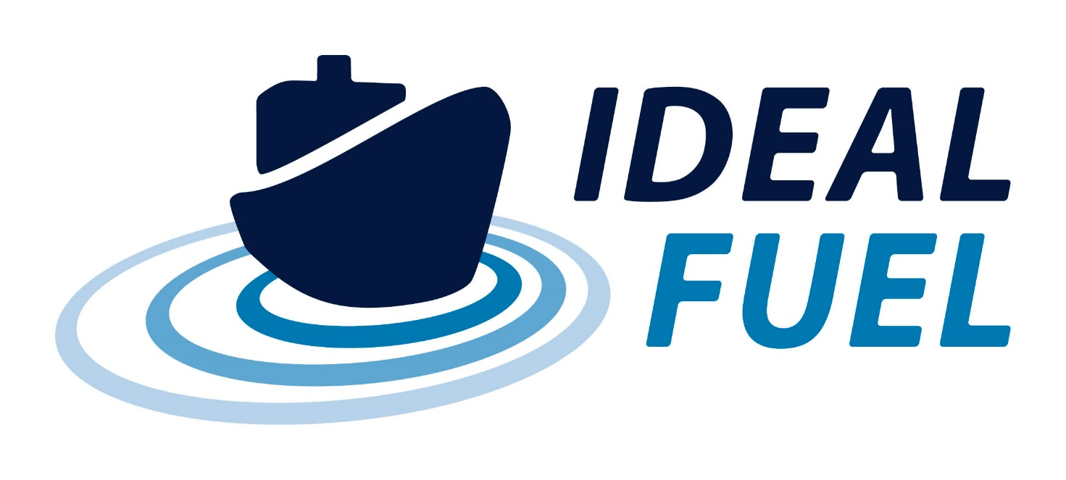

Deliverable Report

D1.2 – NEC – Requirement No.2

|  |  |  |
| --- | --- | --- |
| Deliverable No. | IDEALFUEL D1.2 |  |
| Related WP | WP1 |  |
| Deliverable Title | NEC – Requirement No.2 |  |
| Deliverable Date | 30-10-2020 |  |
| Deliverable Type | REPORT |  |
| Dissemination level | Confidential – consortium members only (CO) |  |
| Written By | Roy Hermanns (TU/e) | 14-10-2020 |
| Checked by | ALL | dd-mm-yyyy |
| Reviewed by | ALL | dd-mm-yyyy |
| Approved by | Project Coordinator | dd-mm-yyyy |
| Status | Draft 1.0 | 14-10-2020 |

Disclaimer/ Acknowledgment

Copyright ©, all rights reserved. This document or any part thereof may not be made public or disclosed, copied or otherwise reproduced or used in any form or by any means, without prior permission in writing from the IDEALFUEL Consortium. Neither the IDEALFUEL Consortium nor any of its members, their officers, employees or agents shall be liable or responsible, in negligence or otherwise, for any loss, damage or expense whatever sustained by any person as a result of the use, in any manner or form, of any knowledge, information or data contained in this document, or due to any inaccuracy, omission or error therein contained.

All Intellectual Property Rights, know-how and information provided by and/or arising from this document, such as designs, documentation, as well as preparatory material in that regard, is and shall remain the exclusive property of the IDEALFUEL Consortium and any of its members or its licensors. Nothing contained in this document shall give, or shall be construed as giving, any right, title, ownership, interest, license or any other right in or to any IP, know-how and information.

This project has received funding from the European Union’s Horizon 2020 research and innovation programme under grant agreement No 883753. The information and views set out in this publication does not necessarily reflect the official opinion of the European Commission. Neither the European Union institutions and bodies nor any person acting on their behalf, may be held responsible for the use which may be made of the information contained therein.

**Publishable summary**

The EU H2020 project IDEALFUEL aims to develop an efficient and low-cost chemical pathway to convert lignocellulosic biomass into a Biogenic Heavy Fuel Oil (Bio-HFO) with ultra-low sulphur levels that can be used as drop-in fuel in the existing maritime fleet. Within this project fuels or fuel-related components will be shipped between the partners. Since two partners (WinGD and BLOOM) are located in non-EU countries, Switzerland, several aspects need to be covered. This is documented within this deliverable, D1.2 concerning the NEC – Requirement No.2 covering the type of materials that IDEALFUEL will transport between the partners within the IDEALFUEL project and its partner deliverable D1.1 showing that the partners obtain and keep copies on file of import/export authorizations as required by national and EU legislation. There are no deviations from the description of this deliverable as given in Annex 1 of the Grant Agreement.

Contents

1 Introduction 5

2 Approach 6

2.1 Documentation of the material exchange 6

2.2 Procedure to exchange project-related material 6

3 Discussion and Conclusions 7

Risk Register 8

Acknowledgement 9

Appendix A – Quality Assurance Review Form 10

**Table of Figures**

No table of figures entries found.

**Tables**

Table 2.1: Material exchange log. 6

**Abbreviations**

|  |  |
| --- | --- |
| Symbol / short name |  |
| Bio-HFO | Biogenic Heavy Fuel Oil |
|  |  |
|  |  |
|  |  |
|  |  |
|  |  |
|  |  |
|  |  |

# Introduction

The EU H2020 IDEALFUEL consortium is spread all over Europe and during the runtime of the IDEALFUEL project, project related items will be transported between the partners. Since two project partners, namely WINGD and BLOOM are located in Switzerland these items / products – mainly fuels – will be shipped between the EU and a non-EU country and some aspects need to be covered according to the ethics self-assessment checklist[1]. This mainly affects the technical partners :

* the Netherlands: TU/e, VERT, GOODFUELS and VARO;
* Germany: OWI and T4F;
* Spain: CSIC;
* Switzerland: WinGD and BLOOM.

These aspects are covered in two deliverables. This deliverable, D1.2, describes the kind of details that will be documented for the - project related - materials that will be transported/shipped between the partners. The second, deliverable D1.1, shows that the partners have confirmed to the coordinator that they will obtain and keep copies on file of import/export authorizations as required by national and EU legislation.

# Approach

## Documentation of the material exchange

The IDEALFUEL research involves partners from non-EU countries. Specifically, exchange of material between project partners BLOOM and WinGD (both located in Switzerland) and the other project partners require the import and export regulation to non-EU countries to be considered (see also deliverable D1.1). An important aspect that needs to be documented is the type of material that is being exchanged. Within the IDEALFUEL project a spreadsheet will be used to document and log this. Table 2.1 gives an overview of what is being documented in this spreadsheet.

Table 2.1: Material exchange log.

|  |  |  |
| --- | --- | --- |
|  | Name | Description |
| 1 | Requesting party | Short name of requesting party |
| 2 | Providing party | Short name of providing party |
| 3 | WP | Related work package number and if possible related task |
| 4a | Material | Type/name of material. |
| 4b | Batch number | If available list the batch number of the material |
| 4c | Manuals / datasheets stored on METT? | All relevant safety manuals and/or datasheets have been stored on the IDEALFUEL internal exchange platform METT. List the related documents here. |
| 4d | Quantity | Indicate the quantity of material (e.g. volume, mass, number of items). |
| 5 | Date of request | Date of request by requesting organisation |
| 6 | Date of supply sent | Date of supply sent by providing organisation |
| 7 | Receiving date | Date that the requesting party receives the material |

The project management tool METT will be used as platform for the consortium partners to exchange and archive these material exchange documents.

## Procedure to exchange project-related material

The following procedure for exchange of material used for the IDEALFUEL project will be followed:

**Procedure concerning the exchange of project-related material between the IDEALFUEL partners:**

1. All partners will specify exactly what material they will be exchanging during the IDEALFUEL project and inform the management team (using the log spreadsheet).
2. Partners wishing to exchange material with WinGD or BLOOM must contact their own legal and security officers, with the aim to get information on national legislation concerning export to non-EU countries.
3. All necessary documents (security certificates, transportation certificates, safety data sheets, etc.) will be acquired by the partners wishing to exchange material.
4. All these documents will be sent to the management team and stored on METT. The management team will provide them upon request to INEA.

# Discussion and Conclusions

This deliverable shows what will be documented by IDEALFUEL related to the exchange of materials. On the project internal exchange platform (METT) the information is stored in excel file. Additional project relevant information, like datasheets and safety reports, of materials that will be transported is also stored on this platform. It is important to mention that the partner deliverable D1.1 shows the confirmation of the partners that they will keep copies on file of import/export authorizations as required by national and EU legislation. There are no deviations from the description of this deliverable as given in Annex 1 of the Grant Agreement.

# Risk Register

No risks foreseen related to this deliverable.



# Acknowledgement

The author(s) would like to thank the partners in the project for their valuable comments on previous drafts and for performing the review.

**Project partners:**

|  |  |  |
| --- | --- | --- |
| # | Partner short name | Partner Full Name |
| 1 | TUE | Technische Universiteit Eindhoven |
| 2 | VERT | Vertoro BV |
| 3 | T4F | Tec4Fuels |
| 4 | BLOOM | Bloom Biorenewables Ltd |
| 5 | UNR | Uniresearch B.V. |
| 6 | WinGD | Winterthur Gas & Diesel AG |
| 7 |  | (Formerly SeaNRG is now GOODFUELS #12) |
| 8 | TKMS | Thyssenkrupp Marine Systems GMBH |
| 9 | OWI | OWI – Science for Fuels gGmbH |
| 10 | CSIC | Agencia Estatal Consejo Superior De Investigaciones Cientificas |
| 11 | VARO | Varo Energy Netherlands BV |
| 12 | GOOD | GoodFuels B.V. |

|  |  |
| --- | --- |
| http://elastic.studioh2o.nl/image.php/userdata/image/ec_1.gif?width=150&height=150&image=/userdata/image/ec_1.gif | *This project has received funding from the European Union’s Horizon 2020 research and innovation programme under grant agreement No 883753* |

# Appendix A – Quality Assurance Review Form

The following questions should be answered by all reviewers (WP Leader, reviewer, Project Coordinator) as part of the Quality Assurance procedure. Questions answered with NO should be motivated. The deliverable author will update the draft based on the comments. When all reviewers have answered all questions with YES, only then can the Deliverable be submitted to the EC.

NOTE: This Quality Assurance form will be removed from Deliverables with dissemination level “Public” before publication.

|  |  |  |  |
| --- | --- | --- | --- |
| Question | WP Leader | Reviewer | Project Coordinator |
|  | NAME (Organisation) | NAME (Organisation) | NAME (Organisation) |
| 1. Do you accept this Deliverable as it is? | Yes / No (elaborate) | Yes / No (elaborate) | Yes / No (elaborate) |
| 1. Is the Deliverable complete?  * All required chapters? * Use of relevant templates? | Yes / No (elaborate) | Yes / No (elaborate) | Yes / No (elaborate) |
| 1. Does the Deliverable correspond to the DoA?  * All relevant actions preformed and reported? | Yes / No (elaborate) | Yes / No (elaborate) | Yes / No (elaborate) |
| 1. Is the Deliverable in line with the IDEALFUEL objectives?  * WP objectives * Task Objectives | Yes / No (elaborate) | Yes / No (elaborate) | Yes / No (elaborate) |
| 1. Is the technical quality sufficient?  * Inputs and assumptions correct/clear? * Data, calculations, and motivations correct/clear? * Outputs and conclusions correct/clear? | Yes / No (elaborate) | Yes / No (elaborate) | Yes / No (elaborate) |
| 1. Is created and potential IP identified and are protection measures in place? | Yes / No (elaborate) | Yes / No (elaborate) | Yes / No (elaborate) |
| 1. Is the Risk Procedure followed and reported? | Yes / No (elaborate) | Yes / No (elaborate) | Yes / No (elaborate) |
| 1. Is the reporting quality sufficient?  * Clear language * Clear argumentation * Consistency * Structure | Yes / No (elaborate) | Yes / No (elaborate) | Yes / No (elaborate) |

1. <https://ec.europa.eu/research/participants/data/ref/h2020/grants_manual/hi/ethics/h2020_hi_ethics-self-assess_en.pdf>