* IDEALFUEL -   
  Lignin as a feedstock for renewable marine fuels

GRANT AGREEMENT No. 883753

HORIZON 2020 PROGRAMME - TOPIC LC-SC3-RES-23-2019

“Development of next generation biofuel and alternative renewable fuel technologies for aviation and shipping”

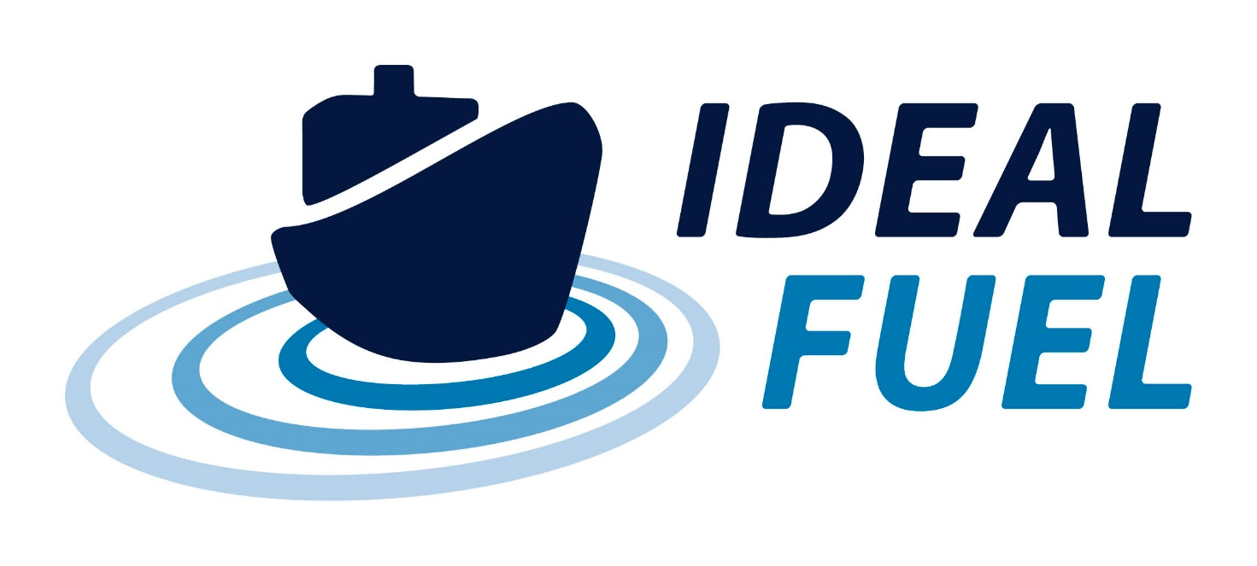

Deliverable Report

D1.1– NEC – Requirement No.1

|  |  |  |
| --- | --- | --- |
| Deliverable No. | IDEALFUEL D1.1 |  |
| Related WP | WP1 |  |
| Deliverable Title | NEC – Requirement No.1 |  |
| Deliverable Date | 30-10-2020 |  |
| Deliverable Type | REPORT |  |
| Dissemination level | Confidential – consortium members only (CO) |  |
| Written By | Roy Hermanns (TU/e) | 14-10-2020 |
| Checked by | ALL | dd-mm-yyyy |
| Reviewed by | ALL | dd-mm-yyyy |
| Approved by | Project Coordinator | dd-mm-yyyy |
| Status | Draft 1.0 | 14-10-2020 |

Disclaimer/ Acknowledgment

Copyright ©, all rights reserved. This document or any part thereof may not be made public or disclosed, copied or otherwise reproduced or used in any form or by any means, without prior permission in writing from the IDEALFUEL Consortium. Neither the IDEALFUEL Consortium nor any of its members, their officers, employees or agents shall be liable or responsible, in negligence or otherwise, for any loss, damage or expense whatever sustained by any person as a result of the use, in any manner or form, of any knowledge, information or data contained in this document, or due to any inaccuracy, omission or error therein contained.

All Intellectual Property Rights, know-how and information provided by and/or arising from this document, such as designs, documentation, as well as preparatory material in that regard, is and shall remain the exclusive property of the IDEALFUEL Consortium and any of its members or its licensors. Nothing contained in this document shall give, or shall be construed as giving, any right, title, ownership, interest, license or any other right in or to any IP, know-how and information.

This project has received funding from the European Union’s Horizon 2020 research and innovation programme under grant agreement No 883753. The information and views set out in this publication does not necessarily reflect the official opinion of the European Commission. Neither the European Union institutions and bodies nor any person acting on their behalf, may be held responsible for the use which may be made of the information contained therein.

**Publishable summary**

The EU H2020 project IDEALFUEL aims to develop an efficient and low-cost chemical pathway to convert lignocellulosic biomass into a Biogenic Heavy Fuel Oil (Bio-HFO) with ultra-low sulphur levels that can be used as drop-in fuel in the existing maritime fleet. Within this project fuels or fuel-related components will be shipped between the partners. Since two partners (WinGD and BLOOM) are located in non-EU countries, Switzerland, several aspects need to be covered. This is documented within this deliverable, D1.1 concerning the NEC – Requirement No.1 for the IDEALFUEL project and its partner deliverable D1.2 covering the type of materials that IDEALFUEL will be transporting between the partners.  This deliverable D1.1 shows that the partners have confirmed to the coordinator that they obtain and keep copies on file of import/export authorizations as required by national and EU legislation. There are no deviations from the description of this deliverable as given in Annex 1 of the Grant Agreement.

Contents

1 Introduction 5

2 Methods and Results 6

2.1.1 Confirmation statements by partners 6

3 Discussion and Conclusions 7

Risk Register 8

Acknowledgement 9

Appendix A – Quality Assurance Review Form 10

**Table of Figures**

No table of figures entries found.

**Tables**

Table 2.1: Confirmation of statement by the partners. 6

**Abbreviations**

|  |  |
| --- | --- |
| Symbol / short name |  |
| Bio-HFO | Biogenic Heavy Fuel Oil |
|  |  |
|  |  |
|  |  |
|  |  |
|  |  |
|  |  |
|  |  |

# Introduction

The EU H2020 IDEALFUEL consortium is spread all over Europe and during the runtime of the IDEALFUEL project, project related items will be transported between the partners. Since two project partners, namely WINGD and BLOOM are located in Switzerland these items / products – mainly fuels – will be shipped between the EU and a non-EU country and some aspects need to be covered according to the ethics self-assessment checklist[1]. This mainly affects the technical partners :

* the Netherlands: TU/e, VERT, GOODFUELS and VARO;
* Germany: OWI and T4F;
* Spain: CSIC;
* Switzerland: WinGD and BLOOM.

These aspects are covered in two deliverables. This deliverable, D1.1, shows that the partners have confirmed to the coordinator that they will obtain and keep copies on file of import/export authorizations as required by national and EU legislation. The second deliverable, D1.2, describes the kind of - project related - materials that will be transported/shipped and what kind of details related to these materials will be documented.

# Approach

## Request for statements by coordinator

The coordinator has contacted all the partners and requested a confirmation of the following statement:

We <PARTNERNAME> as IDEALFUEL project partner confirm that copies of import/export authorizations, as required by national/EU legislation will be obtained and will be kept on file. We are aware that this request is directly related to the items that will be transported/shipped within the IDEALFUEL project, not for all the transport/shipping processes within a company.

## Confirmation statements by partners

All partners have confirmed to the coordinator that they obtain and keep copies on file of import/export authorizations as required by national and EU legislation.

Table .: Confirmation of statements by the partners.

|  |  |  |  |  |
| --- | --- | --- | --- | --- |
| Partner | Name |  | Confirmation Yes/No | Date |
| 1 | Technische Universiteit Eindhoven | TUE | Yes |  |
| 2 | Vertoro B.V. | VER |  |  |
| 3 | TEC4FUELS GmbH | T4F |  |  |
| 4 | Bloom Biorenewables SA | BLOOM |  |  |
| 5 | Uniresearch BV | UNR |  |  |
| 6 | Winterthur Gas & Diesel AG | WINGD |  |  |
| 7 | (Formerly SeaNRG, is now GOODFUELS #12) |  | NA | NA |
| 8 | Thyssenkrupp Marine Systems GmbH | TKMS |  |  |
| 9 | OWI Science for Fuels GmbH | OWI |  |  |
| 10 | AGENCIA ESTATAL CONSEJO SUPERIOR DEINVESTIGACIONES CIENTIFICAS | CSIC |  |  |
| 11 | VARO Energy Netherlands B.V. | VARO |  |  |
| 12 | Goodfuels B.V. | GOOD |  |  |

NA = Not applicable

# Discussion and Conclusions

All partners have confirmed to the coordinator that they obtain and keep copies on file of import/export authorizations as required by national and EU legislation. See also deliverable D1.2 for the details that will be documented of the materials that will be transported/shipped within the IDEALFUEL project. There are no deviations from the description of this deliverable as given in Annex 1 of the Grant Agreement.

# Risk Register

No risks foreseen related to this deliverable.



# Acknowledgement

The author(s) would like to thank the partners in the project for their valuable comments on previous drafts and for performing the review.

**Project partners:**

|  |  |  |
| --- | --- | --- |
| # | Partner short name | Partner Full Name |
| 1 | TUE | Technische Universiteit Eindhoven |
| 2 | VERT | Vertoro BV |
| 3 | T4F | Tec4Fuels |
| 4 | BLOOM | Bloom Biorenewables Ltd |
| 5 | UNR | Uniresearch B.V. |
| 6 | WinGD | Winterthur Gas & Diesel AG |
| 7 |  | (Formerly SeaNRG, is now GOODFUELS #12) |
| 8 | TKMS | Thyssenkrupp Marine Systems GMBH |
| 9 | OWI | OWI – Science for Fuels gGmbH |
| 10 | CSIC | Agencia Estatal Consejo Superior De Investigaciones Cientificas |
| 11 | VARO | Varo Energy Netherlands BV |
| 12 | GOOD | GoodFuels B.V. |

|  |  |
| --- | --- |
| http://elastic.studioh2o.nl/image.php/userdata/image/ec_1.gif?width=150&height=150&image=/userdata/image/ec_1.gif | *This project has received funding from the European Union’s Horizon 2020 research and innovation programme under grant agreement No 883753* |

# Appendix A – Quality Assurance Review Form

The following questions should be answered by all reviewers (WP Leader, reviewer, Project Coordinator) as part of the Quality Assurance procedure. Questions answered with NO should be motivated. The deliverable author will update the draft based on the comments. When all reviewers have answered all questions with YES, only then can the Deliverable be submitted to the EC.

NOTE: This Quality Assurance form will be removed from Deliverables with dissemination level “Public” before publication.

|  |  |  |  |
| --- | --- | --- | --- |
| Question | WP Leader | Reviewer | Project Coordinator |
|  | NAME (Organisation) | NAME (Organisation) | NAME (Organisation) |
| 1. Do you accept this Deliverable as it is? | Yes / No (elaborate) | Yes / No (elaborate) | Yes / No (elaborate) |
| 1. Is the Deliverable complete?  * All required chapters? * Use of relevant templates? | Yes / No (elaborate) | Yes / No (elaborate) | Yes / No (elaborate) |
| 1. Does the Deliverable correspond to the DoA?  * All relevant actions preformed and reported? | Yes / No (elaborate) | Yes / No (elaborate) | Yes / No (elaborate) |
| 1. Is the Deliverable in line with the IDEALFUEL objectives?  * WP objectives * Task Objectives | Yes / No (elaborate) | Yes / No (elaborate) | Yes / No (elaborate) |
| 1. Is the technical quality sufficient?  * Inputs and assumptions correct/clear? * Data, calculations, and motivations correct/clear? * Outputs and conclusions correct/clear? | Yes / No (elaborate) | Yes / No (elaborate) | Yes / No (elaborate) |
| 1. Is created and potential IP identified and are protection measures in place? | Yes / No (elaborate) | Yes / No (elaborate) | Yes / No (elaborate) |
| 1. Is the Risk Procedure followed and reported? | Yes / No (elaborate) | Yes / No (elaborate) | Yes / No (elaborate) |
| 1. Is the reporting quality sufficient?  * Clear language * Clear argumentation * Consistency * Structure | Yes / No (elaborate) | Yes / No (elaborate) | Yes / No (elaborate) |

1. <https://ec.europa.eu/research/participants/data/ref/h2020/grants_manual/hi/ethics/h2020_hi_ethics-self-assess_en.pdf>