* IDEALFUEL -   
  Lignin as a feedstock for renewable marine fuels

GRANT AGREEMENT No. 883753

HORIZON 2020 PROGRAMME - TOPIC LC-SC3-RES-23-2019

“Development of next generation biofuel and alternative renewable fuel technologies for aviation and shipping”



Deliverable Report

D2.1 – Report on the setup of the production line and the optimisation of the process for the production of oligomers

|  |  |  |
| --- | --- | --- |
| Deliverable No. | IDEALFUEL D2.1 |  |
| Related WP | WP2 |  |
| Deliverable Title | Report on the setup of the production line and the optimisation of the process for the production of oligomers |  |
| Deliverable Date | D1512-2020 |  |
| Deliverable Type | Report |  |
| Dissemination level | Confidential – consortium members only (CO) |  |
| Written By | Florent Héroguel (BLOOM) | 04-12-2020 |
| Checked by | Name WP leader (VERTORO) | dd-mm-yyyy |
| Reviewed by | Name Reviewer (Organisation short name) | dd-mm-yyyy |
| Approved by | Project Coordinator | dd-mm-yyyy |
| Status | Draft 1.0 / Draft 2.0 / Final | 13-11-2020 |

Disclaimer/ Acknowledgment

Copyright ©, all rights reserved. This document or any part thereof may not be made public or disclosed, copied or otherwise reproduced or used in any form or by any means, without prior permission in writing from the IDEALFUEL Consortium. Neither the IDEALFUEL Consortium nor any of its members, their officers, employees or agents shall be liable or responsible, in negligence or otherwise, for any loss, damage or expense whatever sustained by any person as a result of the use, in any manner or form, of any knowledge, information or data contained in this document, or due to any inaccuracy, omission or error therein contained.

All Intellectual Property Rights, know-how and information provided by and/or arising from this document, such as designs, documentation, as well as preparatory material in that regard, is and shall remain the exclusive property of the IDEALFUEL Consortium and any of its members or its licensors. Nothing contained in this document shall give, or shall be construed as giving, any right, title, ownership, interest, license or any other right in or to any IP, know-how and information.

This project has received funding from the European Union’s Horizon 2020 research and innovation programme under grant agreement No 883753. The information and views set out in this publication does not necessarily reflect the official opinion of the European Commission. Neither the European Union institutions and bodies nor any person acting on their behalf, may be held responsible for the use which may be made of the information contained therein.

**Publishable summary**

The EU H2020 project IDEALFUEL aims to develop an efficient and low-cost chemical pathway to convert lignocellulosic biomass into a Biogenic Heavy Fuel Oil (Bio-HFO) - with ultra-low sulphur levels - that can be used as drop-in fuel in the existing maritime fleet. While technical lignins are cheap and available in large quantities, their characteristics are not suitable for the development of high-performance marine fuels. Among others, these lignins suffer from low solubilities, large molecular weight, high sulfur content and are generally non-uniform in their chemical nature. One strategy consists in solvent fractionation of technical lignins to extract a high-quality fraction, which can be more suitable for fuels applications. A second strategy consists in the production of high-quality lignin from biomass with alternative bio-refining process. Within IDEALFUEL, the partners selected solvolysis and Aldehyde-Assisted Fractionation (AAF) as the most relevant technologies for the production of high-performance lignin for fuels applications.

The AAF biomass pretreatment technology has been recently disclosed by the Laboratory of Sustainable and Catalytic Processing (LPDC) at EPFL and is currently brought to the market by Bloom Biorenewables Ltd (BLOOM), an IDEALFUEL partner. In this report, a detailed description of the setup the production line and the optimisation of the process for the production of oligomers is described.

First, BLOOM has performed AAF of beechwood at the 15 litres scale to produce stabilized lignin in the 200g-scale. The parameters, including selection of reagents and reactions conditions, have been optimized to prevent undesired degradation pathways and yield uncondensed lignin. Lignin has been isolated as a solid by precipitation and characterized by HSQC NMR which revealed low degree of condensation (high β-O-4 content). In a second step, AAF lignin depolymerization by hydrogenolsis under pressure at the 1 litre scale has been performed to produce lignin oligomers and monomers. Pure, sugar-free lignin oligomers have been isolated by precipitation, sent to the partners and will be characterized in detail within the project.

Contents

1 Introduction 5

2 Methods and Results 6

2.1 Biomass preparation 6

2.2 Aldehyde-assisted fractionation (AAF) 6

2.3 Lignin depolymerization 8

2.4 Isolation of lignin oligomers 9

2.5 Characterization 10

2.5.1. Characterization of AAF-lignin and lignin monomers 10

2.5.2. Characterization of lignin oligomers 11

2.6 Safety considerations 12

2.6.1. Troubleshooting 12

2.6.2. Reagents 14

3 Discussion and Conclusions 16

3.1 Aldehyde-assisted fractionation (AAF) 16

3.2 Lignin depolymerization 16

3.3 Isolation of lignin oligomers 16

4 Recommendations 17

5 Risk Register 18

6 References 19

Acknowledgements 20

Appendix A – Quality Assurance Review Form 21

**Table of Figures and Tables**

Fig. 1. Description of the lignin stabilization pathway in the presence of an aldehyde.

Fig. 2. Mass balance of the AAF process on birch.

Fig. 3. Schematic of the AAF process and steps to recover the three main biomass fractions

Fig. 4. Schematic of the hydrogenolysis step for the depolymerization of AAF-lignin

Fig. 5. Pictures of the 1L Parr depolymerization reactor and lignin powder.

Fig. 6. Schematic of the oligomers isolation step via liquid-liquid extraction

Table 1. Composition analysis of beech used for lignin oligomers production.

Table 2. Typical characteristics of the lignin oligomers obtained using AAF technology

Table 3. Troubleshooting table for the AAF process

**Abbreviations**

|  |  |
| --- | --- |
| Symbol / short name |  |
| AAF | Aldehyde assisted fractionation |
| THF | Tetrahydrofuran |
| EtOH | Ethanol |
| Et2O | diethylether |

Introduction

The so-called Aldehyde Assisted Fractionation (AAF) of biomass allows for an efficient isolation of the main biomass’ fractions with virtually no occurrence of lignin condensation and humins formation from (hemi)cellulose products.1,2 This technology brings unprecedented possibilities for the production of high-quality lignin derivatives that can be incorporated in many markets currently dominated by fossil resources, such as marine fuels. After the AAF biomass pretreatment, the obtained lignin fraction is isolated as a powder by precipitation and depolymerized using hydrogen (as a gas or using H2-donor solvent), yielding a mixture of monomers (20-50%) and oligomers (50-80%). The oligomers are separated from the monomers using a liquid-liquid extraction protocol followed by precipitation and drying, being collected as a brown powder. While lignin monomers have great potential for applications as specialty chemicals, the highly soluble lignin oligomers are great candidates for the production of a surfur-free Crude Lignin Oil (CLO) suitable for further upgrading into a biobased heavy fuel oil (Bio-HFO) compatible with the marine fuel’ value chain.

Within the scope of IDEALFUEL, the D2.1 addresses the setup of the production line and optimisation of the oligomers’ production process by BLOOM. Accordingly, a proper optimisation of the process conditions and simplification of the lab procedure facilitates the achievement of a scalable operation. In the M1-M6 period of the project, BLOOM has defined both standard protocols for biomass fractionation using the AAF technology, lignin isolation and depolymerization as well as the oligomers purification. The safety of the process has been central in this phase. Some reagents have been replaced by greener and safer options, while alternative steps have been implemented in order to preserve workers’ health and to minimize risks.

While depending on the type of biomass used and the conditions of pretreatment and hydrogenolysis, typical yields are 90 g oligomer per kg of initial dry biomass weight. Therefore, to reach the current target of 1 kg of oligomers, 11 kg of hardwood are needed. Due to the lockdown in Switzerland related to the covid-19 pandemic and failure of a key instrument during the production, we are facing a delay in the delivery of oligomers. Nonetheless, the time without installations to operate gave us an opportunity to focus on the equipment needed to scale-up the process and the Techno-Economical Assessment (TEA). We were able to unlock access to bigger installations that will allow us to increase productivity, as well as to perform the subsequent lignin hydrogenolysis step in a larger scale. The optimal AAF conditions are now defined and the operators are familiar with the process, so future delays might occur only in the case of a second lockdown, unexpected operational issues or delays in the delivery of reagents and new equipment.

# Methods and Results

## Biomass preparation

The biomass source is hardwood (beech, 300 kg) provided by a Swiss woodcutter (Jimmy Rochat). The trunks have been debarked and chipped to particles of ca. 5 cm. The biomass was air-dried under ambient conditions (spread on a tarp for 2 weeks) and size-reduced using a Retsch cutting mill with 6 mm grid before use. A detailed composition analysis has been performed using NREL standard protocol.3

Table 1. Composition analysis of beech used for lignin oligomers production.

|  |  |  |  |  |  |  |  |  |
| --- | --- | --- | --- | --- | --- | --- | --- | --- |
| **Moisture (%wt)** | **Extractives (%wt)** | **Weight fraction (%wt), on a dry extracted basis** | | | | | | |
| **Glucans** | **Xylans** | **Arabinans** | **Galactans** | **Manans** | **Klason lignin** | **Acid soluble lignin** |
| 5.7 | 2.6 | 37.1 | 15.3 | 2.1 | 2.1 | 1.9 | 22.8 | 3.7 |

## Aldehyde-assisted fractionation (AAF)

The procedure used for the AAF of biomass is reported below, adapted from the recent report from Telabi et al.4

Wood (1 kg) is added to a 10 L glass reactor equipped with mechanical stirring, together with 4.5 L of solvent (methylTHF), 0.8 L of the stabilizing aldehyde (isobutyraldehyde) and 170 mL of the acid (H2SO4). The reactor is then heated to 85°C and stirred for 3 h. The mixture is then cooled down to 25°C and NaHCO3 (250 g) is slowly added by portions for neutralization. After 30 minutes of neutralization, the mixture is removed from the reactor via canula and filtered on a Büchner to isolate solid cellulose. Cellulose (filtration cake) is washed with fresh methylTHF (3 x 500 mL) and water (3 x 500 mL). The liquor (filtrate and washings) is concentrated under reduced pressure (40°C, 100 mbar) to yield 300 mL of a viscous oil. The oil is added dropwise to 1.5 L of hexane under strong stirring (800 rpm) in order to precipitate the lignin fraction. The mixture is then filtered and lignin is collected as a powder. The filter is further washed with fresh hexane (200 mL) and dried at room temperature overnight. After drying, a second wash step using a Soxhlet extractor and diethyl ether (Et2O) might be performed to remove residual hemicelluloses in the lignin.

The pretreatment conditions were optimized for the scale-up and type of biomass used. The overall goal is to efficiently fractionate biomass while favouring stabilization of reactive lignin and hemicellulose intermediates over condensation. The condensation occurs by the release of reactive intermediates during biomass fractionation under acidic media, leading to the irreversible formation of stable C-C bonds that will not be cleaved in the subsequent mild depolymerization focusing on the cleavage of ether linkages. The stabilization groups, an aldehyde, reacts with reactive diols to form a stable acetal that protects the lignin’ structure, thus preventing its condensation (Fig. 1). Therefore, conditions were screened to optimize, for each biomass, the optimal balance between biomass deconstruction and stabilization, with minimal occurrence of condensation. The parameters include but are not limited to: temperature, reaction time, acid concentration, choice of acid and solvent, biomass loading. For the beech used in this study, the optimal conditions were defined as 85 °C for 4 hours.

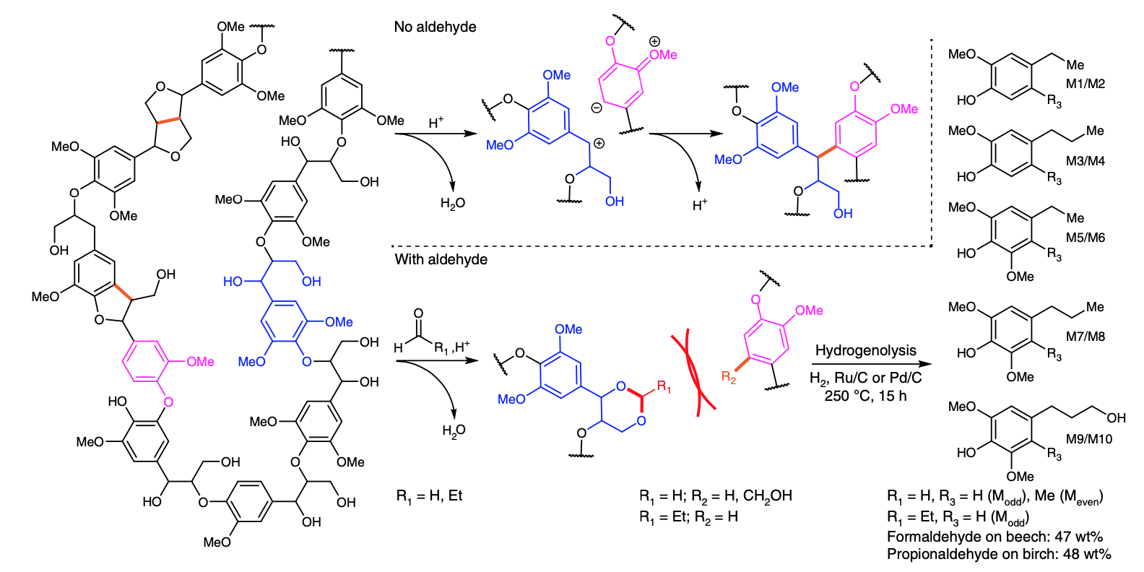

*Fig. 1. Description of the lignin stabilization pathway in the presence of an aldehyde.*

The lignin precipitation step consists in adding an antisolvent to the liquor, in which lignin is insoluble while by-products such as sugars are soluble. The oil concentration is a crucial parameter since a very viscous oil yields poor separation of lignin from by-products while lignin remains soluble in a too diluted oil, and hence does not precipitate. We selected hexane as an antisolvent, which volume should be sufficient to dissolve all by-products. A washing step using hexane or di-ethylether can be used to eliminate residual by-products to obtain high purity lignin. AAF lignin being slightly soluble in di-ethylether, performing this step decreases slightly lignin yield.

As presented in Fig. 2, 1 kg of biomass yields 391 g of cellulose, 185 g of lignin and 107 g of protected xylose. Biomass extractives and humidity have to be also considered for a precise mass balance.

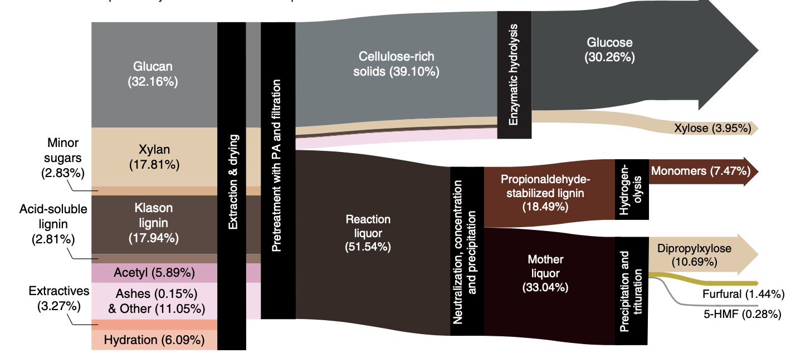

*Fig. 2. Mass balance of the AAF process on birch.4*

Fig. 3 illustrates the AAF process and the subsequent steps for recovering the three main biomass fractions.

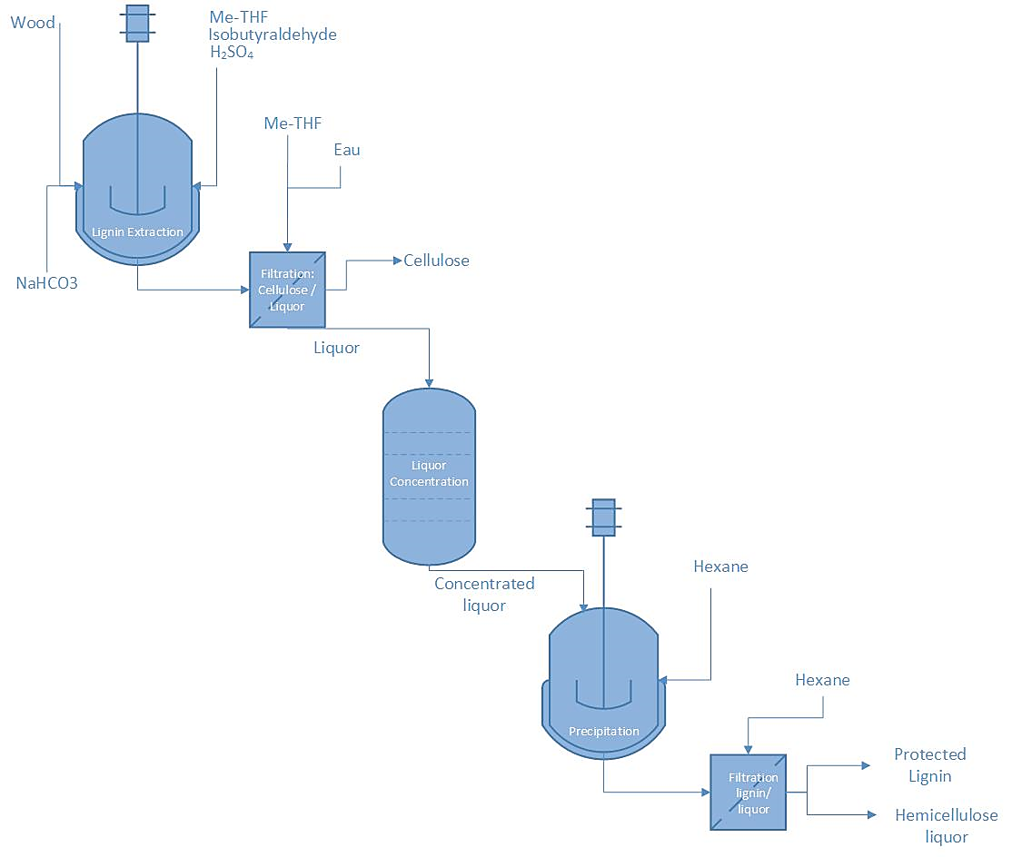

*Fig. 3. Schematic of the AAF process and steps to recover the three main biomass fractions*

## Lignin depolymerization

Lignin is depolymerized by hydrogenolysis, typically mixing 50 g of AAF-lignin powder, 25 g of Ni/SiO2 (BASF, 45 %wt of Ni loading) and 700 mL of ethanol (EtOH) in a 1L Parr reactor. For safety reasons, the pyrophoric catalyst is mixed with an equal amount of water before contacting with EtOH. Instruments specifications are as follows: batch reactor (Parr Instrument 236HC10 915154 HASTB 082114) with 1L capacity; oven (Parr Instrument A2600HC11EE) able to heat up to 300°C; mechanical stirrer (Boston gear 700 series); temperature control box (Omega); rupture disk set to 120bar. After sealing, the reactor is purged 3 times with 10 bar N2 and leaked tested, pressurized with 10 bar of N2, and heated to 220oC for 3 hours (2 hours heating ramp). After colling down to room temperature, the reactor is depressurized and the mixture is filtered to recover the spent solid catalyst. An aliquot is sampled from the liquor and injected to for gas chromatography for aromatics monomers quantification. Yields were calculated using corrected mass yields.5

The catalyst is washed with EtOH until the filtrate is clear (3 x 30 mL). The filtrates of all hydrogenolysis batches were combined and concentrated in vacuo (40°C, 20 mbar). The recovered catalyst can be regenerated at 300 °C (2°C/min ramp) under a hydrogen flow (100 mL/min) for 10 h. Passivation is achieved with air contact once the catalyst reach temperatures below 30 °C.

The conditions applied during lignin hydrogenolysis have a strong influence on the distribution and yields of monomers in the final oil.6 As the focus of the IDEALFUEL project is on the oligomeric fraction, we optimized the aforementioned conditions in order to have homogeneity between the batches. The hydrogenolysis can be also performed under an H2 atmosphere and using other solvents such as THF or 1,4-dioxane. Fig. 4 illustrates the hydrogenolysis step for AAF-lignin depolymerisation.

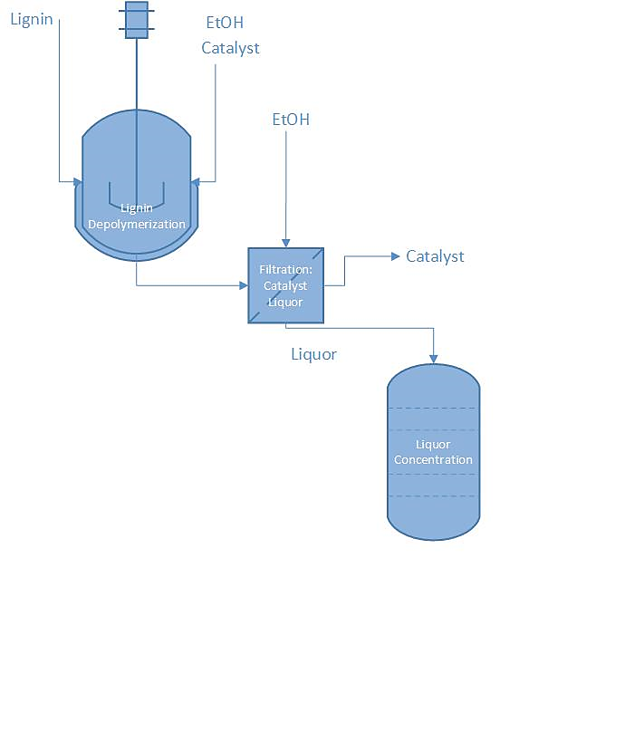

*Fig. 4. Schematic of the hydrogenolysis step for the depolymerisation of AAF-lignin.*

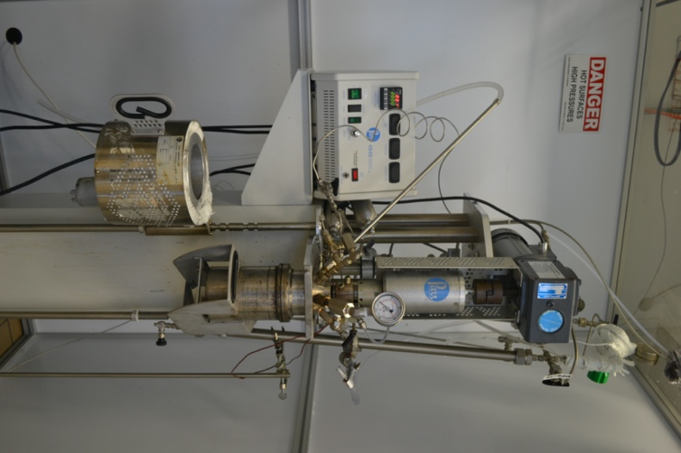 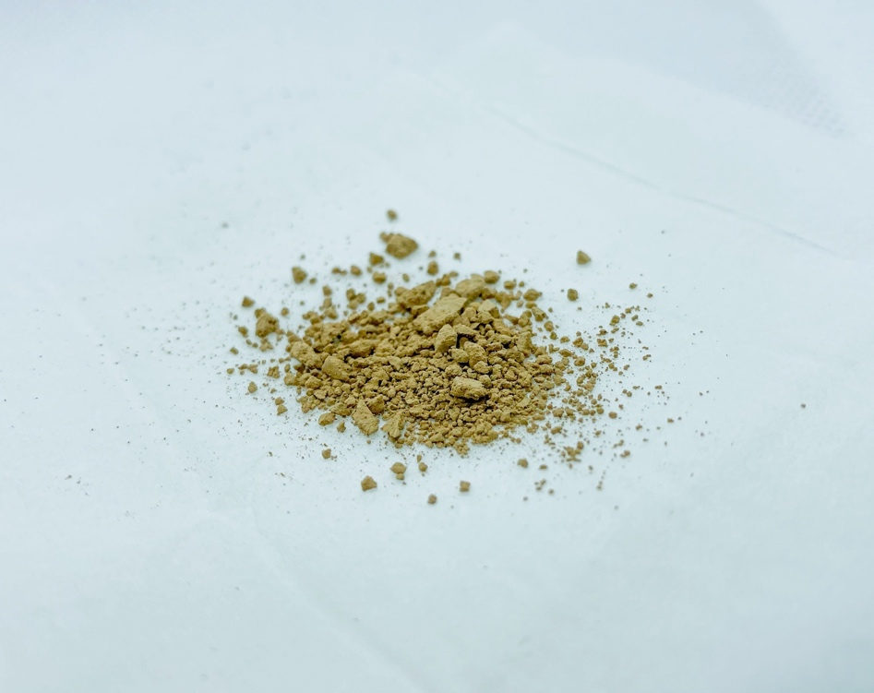

Fig. 5. Pictures of the 1L Parr depolymerization reactor and lignin powder.

## Isolation of lignin oligomers

After removal of EtOH from the lignin depolymerization liquor, monomers are extracted from oligomers with hexane at reflux temperature (70°C) for 15 hours. The oligomers’ oil is concentrated in vacuo (20mbar at 40°C for 20 min) to evaporate residual hexane. The concentrated oil is then diluted in methanol (MeOH) and precipitated in water. Oligomers are recovered by filtration as a brown powder. The oligomers are dried at room temperature and stored in the fridge.

Alternatively, monomers can be distilled from oligomers by vacuum distillation (200 °C, 10-3 mbar) of the product mixture from the hydrogenolysis after EtOH removal, but such conditions could degrade the oligomers’ original properties. Finally, it is an energy-intensive step as it has to be run over a few days to enable a good separation of the monomers. For these reasons, the liquid-liquid extraction seems more viable for scaling-up the procedure. Fig. 5 illustrates the liquid-liquid extraction process for the isolation of BLOOM oligomers.

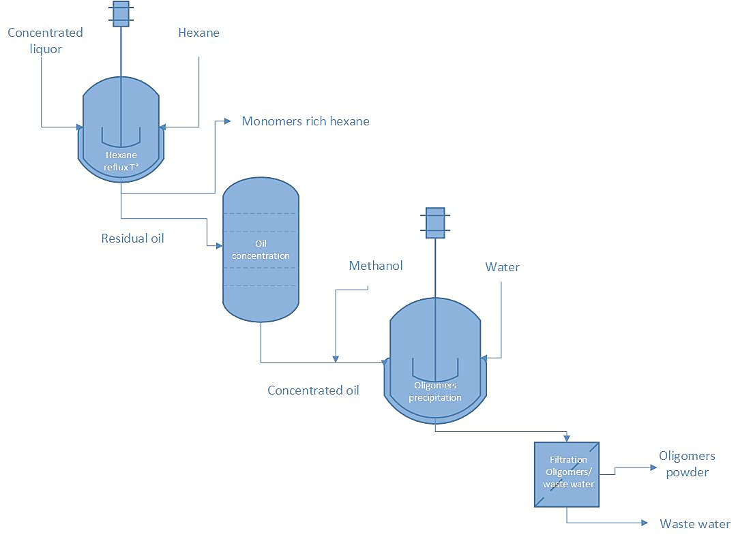

Fig. 6. Schematic of the oligomers isolation steps via liquid-liquid extraction

## Characterization

## 2.5.1. Characterization of AAF-lignin and lignin monomers

The quantification of the monomers obtained after hydrogenolysis of AAF-lignin is of utmost importance in the evaluation of high-end applications for such biobased aromatics. Furthermore, the yield of monomers is useful in the determination of the “quality” of the lignin, as lignins properly stabilized during AAF should ultimately lead to high yields of monomers. A gas chromatography system equipped with a flame ionization detector (GC-FID, model no. 7890B from Agilent Technologies with an autosampler model no. 7963) is used for monomers’ quantification. The GC-FID is equipped with an HP-5 column (length: 30 m, diameter: 0.320 mm, and film: 0.25 μm; cat. no. 19091J-413) from Agilent Technologies. All GC samples were prepared by mixing 0.2 μL of the hydrogenolysis product with 0.1 μL of an internal standard solution (n-decane in dioxane, 2g/ kg) and 0.8 μL of dioxane. N2 was used as carrier gas (25 mL min−1). The injector temperature was set to 250 °C. The oven temperature was kept at 50 °C for 1 minute, then increased to 300 °C at a rate of 15 °C min−1 and held at 300 °C for 7 minutes. Based on the areas of the different monomers and the standard, a yield of gram of monomer per kilogram of biomass was calculated. With the applied pretreatment conditions and hydrogenolysis, yields for beech wood are of typically between 60-90 g monomers and 110-140 g oligomers per kg of biomass.

The degree of protection of the AAF-lignin can be directly assessed using the HSQC-NMR technique. HSQC-NMR (1H–13C multiplicity-edited heteronuclear single-quantum coherence) spectra were acquired on a Bruker NMR spectrometer (model no. Avance III 400-MHz, with BBFO-plus probe) using the following parameters: 32 scans, 1.5 s of delay, 4.7 ppm of transmitter frequency offset (O1P), 13 ppm of spectral width and 32 dummy scans. Sample preparation involves the dissolution of the sample in DMSO-d6. Spectra are processed and analysed using MestReNova software.

All the parameters used for GC and HSQC-NMR analyses have been previously reported.4

## 2.5.2. Characterization of lignin oligomers

A brief description of the procedure used for the characterization of the oligomeric fraction is reported below. Part of this work has been published.7

The molecular weight of the oligomers was measured using a Shimadzu GPC system (Styragel Guard Column, THF as eluent) equipped with refractive index (RI) and ultra-violet (UV) detectors. Polystyrene standards were used for calibration. Prior to the injection in the apparatus, the sample was completely dissolved in THF at a concentration of 1g/L.

The thermal phase transitions in the lignin oligomers were investigated using a TA Discovery DSC 250. All samples were first heated to 50 °C and then tested using heat-cool-heat temperature program between -90 and 200 °C. The heating rate for all measurements was kept at 20 °C min−1 and the tests were carried out under nitrogen atmosphere (flow rate of 20 mL min−1). Around 8–15 mg of each samples was placed between an Al crucible and a non-hermetic Al lid. A similar crucible was used as a reference pan for the DSC experiments. The data was examined for any residual reaction and other phase transitions such as glass transition. The half value of the heat capacity change (ΔCp/2) was considered as glass transition temperature (Tg).

Lignin hydroxyl content was determined by 31P-NMR spectroscopy according to procedures reported in the literature 31P-NMR spectra were recorded at room temperature on a Varian Inova 400 spectrometer using a 5 mm probe.8 The chemical shift scale was calibrated relative to the reaction product of water and the phosphitylating agent (δ 132.2 ppm). Cyclohexanol was used as internal standard and TMDP (2-Chloro-4,4,5,5-tetramethyl-1,3-2-dioxaphospholane) as the phosphitylation agent. Free induction decays were collected with a spectral width of 17 kHz, an acquisition time of 1.2 s, a preparation delay of 10 s and 256 accumulations. A line-broadening factor of 10 Hz was applied before Fourier transformation to the frequency domain. TMDP selectively reacts with the OH groups present in lignin, and the derivatized lignin can be analyzed by NMR. Typical characterization results obtained for BLOOM’ lignin oligomers are reported in Table 1.

Table 2. Typical characteristics of the lignin oligomers obtained using AAF technology7

|  |  |  |  |  |  |  |
| --- | --- | --- | --- | --- | --- | --- |
| Mn (g/mol) a | Mw (g/mol) a | D a | Total OH (mmol/g) b | *f* c | Tg (oC) d | Sulfur (wt%) e |
| 803 | 1600 | 1.9 | 4.85 | 3.89 | 53 | 0.17 |

a Determined by GPC (Mn: number average molecular weight, Mw: weight average molecular weight, D: polydispersity index). b Sum of phenolic, aliphatic and carboxylic hydroxyl groups as determined by 31P-NMR. Aliphatic OH corresponds to 1 mmol/g. c Average functionality, *i.e.* average number of OH groups per oligomer. *f* = Mn x [total OH]/1000. d Glass transition temperature determined by DSC. e Sulfur content determined by elemental analysis.

## Safety considerations

Safety is a priority when setting the production line and optimising the AAF process for the production of oligomers. The main risks during the operation and the orientation on how to proceed are described in the troubleshooting table in section 2.6.1. Furthermore, a list of reagents that need to be handled with care is detailed in section 2.6.2.

## 2.6.1. Troubleshooting

Table 2. Troubleshooting table for the AAF process

|  |  |  |  |  |
| --- | --- | --- | --- | --- |
| Step | Problem | Probability | Effect(s) | Action(s) |
| Pretreatment | Overheating of the reactor | 3 | Evaporation of the solvent  Degradation of compounds  Productivity loss | Online monitoring temperature  performed by operator |
| Pretreatment | Condenser issue | 3 | Loss of the solvent  Degradation of the MR  Loss of the yield |  |
| Pretreatment | Stirring issue | 3 | Loss of yield  Boiling delay  Stirrer breaking | Online monitoring of brewing speed performed by operator  Check the condition of the brewer each month (performed by operator) |
| Pretreatment | Blocking valves and pipe with biomass | 2 | Stop of the production  Exposition to chemicals for operators | Control of the valves before each batch performed by operator  In case of clogging, wear a gas mask to unclog pipes |
| Pretreatment | Combustion of wood inside the reactor | 3 | Stop the production  Evacuation of the building  Damage and material loss  Possible death/hurt of the workers  Possible environmental pollution | Inert the installation by operator |
| Pretreatment | Leak in reactor | 3 | Possible stop of the production  Material damage  Possible hurt of workers  Possible intoxication of workers | Revision of the installation each year perform by an operator |
| Pretreatment | Presence of MR steam in the production hall due to poor sealing | 3 | Evacuation of the building  Stop of the production  Possible intoxication of worker | Sealing test |
| Pretreatment | Stop of nitrogen flow in the reactor | 3 | Presence of oxygen in the reactor  Risk of explosion in case of contact with a flame | Regular control of the available nitrogen content of the building before and during the batch  perform by an operator |
| Pretreatment | Shutdown of the ventilation during the reaction | 3 | Poor ventilation  Possible intoxication of workers | Revision of ventilation each month  perform by an operator |
| Pretreatment | Overpressure in the reactor | 3 | Risk of explosion  Hurt of workers  Intoxication of workers  Possible death of workers | Rupture disk set up by a specialist |
| Pretreatment | Explosion in the reactor | 3 | Stop of the production  Death/Hurt of the workers  Environmental pollution  Damage and material loss | Check before each batch of the peroxide level contained in the recycled solvent  perform by an operator  Control of peroxide detector perform by an operator  Light reactor protection by black paper or yellow glass perform by an operator |
| Neutralization | Reactor overflow | 2 | Stop of the production  Death/Hurt of the workers  Environmental pollution  Damage and material loss | NaHCO3 is replaced by NaOH solution 20% |
| Hydrogenolysis | Overpressure | 3 | Stop of the production  Death/Hurt of the workers  Damage and material loss | Use of heavier solvents  Rupture disk |

## 2.6.2. Reagents

* Hexane is toxic and highly flammable. Use proper protective equipment and a fume hood while handling it. Also, ensure that there are no open flames or spark-generating devices nearby while handling this chemical.
* Diethyl ether is highly flammable. Ensure that there are no open flames or spark-generating devices nearby while handling this chemical.
* Methanol is toxic and highly flammable. Use proper protective equipment and a fume hood while handling it. Ensure that there are no open flames or spark-generating devices nearby while handling this chemical.
* n-Decane is highly flammable. Use proper protective equipment and a fume hood while handling it. Ensure that there are no open flames or spark-generating devices nearby while handling this chemical.
* 1,4-Dioxane is toxic and highly flammable. Use proper protective equipment and a fume hood while handling it. Ensure that there are no open flames or spark-generating devices nearby while handling this chemical.
* Sulfuric acid is extremely corrosive. Use proper protective equipment and a fume hood while handling it.
* MethylTHF is highly flammable. Ensure that there are no open flames or spark-generating devices nearby while handling this chemical.
* Isobutyraldehyde is highly flammable. Ensure that there are no open flames or spark-generating devices nearby while handling this chemical.
* Ethanol is toxic and highly flammable. Use proper protective equipment and a fume hood while handling it. Ensure that there are no open flames or spark-generating devices nearby while handling this chemical.

# Discussion and Conclusions

## Aldehyde-assisted fractionation (AAF)

The team successfully optimized and scaled-up the process for biomass fractionation at the 15L scale with an input of 1 kg biomass per batch and an output of 200 g lignin per batch. A range of solvents and aldehydes have been tested to ensure process safety and sustainability while. Process parameters including reaction time and temperature have been varied to obtain maximum yields and prevent condensation. Lignin has been isolated by precipitation on the 300 g scale after investigating a range of conditions. Results highlighted the importance of lignin purification since the presence of residual impurities complexifies downstream processes.

## Lignin depolymerization

A range of commercial catalysts has been screened and the influence of reaction parameters such as time, temperature and solvent has been rationalized. Lignin depolymerization has been performed at the 1L scale (50 g lignin input, 30 g oligomers output) and the catalyst has been successfully recycled.

## Isolation of lignin oligomers

Lignin oligomers have been purified by liquid-liquid extraction of monomers and precipitation to yield a pure and dry powder. Oligomers have been characterized and results have been shared with partners of WP2.

# Recommendations

# Risk Register

|  |  |  |  |  |
| --- | --- | --- | --- | --- |
| Risk No. | What is the risk | Probability of risk occurrence1 | Effect of risk1 | Solutions to overcome the risk |
| WP2.1 | Delays on setting up the new laboratories and/or receiving new equipment | 2 | 2 | Bloom currently has research agreement with local partners during the transition period |
| WP2.1 | Lockdowns due to the covid-19 pandemic | 1 | 2 | The team will try to move ahead of deadline to anticipate for lockdown |
|  |  |  |  |  |

1) Probability risk will occur: 1 = high, 2 = medium, 3 = Low

# References

(1) Shuai, L.; Amiri, M. T.; Questell-Santiago, Y. M.; Héroguel, F.; Li, Y.; Kim, H.; Meilan, R.; Chapple, C.; Ralph, J.; Luterbacher, J. S. Formaldehyde Stabilization Facilitates Lignin Monomer Production during Biomass Depolymerization. *Science* **2016**, *354* (6310), 329–333. https://doi.org/10.1126/science.aaf7810.

(2) Questell-Santiago, Y. M.; Zambrano-Varela, R.; Talebi Amiri, M.; Luterbacher, J. S. Carbohydrate Stabilization Extends the Kinetic Limits of Chemical Polysaccharide Depolymerization. *Nat. Chem.* **2018**, *10* (12), 1222–1228. https://doi.org/10.1038/s41557-018-0134-4.

(3) National Renewable Energy Laboratory. Determination of Structural Carbohydrates and Lignin in Biomass, 2008.

(4) Talebi Amiri, M.; Dick, G. R.; Questell-Santiago, Y. M.; Luterbacher, J. S. Fractionation of Lignocellulosic Biomass to Produce Uncondensed Aldehyde-Stabilized Lignin. *Nat. Protoc.* **2019**, *14* (3), 921–954. https://doi.org/10.1038/s41596-018-0121-7.

(5) Abu-Omar, M. M.; Barta, K.; Beckham, G. T.; Luterbacher, J. S.; Ralph, J.; Rinaldi, R.; Román-Leshkov, Y.; Samec, J. S. M.; Sels, B. F.; Wang, F. Guidelines for Performing Lignin-First Biorefining. *Energy Environ. Sci.* **2020**. https://doi.org/10.1039/D0EE02870C.

(6) Héroguel, F.; Nguyen, X. T.; Luterbacher, J. S. Catalyst Support and Solvent Effects during Lignin Depolymerization and Hydrodeoxygenation. *ACS Sustain. Chem. Eng.* **2019**, *7* (20), 16952–16958. https://doi.org/10.1021/acssuschemeng.9b03843.

(7) Vendamme, R.; Behaghel de Bueren, J.; Gracia-Vitoria, J.; Isnard, F.; Mulunda, M. M.; Ortiz, P.; Wadekar, M.; Vanbroekhoven, K.; Wegmann, C.; Buser, R.; Héroguel, F.; Luterbacher, J. S.; Eevers, W. Aldehyde-Assisted Lignocellulose Fractionation Provides Unique Lignin Oligomers for the Design of Tunable Polyurethane Bioresins. *Biomacromolecules* **2020**, *21* (10), 4135–4148. https://doi.org/10.1021/acs.biomac.0c00927.

(8) Pu, Y.; Cao, S.; Ragauskas, A. J. Application of Quantitative 31P NMR in Biomass Lignin and Biofuel Precursors Characterization. *Energy Environ. Sci.* **2011**, *4* (9), 3154–3166. https://doi.org/10.1039/C1EE01201K.

# Acknowledgements

The author(s) would like to thank the partners in the project for their valuable comments on previous drafts and for performing the review.

**Project partners:**

|  |  |  |
| --- | --- | --- |
| # | Partner short name | Partner Full Name |
| 1 | TUE | Technische Universiteit Eindhoven |
| 2 | VERT | Vertoro BV |
| 3 | T4F | Tec4Fuels |
| 4 | BLOOM | Bloom Biorenewables Ltd |
| 5 | UNR | Uniresearch B.V. |
| 6 | WinGD | Winterthur Gas & Diesel AG |
| 7 |  | (Formerly SeaNRG, is now GOODFUELS #12) |
| 8 | TKMS | Thyssenkrupp Marine Systems GMBH |
| 9 | OWI | OWI – Science for Fuels gGmbH |
| 10 | CSIC | Agencia Estatal Consejo Superior De Investigaciones Cientificas |
| 11 | VARO | Varo Energy Netherlands BV |
| 12 | GOOD | GoodFuels B.V. |

|  |  |
| --- | --- |
| http://elastic.studioh2o.nl/image.php/userdata/image/ec_1.gif?width=150&height=150&image=/userdata/image/ec_1.gif | *This project has received funding from the European Union’s Horizon 2020 research and innovation programme under grant agreement No 883753* |

# Appendix A – Quality Assurance Review Form

The following questions should be answered by all reviewers (WP Leader, reviewer, Project Coordinator) as part of the Quality Assurance procedure. Questions answered with NO should be motivated. The deliverable author will update the draft based on the comments. When all reviewers have answered all questions with YES, only then can the Deliverable be submitted to the EC.

NOTE: This Quality Assurance form will be removed from Deliverables with dissemination level “Public” before publication.

|  |  |  |  |
| --- | --- | --- | --- |
| Question | WP Leader | Reviewer | Project Coordinator |
|  | NAME (Organisation) | NAME (Organisation) | NAME (Organisation) |
| 1. Do you accept this Deliverable as it is? | Yes / No (elaborate) | Yes / No (elaborate) | Yes / No (elaborate) |
| 1. Is the Deliverable complete?  * All required chapters? * Use of relevant templates? | Yes / No (elaborate) | Yes / No (elaborate) | Yes / No (elaborate) |
| 1. Does the Deliverable correspond to the DoA?  * All relevant actions preformed and reported? | Yes / No (elaborate) | Yes / No (elaborate) | Yes / No (elaborate) |
| 1. Is the Deliverable in line with the IDEALFUEL objectives?  * WP objectives * Task Objectives | Yes / No (elaborate) | Yes / No (elaborate) | Yes / No (elaborate) |
| 1. Is the technical quality sufficient?  * Inputs and assumptions correct/clear? * Data, calculations, and motivations correct/clear? * Outputs and conclusions correct/clear? | Yes / No (elaborate) | Yes / No (elaborate) | Yes / No (elaborate) |
| 1. Is created and potential IP identified and are protection measures in place? | Yes / No (elaborate) | Yes / No (elaborate) | Yes / No (elaborate) |
| 1. Is the Risk Procedure followed and reported? | Yes / No (elaborate) | Yes / No (elaborate) | Yes / No (elaborate) |
| 1. Is the reporting quality sufficient?  * Clear language * Clear argumentation * Consistency * Structure | Yes / No (elaborate) | Yes / No (elaborate) | Yes / No (elaborate) |