EUROPEAN COMMISSION

HORIZON 2020 PROGRAMME - CALL H2020-LC-BAT-2019

Strongly Improved, highly performant and safe all solid state batteries for electric vehicles (RIA)

GRANT AGREEMENT No. 875189



SAFELiMOVE – Deliverable Report

D1.1– Project Management plan

|  |  |  |
| --- | --- | --- |
| **Deliverable No.** | SAFELiMOVE D1.1 |  |
| **Related WP** | WP1 |  |
| **Deliverable Title** | Project Management plan |  |
| **Deliverable Date** | 2020-02-XX |  |
| **Deliverable Type** | REPORT |  |
| **Dissemination level** | Confidential – members only (CO) |  |
| **Written By** | Roos Leupen (UNR) | 2020-02-14 |
| **Checked by** | Maaike van der Kamp (UNR) | 2020-02-17 |
| **Reviewed by** | Frederic Aguesse (CICe) | 2020-02-21 |
| **Reviewed by** | Leire Olaeta (CICe) | 2020-02-25 |
| **Approved by** |  |  |
| **Status** |  |  |

Disclaimer/ Acknowledgment

Copyright ©, all rights reserved. This document or any part thereof may not be made public or disclosed, copied or otherwise reproduced or used in any form or by any means, without prior permission in writing from the SAFELiMOVE Consortium. Neither the SAFELiMOVE Consortium nor any of its members, their officers, employees or agents shall be liable or responsible, in negligence or otherwise, for any loss, damage or expense whatever sustained by any person as a result of the use, in any manner or form, of any knowledge, information or data contained in this document, or due to any inaccuracy, omission or error therein contained.

All Intellectual Property Rights, know-how and information provided by and/or arising from this document, such as designs, documentation, as well as preparatory material in that regard, is and shall remain the exclusive property of the SAFELiMOVE Consortium and any of its members or its licensors. Nothing contained in this document shall give, or shall be construed as giving, any right, title, ownership, interest, license or any other right in or to any IP, know-how and information.

This project has received funding from the European Union’s Horizon 2020 research and innovation programme under grant agreement No 875189. The information and views set out in this publication does not necessarily reflect the official opinion of the European Commission. Neither the European Union institutions and bodies nor any person acting on their behalf, may be held responsible for the use which may be made of the information contained therein.

**Summary**

This handbook is meant as a guide for the execution of the SAFELiMOVE project. It contains information about the project necessary in day-to-day practice. The document is based on Annex I to the Grant Agreement.

Next to summarizing the project structure, all procedures relevant to the project execution are described. These procedures are intended to improve decision making, progress monitoring, communication and management of changes, innovations and risks. They intend to assure good quality of all deliverables in the SAFELiMOVE project.

There are no deviations from the description of this deliverable as given in Annex I of the GA.

**Contents**

1 Project structure 6

1.1 Work packages (WP) 6

WP dependencies 7

WP and task schedule, responsible partners, deliverables 7

1.2 Management and consortium bodies 12

Management structure 12

Project Coordinator 12

General Assembly 13

Work Package Leader Board (WPLB) 14

Work Package Leaders 14

Exploitation and Innovation Manager (EIM) 15

Innovation Team 15

2 Management plan 16

2.1 External project monitoring 16

Periodic reporting 16

Deliverables and milestones 16

2.2 Internal project monitoring 17

Management tools 18

Mett 18

EU-fin 18

2.3 Decision making 19

2.4 Change management 20

Changes in budget 20

Changes in personnel or roles 20

Changes in technical content and timing 21

3 Risk management 22

3.1 Risk Analysis 22

3.2 Critical risks and risk mitigation 22

3.3 Role of the partners and the coordinator in risk management 24

4 Quality Assurance 25

4.1 Quality assurance procedure for deliverables 25

General review procedure 25

4.2 Milestones 28

5 Communication 29

5.1 Acknowledgement of EU funding 29

5.2 Early information of planned dissemination 29

5.3 Internal communication 29

6 Acknowledgement 30

Annex A – Quality Assurance review form 31

**Figures**

Figure 1 Work package structure 7

Figure 2 Gantt Chart 10

Figure 3 Phase-based Work Breakdown Structure SAFELiMOVE 11

Figure 4 Management Structure 12

Figure 5 Overview of deliverable review process 25

**Tables**

Table 1: Overview of WP leaders 14

Table 2 Project progress monitoring: tentative GA-meetings schedule 17

Table 3 Identified risks and their mitigation measures 23

Table 5 Proposed reviewers for deliverables 27

Table 6 List of milestones 28

# Project structure

This chapter describes how the tasks in the SAFELiMOVE project, organized in work packages (WPs), are related to each other. Additionally, the management structure will be addressed as well.

## Work packages (WP)

Within the SAFELiMOVE project there will be 11 WPs, each delivering different aspects for the project. The 11 WPs consist out of 1 management WP, 8 technical WPs including the industrialization perspective and roadmap towards 2030, 1 WP that contains out of the dissemination and exploitation strategy of this project and one last WP that takes care of the ethics requirements.

**WP1 – Technical coordination and administration.** Ensures the project is conducted on time according to the budget and is directed towards the overall project objectives.

**WP2 – Specifications and requirements.** Identifies needs of the users and defines at the start of every phase in the project, the KPIs and design targets to be fulfilled by the cells. It also specifies clear criteria and protocols for the testing of small and large cells and ensures meaningful input and output in between the work packages.

**WP3 – Advanced material set.** Provides a novel, adopted solution of an anode/electrolyte/cathode material system, which is equipped to meet the energy density and stability targets of the project.

**WP4 – Materials processing and small cell design.** Provides materials processing assessment and optimization to develop Li/SE/NMC small pouch prototype cells.

**WP5 – Interface analysis.** Provides detailed characterization of solid-solid interfaces at materials level and proposes evolutions and adaptations of the characterization methods for solid state cell design. It also obtains the design rules for (electro)chemically stable solid-solid interfaces. Provides detailed characterization of solid-solid state interfaces at full cell level and generates the understanding needed for stable solid-solid interfaces under battery operation conditions. Development of new or adapted tests and characterization methods and provides feedback to WP3, WP4, WP6 to optimize material’s design, functionality as well as processability into functional battery layers.

**WP6 – Cell design development and prototyping.** Designs the final ~10 Ah prototype cells according to the specification set in WP2. Upscales manufacturing of solid electrolyte layer and negative and positive electrodes for the final prototype. Manufactures the ~10 Ah prototypes and develops a battery demo module demonstrator of the developed technology: a 24 V and 10 Ah module.

**WP7 – Testing and aging at multi-cell level.** Assesses the performance and cycling life of full test cells and the performance of large cells and provides experimental evidence to mechanisms and provides electrochemical parameters. Assesses solid state cells and the performance of a battery module. Obtains user validation on the developed technology.

**WP8 – Industrialization perspective and Roadmap towards 2030.** Develops and evaluates volume up production chain for SSB and materials. Makes a cost model and gives feedback to meet the targeted price (100€/kWh). Provides feedback to Standardization body for testing method of solid-state battery, performs life cycle assessment of SAFELiMOVE cell and process. Ensures the sustainability and recyclability of the chosen materials and develops a research and development roadmap for achieving 2030 battery performance. Evaluates the life time issues and improvement potential.

**WP9 – Multiscale-Multiphysics modelling. A**ims to drive the iterative development of SAFELiMOVE cell technology through physics-based continuum modelling and semi empirical modelling approach.

**WP10 – Dissemination, exploitation strategy & business plans.** Increases the visibility of SAFELiMOVE and support the impact of the project. The necessary dissemination and communication activities will be planned and undertaken. In addition, a continuous evaluation of impact and planning of exploitation activities are included.

**WP11 – Ethics requirements.** Ensures compliance with the 'ethics requirements' dual-use items and import/export authorizations.

### WP dependencies

In Figure 1 below, relations between the WPs are shown schematically.

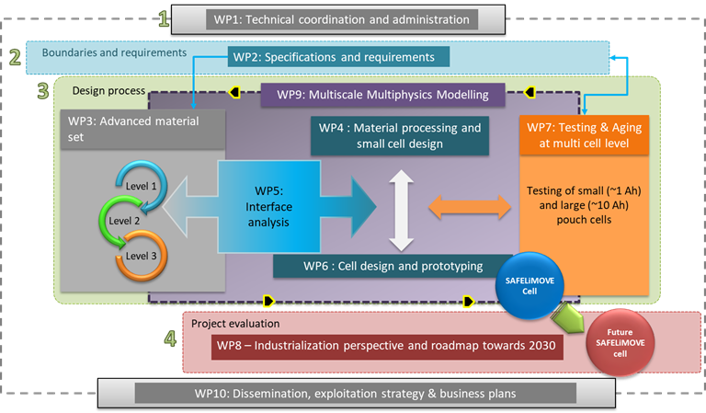

Figure Work package structure

### WP and task schedule, responsible partners, deliverables

In the Gantt chart and Work Breakdown structure on the next pages, the schedule of all WPs and the (sub)tasks they include is shown. For each WP and each task, the appointed WP/(sub)task leader (identified with an “L”) and involved partners (identified with an “P”) are identified. Next to this, deliverables and their timing have been identified.







Figure 2 Gantt Chart

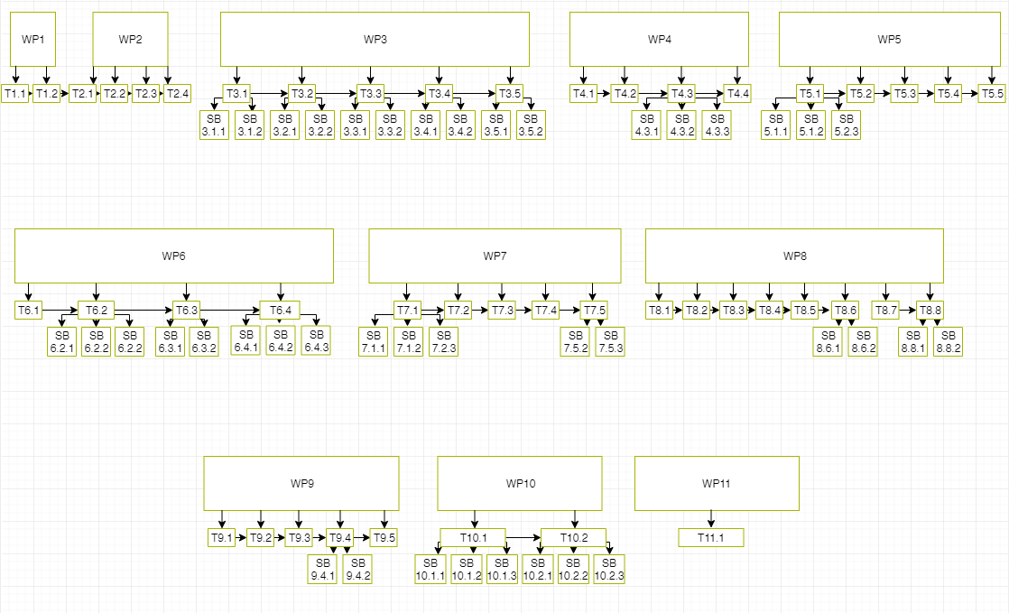

Figure Phase-based Work Breakdown Structure SAFELiMOVE

## Management and consortium bodies

### Management structure

The management structure of the SAFELiMOVE project is depicted in Figure 3 below.

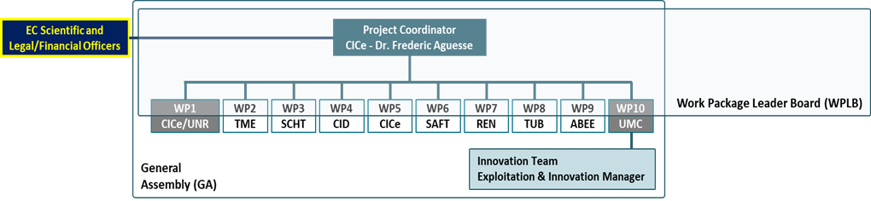

Figure Management Structure

### Project Coordinator

Frédéric Aguesse, Research Group Manager of the Cell and Electrochemical Testing group, has been appointed as designated Project Coordinator (PC). The PC will be supported by the Back-Office in administrative, operational and legal tasks of the project as well as the event management and internal communication. The coordinator is responsible for the overall project management, including coordination of the scientific and technical work plan, innovation management and preparative exploitation activities. Of course, all partners have their responsibility to perform the tasks they are assign to *in time, within budget, and to a high quality*.

The following tasks will be carried out by the Project Coordinator:

* Overall technical coordination of the scientific and technical work plan;
* Maintaining contact with the EC (project, legal and financial officers);
* Notifying the project officer of developments that may require amendments of the Grant Agreement;
* Providing overviews of the work progress to the EC (project officer);
* Final review and approval of deliverables submitted to the EC;
* Chairing General Assembly, Executive Board and Stakeholder Group meetings

The coordinator will be supported by the administrative manager (UNR). UNR will support the PC on the legal, contractual, ethical, financial and administrative management of the project acting as first point contact for all administrative and financial matters. Together CICe and UNR will:

* + Support the consortium and project coordinator in the daily management of the project;
  + Act as contact point for all partners and maintaining a high level of communication within the consortium;
  + Organising and documenting project meetings, like General Assembly, and Work Package Leaders Board;
  + Managing deliverables and administrative documents, e.g. financial plans, (progress) reports etc.;
  + Producing and updating overviews of consortium expenses and deviations and keeping track of finances;
  + Coordinate the preparation of the periodic management reports and the final report

For legal, administrative and technical issues the partners should contact the project management team before contacting the Project Officer. For legal & administrative issues contact Leire Olaeta (CICe) & Maaike van der Kamp (UNR), with in cc: Roos Leupen (UNR). For technical issues contact Frederic Aguesse (CICe) & Stephane Levasseur (UMC).

For administrative and financial issues the responsibilities have been divided between CICe and UNR as follows:

CICe is responsible for:

* Administration of the EU financial contribution and distribution thereof within the consortium;
* Management of the financial, organizational risks in the project

UNR is responsible for:

- Day to day contractual, administrative management and financial management;

- Set-up and maintenance of web-based tool (Mett®) for internal communication, documentation (archive);

- Monitoring of the project progress;

- Keep track of the costs and budget situation and create an early-warning system;

- Collection administrative documents and transmission to the Commission/Participant Portal

CICe and UNR are together responsible for:

* Monitoring of compliance by the beneficiaries under the Grant Agreement;

- Maintain the Grant and Consortium Agreement including the preparation of Amendments;

- Arranging the review of Deliverables to safeguard quality;

- Compilation of contractual periodic and final reports input provided by WP leaders;

- Set-up and maintenance of adequate communication with the Commission’s Project Officer(s) on the project’s progression and other relevant issues.

### General Assembly

The GA is the principal decision-making body of the project for all strategic, longterm and medium-term tactical decisions. It will be chaired by the PC and is composed of one representative of each partner. This nominated representative will have the authorization to discuss, negotiate and agree decisions or provide recommendations made by the organs within the frame of their responsibilities. The GA will exchange the work carried out in the different WPs in order to support the implementation and running of the project. The main objective of the GA is to advise and support the decisions of the PC on operational and management issues. Furthermore, the GA will be an effective and efficient communication hub. This board will be responsible for all decisions of general nature within the frame of the EC Contract and the Consortium Agreement. Each beneficiary will have one vote. More detailed voting mechanisms and the detailed responsibilities and tasks can be found in the Consortium Agreement. GA meetings will be convened every 6 months in face to face consortium meetings and whenever needed in audio conferences. The meetings will be organised by the PC.

### Work Package Leader Board (WPLB)

The WPLB is the supervisory body for the project execution at an operational level. It is composed by the Work Package Leaders and the PC and will support the PC on the technical management of the project. The WPLB meeting will take place monthly by telecon.

### Work Package Leaders

The day-to-day conduct of scientific work packages will be managed by the WP Leaders. WP Leaders will be in charge of leading technical progress in order to ensure WP goals are met on time and within budget restrictions and of reporting research progress to the WPLB. Their tasks include:

* + Maintaining monthly contact with the task leaders and coordination of activities within the work package;
  + Ensuring completion of work package activities and deliverables on time, within budget and of high quality;
  + (In)formal reporting on work package progress, quality and risk status to the coordinator and WPLB;
  + Reviewing and approval of all formal work package deliverables;
  + Managing of risks within the work package

The following beneficiaries and persons have been identified as WP Leader:

Table 1: Overview of WP leaders

|  |  |  |  |
| --- | --- | --- | --- |
| WP | WP Title | WP Leader | WP Leader  (Person) |
| WP1 | Technical coordination and administration | CICe | Frederic Aguesse |
| WP2 | Specifications and requirements | TME | Laurent Castro |
| WP3 | Advanced material set | SCHOTT AG | Andreas Roters |
| WP4 | Materials processing and small cell design | CIDETEC | Elisabetta Fedeli |
| WP5 | Interface analysis | CICe | Maria Martínez |
| WP6 | Cell design development and prototyping | SAFT | Erwan Dumont |
| WP7 | Testing and aging at multi-cell level | RENAULT SAS | Nathalie Delpuech |
| WP8 | Industrialization perspective and Roadmap towards 2030 | TUB | Robert Hahn |
| WP9 | Multiscale-Multiphysics modelling | ABEE | Noshin Omar |
| WP10 | Dissemination, exploitation strategy & business plans | UMICORE | Stephane Levasseur |
| WP11 | Ethics requirements | CICe | Leire Olaeta |

For **task leaders** a similar set of tasks as for work package leaders is valid, be it on a task level.

### Exploitation and Innovation Manager (EIM)

The EIM will be Dr. Stephane Levasseur from UMC. The EIM is responsible for defining the exploitation strategy to maximize the impact of the project together with partners:

- Identify innovative results that might become a new product, project and service or be the basis for further research projects.

- Identify key exploitable results and propose the best strategy to exploit them, including IP strategy, risk analysis and business plan.

- Perform market and technical surveillance to identify new market niches and trends to reinforce the impact of the project.

- Networking and collaboration with stakeholders, academia, research community, industry agents and policy makers.

### Innovation Team

The Innovation Team comprises the Exploitation and Innovation Manager and the support of the project participants as well as the PC and is chaired by the EIM. The purpose of the Innovation Team is to evaluate the project performance and to advise the GA with regard to potential market exploitation beyond project plans, to provide the GA with analyses of the market situation, especially with regard to changes, and to coordinate patents’ research as well as patent filing within the project. The Innovation Team meets every three months.

# Management plan

In this chapter all procedures and tools for general management of the project are addressed.

## External project monitoring

### Periodic reporting

This periodic report for the EC contains a technical report and a financial report.

The technical report should contain:

* Part A, structured tables from the online grant management system
  + Summary
  + Web-based tables covering issues related to the project implementation (e.g. work packages, deliverables, milestones, etc.)
  + Questionnaire about the economic and social impact
* Part B, free text, addressing:
* explanations of the work carried out by all beneficiaries during the reporting period
* an overview of the progress towards the project objectives, justifying the differences between work expected under Annex I and work actually performed, if any.

The financial report consists of structured forms from the online grant management system, including:

* individual financial statements (Annex 4 to the GA) for each beneficiary
* explanation of the use of resources and the information on subcontracting and in-kind contributions provided by third parties, from each beneficiary for the reporting period concerned
* periodic summary financial statement including the request for interim payment.

### Deliverables and milestones

The coordinator must submit the Deliverables identified in Annex 1 of the Grant Agreement, in accordance with the timing and conditions set out in it. More information about monitoring, preparation and submission of deliverables and milestones can be found in Chapter 4 – Quality Assurance.

## Internal project monitoring

GA meetings will be held on a regular basis to facilitate the progress monitoring. The consortium has established the following GA meeting calendar to supervise the progress of the activities:

Table 2 Project progress monitoring: tentative GA-meetings schedule

| Meetings | Month | date | Participants | (Proposed) location |
| --- | --- | --- | --- | --- |
| Kick off | 1 | Jan 2020 | All partners and EC officer (invited) | Vitoria-Gasteiz, Spain |
| GA #2 | 6 | June 2020 | Partner representatives and EC officer (invited) | Mainz, Germany |
| GA #3 | 13 | Jan 2021 | Partner representatives and EC officer (invited) | Paris, France |
| GA #4  & Review meeting | 18 (or later) | Sept 2021 (or later) | Partner representatives and EC officer | Brussels, Belgium |
| GA #5 | 24 | Jan 2022 | Partner representatives and EC officer (invited) | Aachen, Germany |
| GA #6 | 30 | June 2022 | Partner representatives and EC officer (invited) | Donostia-San Sebastian/Arrasate, Spain |
| GA #7  & Review meeting | 36 (or later) | Mar 2023 (or later) | Partner representatives and EC officer | Brussels, Belgium |
| GA #8 | 42 | Sep 2023 | Partner representatives and EC officer (invited) | Berlin, Germany |
| Final Event | 48 | Nov 2023 | Partner representatives and EC officer (invited) | Vitoria-Gasteiz, Spain |
| Final review meeting | 48 (or later) | Nov 2023 (or later) | Partner representatives and EC officer | Brussels, Belgium |

Every 6 months, all partners are requested to complete a short internal progress report. The partners will be asked to indicate any problem regarding meeting deadlines, completing the work as planned and budgets. The idea is to set up and maintain an ‘early-warning’ system (for possible technical and financial risks) via clear, simple and transparent procedures. Reporting will involve:

- Progress made in partner’s work for specific WPs, in comparison with DoA (deviations, corrective actions,…)

- Status of deliverables

- Status of milestones

- Financial report (via EU-fin, see following sub-sections): a simple overview (per WP) of the costs and PMs spent in the specific period, including short clarification. Deviation from Annex I with respect to the budget should also be reported.

Furthermore, each WP leader may be requested to provide a brief management report on the major achievements, (novel) risks and problems encountered (critical or not critical) of the WP.

When relevant or deemed necessary, the internal progress reports will be discussed during GA-meetings.

Next to this, the status of risks as identified in the risk management table (Table 1.3.5 of Annex 1 of the GA) will be reported, indicating whether properly addressed or whether actions are needed to be taken (see separate section on risk management); if necessary extra risks (unforeseen during the proposal preparation) will be added and monitored.

Furthermore, progress and activities towards the preparation of Deliverables will be monitored (more information about monitoring, preparation and submission of deliverables and milestones can be found in Chapter 4 – Quality Assurance).

Milestone tracking will be also be used to monitor the progress.

Specific management tools may be used to progress internal monitoring and reporting (more information in following sub-sections). UNR is setting up and preparing the necessary tools.

### Management tools

### Mett

The management tool [Mett](https://uniresearch.mett.nl/h2020+projects/safelimove/default.aspx) will be used as platform for the partners to exchange and archive documents.

Special pages are dedicated to the different documents of the project (deliverables, periodic reports, video and photos, contact list etc).

### EU-fin

This tool allows the coordinator to generate automatically cost reports comparing e.g. the actual expenses versus the budget per beneficiary, WP, activity, etc. Other functionalities are creating charts for comparing deliverables planned vs. actual, budget planned vs. actual, etc.

Below are just few examples of possible graphs and statistics which can be prepared, such as PMs spent per WP; budget spent in comparison with planned (also possible at WP level).

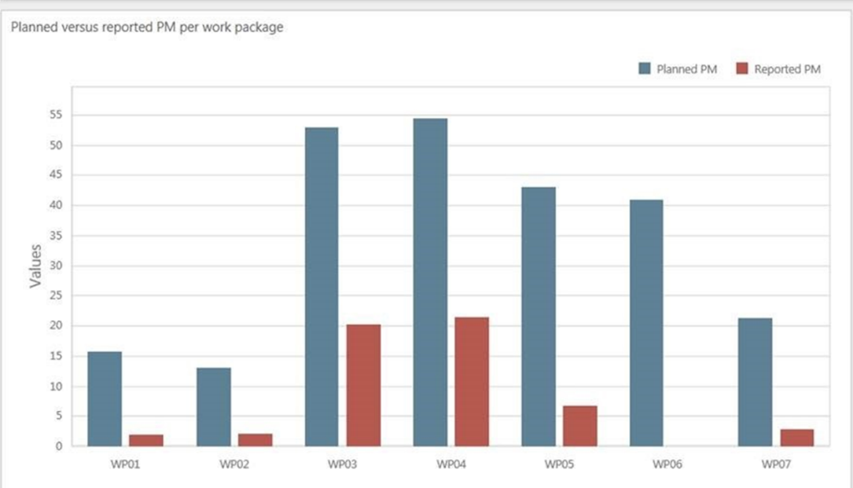

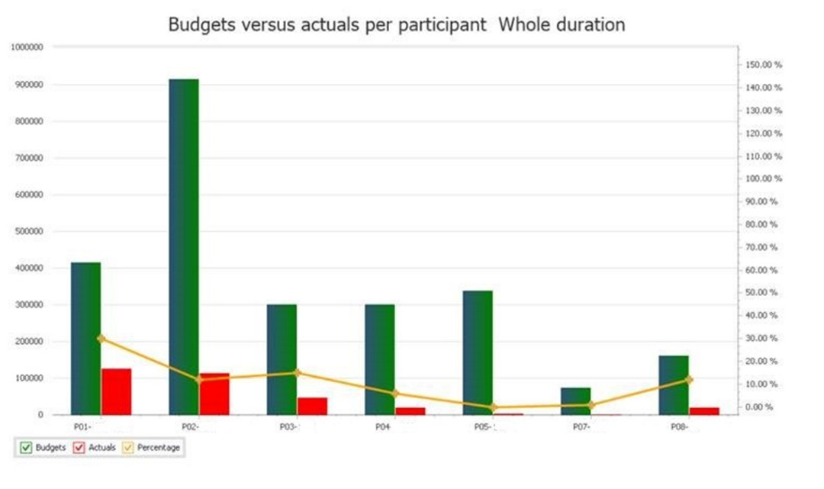

At the beginning of the project, a financial planning will be prepared (by UNR) in EU-Fin. In there the total project costs for each period will be divided among the different WPs (according to the budget file prepared during the proposal preparation) and categories.

Every 6 months the partners will be asked to report on project costs. This information will also be used to complete the official periodic reports (after M18, M36 and M48).

## Decision making

The project will be governed by the Grant Agreement signed with the European Commission and the Consortium Agreement (CA) signed among the partners, both before the project’s official launch. The CA, based on DESCA model, covers all the relevant issues necessary for the proper execution of the project such as the responsibilities (including Project Coordinator, GA, Exploitation and Innovation Manager and individual parties), liabilities, voting rules, joint-ownership, background knowledge, intellectual property rights, knowledge management, grant distribution, rules for publishing information, conflict resolution, admission of new partners, etc.

The voting rules and quorum for the GA are:

* The GA shall not deliberate and decide validly unless two-thirds (2/3) of its members are present or represented (quorum).
* Each member of the GA present or represented in the meeting shall have one vote.
* Decisions shall be taken by two-thirds (2/3) of the votes with exception of decisions concerning the entry of a new Party, any amendment to the Grant Agreement or the exclusion of a party in which cases the votes have to be unanimous.

## Change management

In this collaborative project, involving 15 partners, a shift in the 48 months’ planning or a change in the budget may happen. This is quite normal but these changes shouldn’t come as a surprise. Therefore, the project management team and the entire consortium are committed to maintain an open and transparent communication system.

### Changes in budget

Each partner is requested to:

* Report immediately, as soon as the possibility of a budget modification is considered, to the coordinator.
* Provide the financial report each 6 months and clearly report on the expenditures and financial planning.

The coordinator together with the project management team will evaluate the situation, propose scenarios and possible solutions, and inform accordingly the Project Officer for further discussion and alignment.

Below a list of the most common situations which may raise:

* Budget shift at partner level (only one partner involved, the total costs are not changing): some budget needs to be shifted from one WP to another or from one category to another (e.g. from travel to ‘other direct costs’) -> in principle no amendment to the Grant Agreement will be necessary, but this should be discussed with the Project Officer. Convincing justification should be provided.
* Budget shift between partners -> in principle no amendment to the Grant Agreement will be necessary, but this should be discussed with the Project Officer. Convincing justification should be provided.
* Changes in subcontracting/new subcontracting. An amendment to the Grant Agreement is probably necessary. Partners should inform the project management team as soon as possible and provide convincing justification. The project management team will contact the Project Officer.

### Changes in personnel or roles

A project contact list is available on Mett and maintained updated by UNR with inputs from all partners. Changes in personnel need to be communicated to the project management team (this project is dealing with confidential research information and in case someone leaves the team it is important to remove his/her access to the project document database).

Furthermore:

* Changes at GA and WPL/WPLB level need to be presented and discussed during the GA/WPLB-meetings.
* In case of change of the Coordinator an Amendment to the Grant Agreement will be necessary.

### Changes in technical content and timing

Each change related to the technical content and timing needs to be reported to the Project Officer (via the Project Coordinator).

Minor re-planning and re-alignment of the activities may be implemented but in case of changes in the scope/objectives of a specific WP an Amendment to the Grant Agreement will be necessary.

Partners are requested to immediately report possible changes to the WP Leader who will evaluate the situation and inform the management team.

# Risk management

As part of the overall management plan for the SAFELiMOVE project, this chapter describes the risk management plan. It identifies conditions that may put the project at risk and provides guidance for managing these. It also provides methods for and establishes roles and responsibilities of all participants in the risk management process.

## Risk Analysis

Since the probability of failure in research and innovation projects is considerable, risk factors in the SAFELiMOVE work plan should be analysed on a regular basis. Therefore, WP1 contains the Deliverables 1.2 and 1.3 that are dedicated to the Risk Management Plan. D1.2 will include a detailed risk management plan, with the identification of potential risks, their mitigation measures and procedures to foresee the risks and implement the mitigation measures before the risk materializes. D1.3 is the updated risk management plan that will be made to ensure the proper execution of the final tasks of the project and the consecution of the defined objectives.

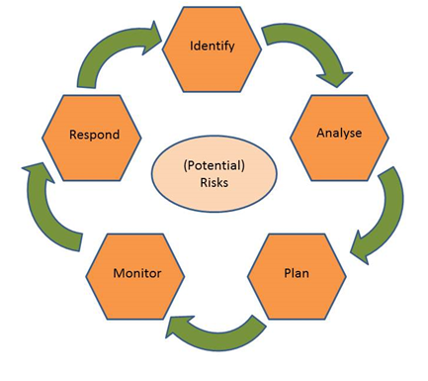Risks are approached according to the steps which together form the “circle” of risk management:

* Identify 🡪 In this step, risks are identified, with the moments at which they could occur and the specific symptoms of the risks.
* Analyse 🡪 Here, the risk is analysed further, looking also into the potential effects and consequences of the risk.
* Plan 🡪 In this step, plans are developed for management of the specific risk, as well as contingency plans.
* Monitor 🡪 The actual status of the risk is monitored, using e.g. the risk symptoms as identified in the first step.
* Respond 🡪 The specific risk management plan is put into action, when the monitoring step has shown the need for this. Actions are taken here to prevent the risk from happening full force or to avoid undesired consequences of the risk.

The risk management circle formed by these five steps will continuously be performed during the project.

## Critical risks and risk mitigation

In table 5, an overview is presented of the most important risks and potential mitigation strategies (as presented in section 1.3.5 of Annex 1). Other risks may materialise and will be reported during the internal and periodic project reporting moments, as described above.

Table 3 Identified risks and their mitigation measures

| Risk No. | Description of risk | WP Number | Proposed risk-mitigation measures |
| --- | --- | --- | --- |
| 1 | The final SAFELiMOVE cell (Cell Gen1) cannot fulfil the OEM requirements. | WP3, WP4, WP6, WP7 | Production steps will be initiated as early as possible and great attention will be given in phase-wise development |
| 2 | Materials scale-up does not reach the targeted levels of production | WP6 | Early considerations on required efforts in production upscaling to 10 kg range already during material development and derive changes. Decrease the upscaling target mass and preparation of smaller batches to supply to provide the required material amount. |
| 3 | LiM is unable to meet the fast charging requirement | WP3, WP4, WP6 | Change: the surface treatment, charging protocol. |
| 4 | Solid Electrolyte cannot fulfil the conductivity requirement | WP3 | Change ratio of ceramic in polymer and modify  the functionalities introduced into the polymer  structure in order to decrease the interface  resistance between the components and improve the lithium conduction path. |
| 5 | Solid electrolyte/electrode  interfacial resistance cannot meet the target | WP3, WP4, WP5, WP6 | Change in the processing method, application  of external pressure, screening of electrolyte  additives and use of electrode surface treatments or artificial SEI. |
| 6 | Solid electrolyte/electrode  contact not stable enough for long life cycle | WP3, WP4, WP5, WP6 | Identification of sensitive processing steps and  process adaption to optimum conditions. |
| 7 | Cell mass production  hampered due to difficulty in LiM handling | WP3, WP4, WP6 | Increase slightly the thickness of the Li anode. |
| 8 | Lack of time to evaluate the 10 Ah Pouch Cell | WP7 | Modelling projection will be performed to  estimate life based on available data. |
| 9 | Some input parameters for multiscale model are difficult to obtain | WP9 | Starting from educated guess, the output will  be fitted with experimental results for different  conditions providing better estimation. |
| 10 | Lack of 10 Ah Pouch Cells for building the demo module prototype in time | WP6, WP7 | Build and test “on-bench” demo module based on 1 Ah pouch cells. |
| 11 | Breach of IPR conditions as per Consortium Agreement | WP1, WP10, WP11,  WP2, WP3, WP4, WP5,  WP6, WP7, WP8, WP9 | The GA, as it will be stated in the Consortium  Agreement, will be the main body in charge of  monitoring and solving all the IPR aspects during  and after the project execution. |
| 12 | Infringe on existing patents | WP1, WP10, WP11,  WP2, WP3, WP4, WP5,  WP6, WP7, WP8, WP9 | EIM will scan the IP environment worldwide and  update the consortium in a timely manner. Risk of infringement could be avoided by adapting project development trajectory. |
| 13 | No clear IP esponsibility | WP1, WP10, WP11,  WP2, WP3, WP4, WP5,  WP6, WP7, WP8, WP9 | A clear management structure ensures that  all decisions are made following a consensus  approach. IP is one of the main aspects to be  considered by this management structure. |
| 14 | Dissemination of the project results is not sufficient to create impact | WP1, WP10, WP11,  WP2, WP3, WP4, WP5,  WP6, WP7, WP8, WP9 | The consortium is strongly determined to create  sustaining impact, and a dedicated work package under the lead of the EIM will plan and execute this. |
| 15 | Lack of communication or consensus | WP1, WP10, WP11,  WP2, WP3, WP4, WP5,  WP6, WP7, WP8, WP9 | Additional regular telephone conferences and  virtual meetings could be scheduled. |
| 16 | Low level of quality in  technical studies. Delays in milestones or deliverables. | WP1, WP10, WP11,  WP2, WP3, WP4, WP5,  WP6, WP7, WP8, WP9 | The WPLB will monitor continuously progress of  work in accordance to defined work plans every  six months, to mitigate this risk. |

## Role of the partners and the coordinator in risk management

The monitoring of risks, and the reporting of new, as yet unidentified risks, will be a task of everyone involved in SAFELiMOVE. The GA assesses the possible occurrence of the risks and decides on the mitigation measures or, when required, a modification of the work plan.

The roles and responsibilities in risk management are:

* Task leaders: will identify risks, develop mitigation strategies and contingency plans for their tasks and monitor risks. Report potential risk factors to their Work Package Leader.
* Work Package Leaders, consolidate risk and develop mitigation strategies and contingency plans on WP level. Report potential risk factors to the Project Coordinator and other WPLs.
* Project Coordinator, responsible for the risk management of the whole project. Identifies risk, develops mitigation strategies and contingency plans, monitors risk and reports risk status in the periodic progress reports to the EU, including planned contingency measures.

.

# Quality Assurance

## Quality assurance procedure for deliverables

The term “Deliverables” refers to the formal SAFELiMOVE Project Deliverables as described in the Grant Agreement No. 875189. An overview of all formal SAFELiMOVE deliverables is presented in Table 5. To ensure their quality all SAFELiMOVE deliverables will be reviewed internally before submission.

All technical deliverables should have:

* Public executive summary (1-2 pages)
* Core part of approx. 10-15 pages (depending on the kind of report): real content on the technical developments, with clear description what work was done, results and a discussion why certain decisions were taken, based on the provided technical information
* Risk table (if applicable) with real risks and an elaboration on the risks
* Conclusions and recommendations for future work

The authors should use the deliverable template as provided on Mett.

### General review procedure

The review procedure has the following timelines and steps to submit the deliverable in time:

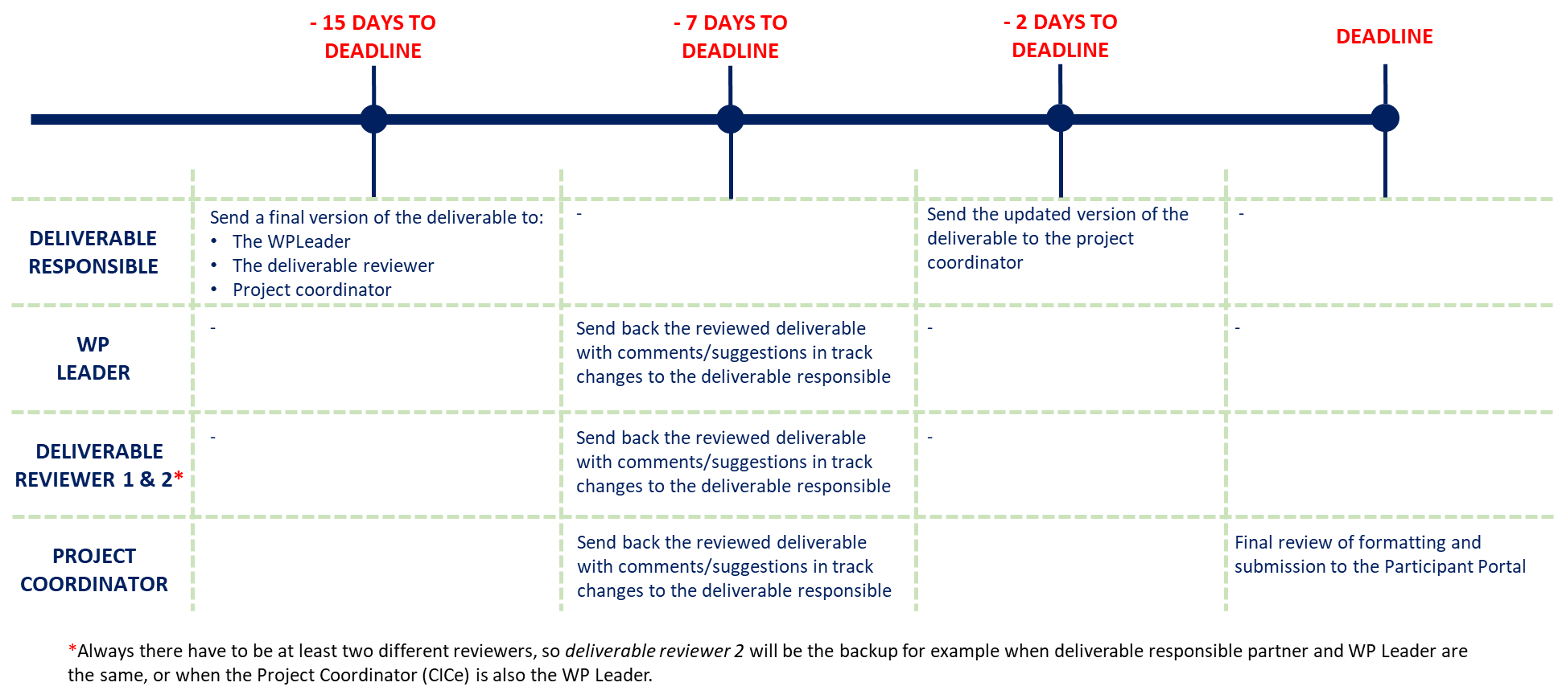

Figure 5 Overview of deliverable review process

All deliverables should show to have followed the procedure above by indicating in the deliverable itself the persons that have performed the quality review.

Each reviewer uses the standard review form (shown in Annex A of this document) to document his/her review findings. After reviewing, the reviewer sends his/her comments to the authors of the deliverable. The author(s) revises the deliverable according to the review result within a maximum of five days after receiving the request for quality improvement.

The Project Coordinator ensures that requested improvements are implemented by the author(s) and performs the final review. Once the deliverable is approved by the Project Coordinator, the Project Coordinator then submits the deliverable to the Commission in electronic form (PDF) via the SyGMa portal. The project management team stores the submitted deliverables on Mett (section Documents / SUBMITTED DELIVERABLES / Dx.x /).

Table 5 shows a list of the deliverables and proposed reviewers.

|  |
| --- |
| Table 5 Proposed reviewers for deliverables |

## Milestones

WP Leaders are responsible for the achievement of WP related milestones. WP Leaders report to the GA if they think a milestone has been achieved and the means of verification as reported in SyGMa should be met. It will then be discussed, after which the management team can report to the Commission (including short info to describe the achievement and date). The table below shows the milestones.

Table 6 List of milestones

|  |  |  |  |  |
| --- | --- | --- | --- | --- |
| MS | MS title | WP number | Lead beneficiary | Due date (month) |
| MS1 | Level 1 materials are selected for further processing and characterization | WP3, WP4 | SCHOTT | M7 |
| MS2 | Fabrication of coin cell with Level 1 material and delivery for testing | WP4 | CIDETEC | M12 |
| MS3 | Level 2 materials are developed based on the characterization of WP3 and WP5, the processing feedback in WP4 and WP6 | WP3, WP4, WP5, WP6 | SCHOTT | M22 |
| MS4 | 15-20: 1 Ah GEN1 pouch cells with Level 2 material assembled and delivered for testing | WP4, WP5, WP7 | CIDETEC | M30 |
| MS5 | Electrochemical model of all solid-state LiM battery | WP9 | ABEE | M32 |
| MS6 | Level 3 materials are developed based on the characterization, modelling, processing and performance feedback of the other WPs | WP3, WP4, WP5, WP6, WP9 | CICE | M38 |
| MS7 | 15-20:1 Ah GEN2 pouch cells with level 3 material with detailed understanding of the behaviour and needs for stable operation of solid-solid interfaces assembled and delivered for testing | WP4, WP5, WP7 | CIDETEC | M40 |
| MS8 | 20-25 units of 10 Ah GEN1 prototypes available for testing | WP6 | SAFT | M42 |
| MS9 | 24 V and 10 Ah battery demo module demonstrator | WP6, WP7 | IKERLAN | M48 |

# Communication

Internal communication will be stimulated as much as possible by the management team and the GA members. Frequent teleconferences and meetings will be organised among partners.

## Acknowledgement of EU funding

*From Article 29.4 of the GA:*

Unless the Agency requests or agrees otherwise or unless it is impossible, any dissemination of results (in any form, including electronic) must:

(a) display the EU emblem and

(b) include the following text: “This project has received funding from the European Union’s Horizon 2020 research and innovation programme under grant agreement No 875189”.

When displayed together with another logo, the EU emblem must have appropriate prominence. For the purposes of their obligations under this Article, the beneficiaries may use the EU emblem without first obtaining approval from the Agency.

*From Article 29.5 of the GA:*

Any dissemination of results must indicate that it reflects only the author's view and that the Agency is not responsible for any use that may be made of the information it contains.

## Early information of planned dissemination

*From Article 8.4.2.1 of the CA:*

Prior notice of any planned publication shall be given to the other Parties at least 45 calendar days before the publication. Any objection to the planned publication shall be made in accordance with the Grant Agreement in writing to the Coordinator and to the Party or Parties proposing the dissemination within 30 calendar days after receipt of the notice. If no objection is made within the time limit stated above, the publication is permitted.

~~Please note: Any dissemination activities outside the EU should be first approved by the EC. If any of the partners is planning on doing a dissemination activity outside the EU it should be first communicated to the PC. The PC will contact the PO to get the approval.~~

## Internal communication

Some simple rules for internal emails:

* Start your message subject with: SAFELiMOVE
* Use e-mail in a good way: do not overuse/spam
* Use Mett for sharing large documents
* Make clear what you expect from others (detail, timing, how to receive)
* Confidentiality: mark your messages if the info is confidential

Contact list:

* Contact list is responsibility of UNR
* Partners to make sure the correct info is at UNR
* List can be found on Mett

# Acknowledgement

The author(s) would like to thank the partners in the project for their valuable comments on previous drafts and for performing the review.

**Project partners:**

|  |  |  |
| --- | --- | --- |
| # | Partner | Partner Full Name |
| 1 | CICe | CENTRO DE INVESTIGACION COOPERATIVA DE ENERGIAS ALTERNATIVAS FUNDACION, CIC ENERGIGUNE FUNDAZIOA |
| 2 | SCHOTT | SCHOTT AG |
| 3 | UMICORE | UMICORE |
| 4 | HYDRO-QUEBEC | HYDRO-QUEBEC |
| 5 | SAFT | SAFT |
| 6 | RENAULT SAS | RENAULT SAS |
| 7 | TME | TOYOTA MOTOR EUROPE NV |
| 8 | IKERLAN | IKERLAN S. COOP |
| 9 | CEA | COMMISSARIAT A L ENERGIE ATOMIQUE ET AUX ENERGIES ALTERNATIVES |
| 10 | CIDETEC | FUNDACION CIDETEC |
| 11 | TUB | TECHNISCHE UNIVERSITAT BERLIN |
| 12 | RWTH AACHEN | RHEINISCH-WESTFAELISCHE, TECHNISCHE HOCHSCHULE AACHEN |
| 13 | ABEE | AVESTA BATTERY & ENERGY ENGINEERING |
| 14 | LCE Srl | LIFE CYCLE ENGINEERING SRL |
| 15 | UNIRESEARCH BV | UNIRESEARCH BV |

|  |  |
| --- | --- |
| http://elastic.studioh2o.nl/image.php/userdata/image/ec_1.gif?width=150&height=150&image=/userdata/image/ec_1.gif | *This project has received funding from the European Union’s Horizon 2020 research and innovation programme under Grant Agreement no. 875189* |

# Annex A – Quality Assurance review form

The following questions should be answered by all reviewers (WP Leader, reviewer 1, reviewer 2 and the project coordinator) as part of the Quality Assurance procedure. Questions answered with NO should be motivated. The author will then make an updated version of the deliverable. When all reviewers have answered all questions with YES, only then the deliverable can be submitted to the EC.

NOTE: For public documents this Quality Assurance part will be removed before publication.

|  |  |  |  |  |
| --- | --- | --- | --- | --- |
| Question | WP Leader | Peer reviewer 1 | Peer reviewer 2 | Technical Coordinator |
|  | NAME | NAME | NAME | NAME |
| 1. Do you accept this deliverable as it is? | Yes / No (motivate) | Yes / No (motivate) | Yes / No (motivate) | Yes / No (motivate) |
| 1. Is the deliverable completely ready (or are any changes required)? | Yes / No (motivate) | Yes / No (motivate) | Yes / No (motivate) | Yes / No (motivate) |
| 1. Does this deliverable correspond to the DoW? | Yes / No (motivate) | Yes / No (motivate) | Yes / No (motivate) | Yes / No (motivate) |
| 1. Is the Deliverable in line with the SAFELiMOVE objectives? | Yes / No (motivate) | Yes / No (motivate) | Yes / No (motivate) | Yes / No (motivate) |
| 1. WP Objectives? | Yes / No (motivate) | Yes / No (motivate) | Yes / No (motivate) | Yes / No (motivate) |
| 1. Task Objectives? | Yes / No (motivate) | Yes / No (motivate) | Yes / No (motivate) | Yes / No (motivate) |
| 1. Is the technical quality sufficient? | Yes / No (motivate) | Yes / No (motivate) | Yes / No (motivate) | Yes / No (motivate) |