EUROPEAN COMMISSION – FCH JU

HORIZON 2020 PROGRAMME - TOPIC H2020-FCH-02-4-2019

New Anion Exchange Membrane Electrolysers

GRANT AGREEMENT No. 875024

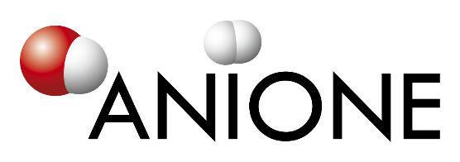

Anion Exchange Membrane Electrolysis for Renewable Hydrogen Production on a Wide-Scale

ANIONE – Deliverable Report

D7.3 – Dissemination Plan & Knowledge Management Protocol – 1st draft

|  |  |  |
| --- | --- | --- |
| **Deliverable No.** | ANIONE D7.3 |  |
| **Related WP** | WP7 |  |
| **Deliverable Title** | Dissemination Plan & Knowledge Management Protocol |  |
| **Deliverable Date** | 30-06-2021 |  |
| **Deliverable Type** | REPORT |  |
| **Dissemination level** | Confidential – consortium members only (CO) |  |
| **Lead Beneficiary** | UNR |  |
| **Author(s)** | Eva Bøgelund (UNR) | 08-06-2020 |
| **Checked by** | Anne Molinari (UNR) | 16-06-2020 |
| **Reviewed by** | Consortium partners |  |
| **Approved by** | Antonino Aricò (CNR-ITAE) - Project Coordinator | xx-xx-2020 |
| **Status** | Draft 1.0 | 08-06-2020 |

Disclaimer/ Acknowledgment

Copyright ©, all rights reserved. This document or any part thereof may not be made public or disclosed, copied or otherwise reproduced or used in any form or by any means, without prior permission in writing from the ANIONE Consortium. Neither the ANIONE Consortium nor any of its members, their officers, employees or agents shall be liable or responsible, in negligence or otherwise, for any loss, damage or expense whatever sustained by any person as a result of the use, in any manner or form, of any knowledge, information or data contained in this document, or due to any inaccuracy, omission or error therein contained.

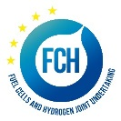

All Intellectual Property Rights, know-how and information provided by and/or arising from this document, such as designs, documentation, as well as preparatory material in that regard, is and shall remain the exclusive property of the ANIONE Consortium and any of its members or its licensors. Nothing contained in this document shall give, or shall be construed as giving, any right, title, ownership, interest, license or any other right in or to any IP, know-how and information.

This project has received funding from the Fuel Cells and Hydrogen 2 Joint Undertaking (JU) under grant agreement No 875024. This Joint Undertaking receives support from the European Union’s Horizon 2020 research and innovation programme, Hydrogen Europe and Hydrogen Europe research. The information and views set out in this publication does not necessarily reflect the official opinion of the European Commission. Neither the European Union institutions and bodies nor any person acting on their behalf, may be held responsible for the use which may be made of the information contained therein.

**Publishable summary**

Deliverable D7.3 concerns the Dissemination Plan and Knowledge Management protocol for the ANIONE project. The Dissemination Plan describes the implementation strategy of the dissemination of the ANIONE project and aims to maximise the impact of the project results. The Dissemination Plan also describes the target audience and means to reach this audience in the most efficient way possible. The Knowledge Management protocol for the ANIONE project ensures that all newly created Intellectual Property (IP) is identified and that measures to protect it are taken if needed.

Contents

1 Introduction 4

1.1 Project Objectives 4

1.2 Dissemination Objectives 4

1.3 Dissemination versus Exploitation 5

1.4 Aim of the Dissemination Plan 5

2 Dissemination Strategy and Tools 6

2.1 Tools for Dissemination 6

2.1.1 Project Visual Identity and Logo 7

2.1.2 Templates 7

2.1.3 Website 7

2.1.4 Newsletter 8

2.2 Dissemination Database 8

2.3 Dissemination Activity Tracker 9

3 Dissemination Goals, Target Audiences, and Communication Channels 10

3.1 Dissemination to Internal Stakeholders 10

3.2 Dissemination to the Scientific Community 11

3.2.1 Goals 11

3.2.2 Channels 11

3.3 Dissemination to External Stakeholders 12

3.3.1 Goals 12

3.3.2 Channels 12

3.4 Dissemination to the General Public 13

3.5 Dissemination to Stimulate Exploitation 13

3.6 Feedback to the European Commission and FCH-JU 13

4 Roles and Rules for Dissemination 14

4.1 Roles of Partners in Dissemination Activities 14

4.1.1 Role of the Dissemination WP Leader 14

4.1.2 Role of the Exploitation Manager 14

4.1.3 Role of the Project Partners 15

4.2 Rules for Dissemination 15

4.3 Review of Deliverable Reports 16

4.4 Review of External Publications 17

5 Knowledge Management Protocol 18

5.1.1 Identification of Created IP 18

5.1.2 IP Ownership 19

5.1.3 Transfer of Results 19

6 Risk Register 20

Acknowledgement 21

Appendix A – Quality Assurance 22

**Table of Figures**

Figure 2‑1 ANIONE Logo 7

Figure 2‑2 ANIONE Website 8

Figure 2‑3 Overview of ANIONE Website activity from Jan 2020 (Project start) to June 2020 (now) 9

Figure 3‑1 Overview of dissemination and exploitation activities 10

**Tables**

Table 2‑1 Overview and quantification of general ANIONE Dissemination Activities 6

Table 4‑1 Examples of documents that must be reviewed and approved before submission or sharing outside of the project Consortium 16

# Introduction

Deliverable D7.3 – Dissemination Plan & Knowledge Management Protocol, concerns the Dissemination Plan and Knowledge Management protocol for the ANIONE project. The document is the third deliverable of Work Package 7 – Dissemination, Communication and Exploitation. The main objectives of WP7 are to ensure that the ANIONE project activities and results are promoted to relevant target groups (stakeholders, end-users, interest groups, industries, and suppliers) and to raise awareness of ongoing research and developments in the field of hydrogen technology.

Specifically, D7.3 will identify target audiences, optimised communication channels to reach these, and outline the timing of dissemination activities during the ANIONE project lifetime. The exploitation of project results beyond the lifetime of the project will be described in detail in D7.5 – Exploitation Plan of Project Results (expected in M36) and will only be briefly discussed in this document.

In addition, D7.3 will set up a protocol for Knowledge Management to ensure that project results and newly created or identified Intellectual Property Rights (IPR) are protected (if needed).

The first plans for dissemination of the ANIONE project are outlined in the DoA (Annex 1 to the grant Agreement). This plan will be expanded and updated continuously throughout the project lifetime and will be evaluated and discussed at every Steering Committee meeting (approximately every 6 months). This Dissemination Plan should therefore be seen as a living document.

## Project Objectives

The overall objective of the ANIONE project is to develop technology for high-performance, cost-effective, and durable anion exchange membrane water electrolysis. This technology will be developed from TRL 2 (basic technology research) to TRL 4 (component validation) during the lifetime of the project. With its technology the ANIONE project aims to contribute to the roadmap addressing the achievement of a wide scale, decentralised hydrogen production infrastructure with the long-term goal to reach net zero CO2 emissions in EU by 2050.

## Dissemination Objectives

Overall, the aim of the dissemination activities in the ANIONE project is to ensure the highest visibility of the project activities and maximise the potential impact of the project results by promoting them to stakeholders, policy makers, suppliers, and potential end-users to accelerate the implementation of the research findings. In addition, dissemination of the project results and findings to the scientific community and other experts in the field of hydrogen fuel cells will be achieved through presentations at workshops and conferences and through scientific journal publications. It is also the ambition of the ANIONE project to disseminate results to non-specialist members of the public with the goal to promote public interest, understanding, and engagement in new research and technology developments in the EU. Specifically, the ANIONE dissemination objectives are:

To communicate project results to stakeholders, policy makers, industry, and suppliers to accelerate the exploitation of the research findings.

* To present project results at international conferences, and in dedicated workshops, trade fairs, through scientific publications, newsletters, flyers, and via a dedicated project website.
* To develop appropriate channels for communication of project activities and results to a non-specialist audience, e.g., contribute to public understanding of scientific research and technological development in Europe in the field of hydrogen by publishing informative articles in science divulgation journals and participating to interviews.
* To facilitate technology transfer and accelerate the exploitation of the on-going research activities.
* To achieve an optimum knowledge management including appropriate handling of IPR's through a project Knowledge Management and Dissemination protocol (this document).
* Organise a focused workshop to disseminate project results and encourage future collaboration needed to capitalize the project's results and to further increase the technology readiness level.

## Dissemination versus Exploitation

In its brochure “Making the Most of Your H2020 Project”*[1]*, the European IPR Helpdesk defines Dissemination as the public disclosure of the results of the project by any appropriate means and in any medium. The objective of dissemination is defined as the transfer of knowledge with the aim to enable others to use the results in their own work. On the other hand, Exploitation is defined as the utilisation of results in further research activities or developments other than those covered by the project. The objective of Exploitation is the effective use of project results for commercial purposes such as creating and marketing a product or process but also for improving policies for example via standardisation activities, and for tackling economic and societal problems.

The major difference between Dissemination and Exploitation is that some dissemination activities are carried out during the project lifetime while exploitation activities mainly take place at the end and after the completion of the project once project results have been obtained. However, if potentially exploitable project results are obtained before the end of the project, activities to exploit these can begin earlier.

## Aim of the Dissemination Plan

The aim of the Dissemination Plan is to define a comprehensive communication strategy for the ANIONE project that describes the targeted audiences (scientific community and network, stakeholders, end-users, general public) and how these audiences will be reached. It also outlines the overall timing of dissemination activities throughout and after the project lifetime. The Dissemination Plan emphasises the dissemination of tangible results and the importance of tailoring the communication of these to the various audience groups for maximal impact. The Plan follows the Commission Guidelines for Communicating EU Research[2]. In addition, the Dissemination Plan will describe the procedure for dissemination as agreed in the Consortium Agreement and define a protocol for Knowledge Management.

# Dissemination Strategy and Tools

Because the ANIONE project is funded by public EU money, it is important to report to the citizens of the EU on how their money is spent. In general, it is appropriate to ensure that the project results and findings benefit the EU as a whole (for example by paving the way to exploitation of the project results towards European leadership in Hydrogen and Fuel cell industry). This includes making the project results known to the widest possible groups of potential users and generally maximising the impact of the work carried out in the project as much as possible.

The timing of the dissemination activities is crucial for an effective communication of the project results. The Work Package Leader (UNR) and the Project Coordinator (CNR-ITAE) will therefore monitor the timeline of the planned project tasks and activities in order to optimise the timing of dissemination activities. Table 2‑1 presents an overview of the general ANIONE dissemination activities.

Table 2‑1 Overview and quantification of general ANIONE Dissemination Activities

|  |  |  |
| --- | --- | --- |
| **Target** | **Media/activities** | **Objectives** |
| **Dissemination** | | |
| **Scientific community** | - Journal publications (>10)  - Conference presentations (>10)  - Conference organisation (≥1)  - Website, Brochure  - Newsletters (≥6, half yearly) | - Communication on the project advances and potential output  - Clustering with interested **research teams and industries** for future collaboration  - Clustering with related FCH2 JU funded projects to mutually add value |
| **Dissemination & Communication** | | |
| **Industry, policy makers, Public bodies** | - Meetings & exhibitions (≥3)  - Press releases (≥3)  - Final workshop (1) | - Communication about specific ANIONE advances  - Investigation of future/potential **exploitation opportunities** |
| **Communication** | | |
| **General Public** | - Website  - Brochure  - Press releases  - Social networks | − Communication on latest science and technology achievements  − Raise public awareness on ANIONE goals and objectives with regard to EU policy for energy and transport applications from the perspective of meeting Europe’s energy, environmental and economic challenges (**societal impact**) |
| **Partners** | -   Project Shared Workspace | -   Facilitate and improve **communication** efficiency **internally** |

## Tools for Dissemination

Several dissemination tools have been developed for the ANIONE project. These include the project visual identity, including the project logo, the project public website ([www.anione.eu](http://www.anione.eu)), and a number of project templates (posters, flyers, presentations, (e-)newsletters, deliverables, milestones). The work with these tools has already started and is reported in deliverables D71. – Project Visual Identity and D7.2 – Project Website and Dissemination Database. The following sections will serve as a brief overview of the ANIONE dissemination tools.

### Project Visual Identity and Logo

A graphical project identity composed of multiple visual elements that aim to represent the project has been designed for ANIONE. The graphical identity includes the project logo, fonts, and colours. These elements will be incorporated in the design of all dissemination material related to the project. The visual identity sets the mood of the project website, the project newsletters, and any future project dissemination material. The main purpose of the visual identity is to provide the project with consistent and easily recognisable dissemination material. The ANIONE logo and colour scheme are presented in Figure 2‑1.

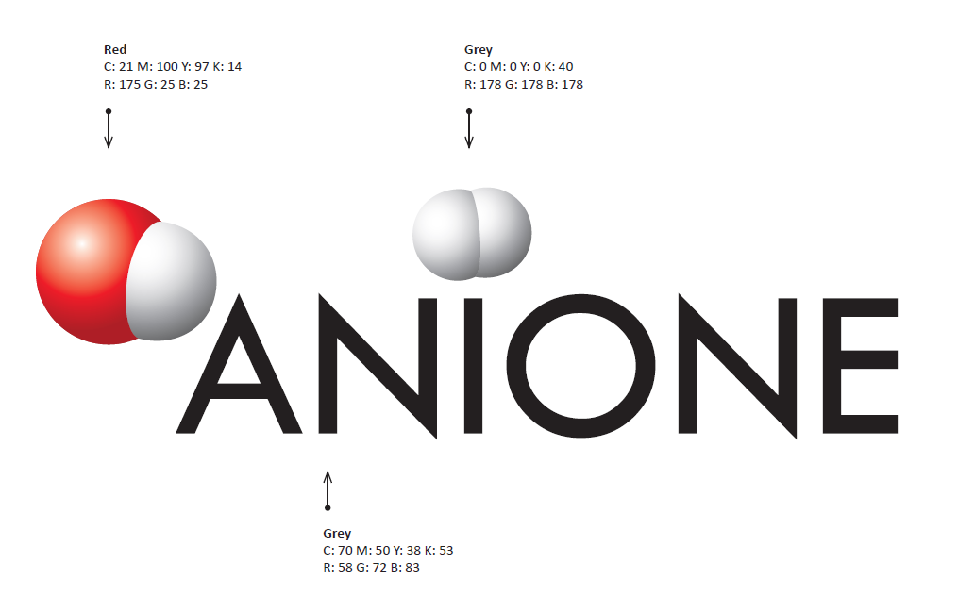

Figure 2‑1 ANIONE Logo

### Templates

Standard templates for the dissemination of ANIONE project results have been designed for presentations and posters (PowerPoint file) and Deliverable and Milestone reports (Word file). These templates include the project logo and project colour scheme and are available for download by all project partners via [Mett](https://uniresearch.mett.nl/h2020+projects/anione/anione+-+documents/7+templates++manuals+-+anione/default.aspx#folder=1545348) (an online platform for sharing documents, restricted to project parnters). To ensure that ANIONE project results are presented in a consistent way, project partners are encouraged to always use the project templates when dissemination project results both internally and externally. If needed, addition templates for specific dissemination activities will be develop as the project evolves.

### Website

The ANIONE project website is the first point of contact for third parties interested in the project and its activities. It is designed to provide an easily accessible overview of the project objectives, concepts, and Consortium partners. Visitors can navigate the website through the menu bar at the top of the page. Newsletters and technical project publications will be posted on the website together with links to EC documents. The website also features a calendar of previous and upcoming events related to the ANIONE project such as Consortium meetings, conferences, and workshops were ANIONE project partners will be present or ANIONE project results will be presented. The texts on the project website are updated regularly (with an expected average of at least 10 updates per year).

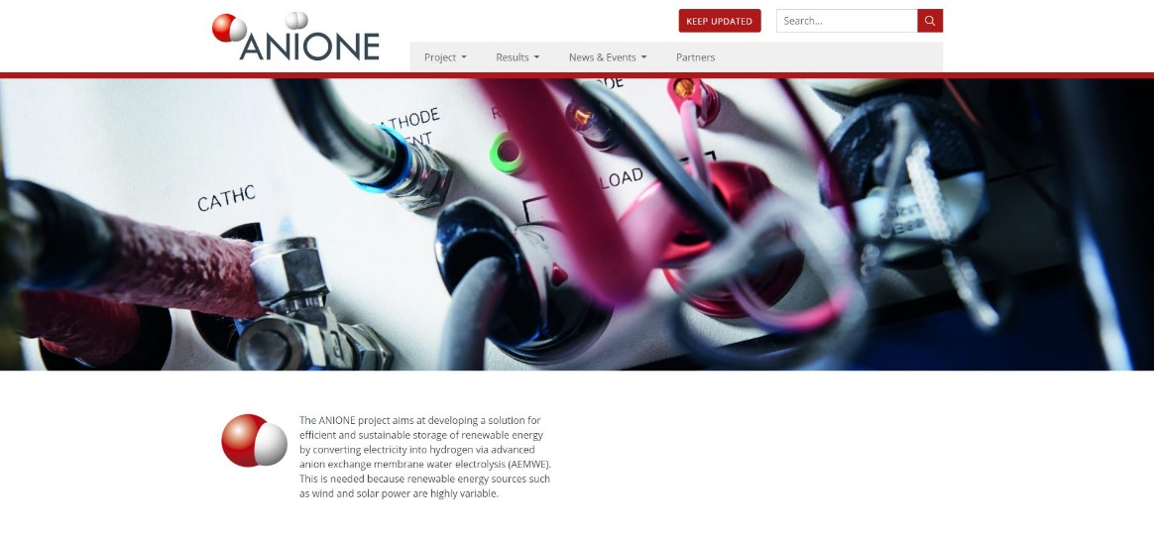

Figure 2‑2 ANIONE Website

### Newsletter

Newsletters reporting on ongoing and archived project results and activities will be published at least once a year throughout the project lifetime. Newsletters will be distributed to the contacts registered in the Dissemination Database (see section 2.2). The newsletters aim to communicate about the project to a wide audience and will therefore be written in general, non-scientific terms. For exports and especially interested parties, the newsletters will provide links to technical reports where possible (i.e., if not concerning confidential or otherwise protected information).

## Dissemination Database

Project partner UNR will collect contact details of stakeholders and other interested parties in a “Dissemination Database” (see D7.2, Section 3). E-newsletters with project updates will be sent to these addresses. The database is available on Mett for all partners. Project partners providing contact information for the Dissemination Database are responsible for ensuring that these contacts are correct and that contacts have agreed to receive information about the ANIONE project. In addition, interested parties can [sign up](https://anione.eu/subscribe-newsletter/) for the ANIONE newsletter via the project website. The information stored in the Dissemination Database is divided into the following categories:

|  |  |  |
| --- | --- | --- |
| Connection to ANIONE | Focus of organisation / Main Activity | Type of organisation |
| Participant | Research | Type of organisation |
| Stakeholder | Commercial company | Research institute |
| EU | Policy maker | University |
| Affiliated entity/company | NGO | NGO |
| Client | Governmental | Public entity/Local Authority |
|  | Lobby group | Supplier company |
|  | Municipality | Energy Company |
|  | Legislation/Standardisation | EU commission |
|  |  | EU country |
|  |  | EU project |
|  |  | Transmission System Operator |
|  |  | Standardisation committees |

## Dissemination Activity Tracker

A complete overview of dissemination activities relating to the ANIONE project will be kept by UNR. This document will be updated throughout the project lifetime and will be used as the basis for reporting in the EC system. All dissemination activities will be categorised according to the following types of activities:

* General dissemination activity
* Publication (scientific, general)
* IP Rights and Results (patents)
* Exploitable foreground

Partners will be invited to report on planned and achieved dissemination activities to the WP7 Leader (UNR) and Project Coordinator on a regular basis. In addition, partners will be requested to report on planned and achieved dissemination activities every 6 months as part of the internal project progress monitoring. In addition to tracking dissemination activities, the Dissemination Activity Tracker will also track the number of visitors to the project website. An overview of the website activity for the first 6 months of the project is given in Figure 2‑3.

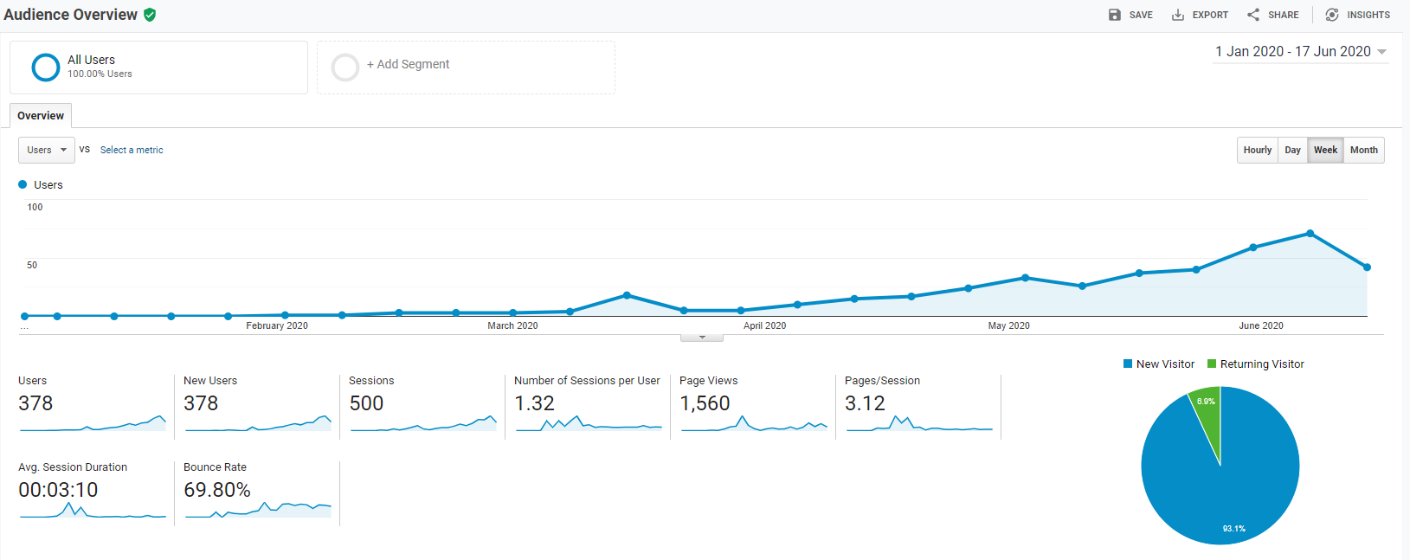

Figure 2‑3 Overview of ANIONE Website activity from Jan 2020 (Project start) to June 2020 (now)

# Dissemination Goals, Target Audiences, and Communication Channels

The following paragraphs describe the internal and external dissemination target audiences, together with the channels that will be used to reach them. If more target audiences are identified during the project, they will be included in the communication strategy and future updates to this document. Figure 3‑1 presents an overview of the dissemination and exploitation activities for the project. In the subsections below, the dissemination activities, target audiences, and communication channels will be discussed further.

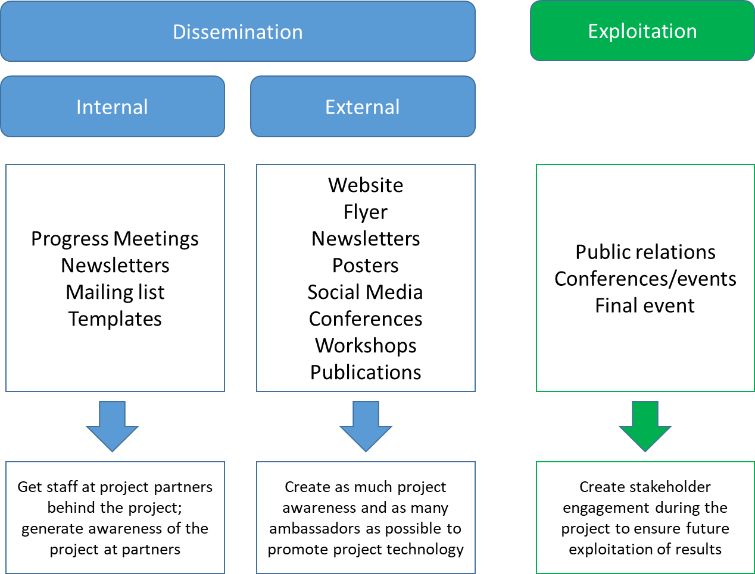

Figure 3‑1 Overview of dissemination and exploitation activities

## Dissemination to Internal Stakeholders

The internal stakeholders are the project Consortium partners. Project information is shared and exchanged between the project partners via regular WP and task progress meetings and half-yearly Steering Committee (SC) meetings. The **goal** of the communication is to ensure that the project is progressing smoothly, meets its targets in terms of timelines and achievements, and that all project activities are documented properly. The main **channel** for communication to the internal stakeholders is Mett where partners can access and share information.

In general, SC meetings will be face-to-face meetings while WP meetings will be mostly conducted via teleconference. For SC meetings where travels are required and costs are made, each project partner is responsible for keeping their records related to this travel. After each SC meeting, the meeting agenda, meeting minutes, and meeting list of participants will be uploaded to Mett.

In addition, the ANIONE project will participate in the **Hydrogen Mission Innovation Challenge** (IC8 - Renewable and Clean Hydrogen) with the purpose of facilitating international collaborations and interaction between related projects. Consortium partners HYE and IRD will engage their sister companies based in Canada and the US to promote links with similar projects carried out in North America. This will add a global dimension to the dissemination of the ANIONE project results. The purpose of the IC8 interaction is to ensure that relevant innovations from North America will be brought into the ANIONE project. At the same time, the exploitation of the ANIONE project results internationally will be facilitated. The experts from the US and Canada will be invited to participate in web meetings with the project Consortium with the purpose of strengthening the international cooperation.

## Dissemination to the Scientific Community

Dissemination of the ANIONE project results to the scientific (research and academic) community will primary be carried out by the project research partners (CNR-ITAE, CNRS, PV3, IRD, HYE). The ANIONE project is a scientific research action that will advance its technology from TRL 2 to TRL 4. The work carried out in the project will allow for significant progress in the field of efficient and sustainable anion exchange membrane water electrolysis (AEMWE) technology. Through the ANIONE project, the project research partners have the opportunity to showcase their recent technology development and share their scientific studies with the broader hydrogen technology community. Visibility of the partners in ANIONE project may also encourage new master and PhD students to join the field of fuel cells technology.

### Goals

The main goal for dissemination of project results to the scientific community is to inform on the advances made in the framework of the ANIONE project in field of AEMWE technology. In addition, this communication is intended to attract the interest of research teams and industries in the field to explore the potential for future collaborations. Also, clustering activities with related FCH2 JU funded projects will be investigated for mutually added value. In this respect, a collaboration with the CHANNEL and NEWELY projects has been established to define common testing protocols.

### Channels

The channels for dissemination of ANIONE project results aimed at the scientific community include, but are not limited to, the following:

* Publications on advances and results in (inter)nationally renowned peer-reviewed scientific journals via (Open Access) scientific articles,
* Presentations of project results at (inter)national conferences e.g. International Society of Electrochemistry (ISE), Electrochemical Society meetings (ECS), FCH 2 JU Programme Review Days, World Hydrogen Energy Conference (WHEC) etc.,
* Networking at conferences, workshops, and other technology event to advertise the project’s results and identify related initiatives and projects to open new collaboration paths,
* Announcements of developments on the project website,
* Announcements of developments on the websites of the Consortium partners,
* Interviews with journalists (at a time of the researchers’ best convenience),
* Organisation of a workshop at the end of the project.

Based on the professional contacts of each research project partner, and their association to relevant scientific networks, the impact of the disseminated ANIONE project results to the scientific community will be maximised.

## Dissemination to External Stakeholders

External stakeholders are by far the broadest target audience for dissemination of ANIONE results. This group includes electrolysis technology stakeholders (industries, manufactures, suppliers), legislative and regulatory authorities, standardisation committees (e.g. ISO), policy makers (national and EU), and potential end users (e.g. HRS, P2G, energy utilities, grid operators, FCEVs, chemical industries).

A selection of these external stakeholder will form the **Stakeholder’s Group.** These will be persons interested in the AEM electrolysis technology both in terms of technology development and deployment. The Stakeholder’s Group will be invited to specific workshops organised within the project to provide feedback on project results and input about relevant international technical as well as political and strategic developments in the field.

A list of stakeholders that can be informed about project developments will be shared with all project partners in our internal project workspace.

### Goals

The goal for dissemination to external stakeholders is to engage these in the project achievements and here through increase the probability for widescale market acceptance of the developed technology, processes, and devices. Informing external stakeholders, and sharing tangible knowledge with them, also provides the project partners with concrete opportunities for promoting ANIONE results, receiving feedback, and engaging in dialogue with potential end users and future suppliers. As such, the dissemination of ANIONE results to external stakeholders is a unique opportunity for the project industrial partners (POCELLTECH, PV3, IRD, HYE) to showcase their state-of-the-art technology and boost their reputation and visibility at the frontier of the (inter)national market for hydrogen technology. This is in line with the ambition of the EU to stimulate industry and science in Europe by funding research and innovation actions such as ANIONE. To ensure that the project results and developments can make a smooth transition to market, it is important that the external stakeholders understand the project ambition and the products and knowledge that the partners will deliver in the project. Visibility of the partners and activities in ANIONE may also encourages new talent to join the companies and create more jobs.

### Channels

The channels for dissemination of ANIONE project results aimed at external stakeholders include, but are not limited to, the following:

* Posts on the project website,
* Flyers and newsletters containing links to the project website,
* Participation in professional exhibitions and trade fairs with project related stands in order to disseminate the project results directly to industry and ensure a mass deployment of the product at the end of the project,
* Organising a dedicated final workshop to promote dissemination of main project results and pave the way for future exploitation activities,
* Organise joint workshops with Mission Innovation partners to address and promote international cooperation.

## Dissemination to the General Public

In addition to the external stakeholders, the ANIONE project will disseminate its results to members of the general public (e.g. consumers interested in the “green transition”, users of popular science media). The **goal** of this dissemination is to promote public interest in research carried out by scientific institutes around Europe and engage the public in ongoing European technological developments. The stimulation of research activities through EU funding schemes is critical for the competitiveness of European industries and research institutes. To maintain and extend public support of these developments, dedicated dissemination activities towards the general public is curial. The ANIONE project results provide an opportunity to showcase the benefits of innovations in hydrogen technology to the public. In time, this development will result in efficient, sustainable, and cheap hydrogen fuel cell technology that will benefit the EU and its citizens with a greener energy sector. Also, promoting and showcasing exciting aspects of new technology can inspire students at all levels of the educational systems throughout the EU member states to pursue an education in the field of research and technology development. The **channel** for dissemination of results to the general public is the project website as well as newsletters and project overview and facts sheets.

## Dissemination to Stimulate Exploitation

The dissemination activities described in this document prepare for the project exploitation phase (mainly at the end and after the completion of the project) that will bring the new technology to the market. The details of the exploitation efforts will be described in a dedicated deliverable, D7.5 (expected in M36).

## Feedback to the European Commission and FCH-JU

Throughout the project lifetime, activities and progress in the ANIONE project will be reported to the FCH2 JU and the appointed Project Officer. With this feedback, the FCH2 JU and European Commission can:

* monitor the project progress,
* help to amplify the project message of outcomes and developments,
* offer opportunities for policy input,
* identify new opportunities for future projects or topics,
* improve the quality of European innovation support.

FCH2 JU and EC staff will be invited to all common ANIONE meetings and workshops.

# Roles and Rules for Dissemination

## Roles of Partners in Dissemination Activities

This section outlines the role and expectations of the Dissemination WP Leader (UNR), the Exploitation Manager (PV3), and the project partners in dissemination activities.

### Role of the Dissemination WP Leader

As Leader of WP7, UNR is responsible for the overall communication, dissemination and exploitation activities of the ANIONE project. However, the identification of results suitable for dissemination is the responsibility of the project partner who carries out the activities leading to these results. Therefore, the information sources for dissemination activities in WP7 are the other WPs in the project. Because the ANIONE project aims to develop its technology from TRL 2 to 4, the expected project results are envisioned to be of a pre-competitive nature. Exploitation activities will therefore focus on the medium and long-term exploitation prospective while dissemination activities will focus on promoting the project results throughout the project lifetime. These dissemination activities will be performed by all project partners and will be monitored by UNR together with the Project Coordinator. Dissemination activities will be monitored regularly and reported during half-yearly progress meetings with the full Consortium.

### Role of the Exploitation Manager

Innovation management and definition of exploitation activities are processes which require an understanding of both market and technical problems with a goal of successfully implement new and creative ideas. A new or improved product, service, or process is its typical outcome. Innovation management of the ANIONE project will be carried out and coordinated by the Exploitation Manager (Dr. Nicholas van Dijk - PV3) in collaboration with the other consortium partners. The role and responsibilities of the Exploitation Manager is outlined in the DoA (Annex 1 of the Grant Agreement). These included the responsibly for managing key aspects regarding patents, licenses, royalties, and dissemination of the intellectual property (IP) arising from the project, as well as drafting the exploitation plan for the project. In addition, the Exploitation Manager will coordinate negotiations between the Consortium and external parties regarding specific exploitation aspects. Project partner HYE will assist PV3 in promoting the project technology among potential end users. In addition, PV3, assisted by the other industrial partners (POCELLTECH, IRD, HYE), will organise a series of exploitation sessions during progress meetings to prepare the exploitation strategies of the project results with emphasis on protecting the created knowledge and results within the project (see Section 5 - Knowledge Management Protocol for more detail). With this approach both the technical and market problems will be analysed and addressed. This will allow the consortium to respond to both external and internal opportunities.

The role of the Exploitation Manager will be further described in the deliverable dedicated to the Exploitation plan of the project results (D7.5 planned at M36).

### Role of the Project Partners

All project partners are expected to participate actively in the dissemination of the ANIONE project and contribute in undertaking measure to exploit the project results. Partners will be asked (by the WP Leader) to provide regular updates on planned and achieved dissemination activities and should always inform the WP Leader and Project Coordinator of any dissemination activities they are planning. In addition, the DoA outlines the roles for project research partners and project industrial partners in terms of dissemination. Project research organisations are expected to ensure that technical advances are shared (as far as possible) with other leading researchers in the sector. Project industrial organisations are expected to target potential end users to prepare them for potential benefits of AEM technologies and keep policy makers up to date on potential costs and use of AEM while identifying the need for international support for green hydrogen.

## Rules for Dissemination

All ANIONE information (results, conclusions, recommendations, etc.) must be reviewed and approved before it is shared outside the project Consortium. The rules of dissemination and publication of ANIONE project results are described in Section 8.3 of the Consortium Agreement. A copy of the relevant section is given in the box below.

|  |
| --- |
| **8.3 Dissemination**  **8.3.1 Dissemination of own Results**  8.3.1.1 During the Project and for a period of 1 year after the end of the Project, the dissemination of own Results by one or several Parties including but not restricted to publications and presentations, shall be governed by the procedure of Article 29.1 of the Grant Agreement subject to the following provisions.  Prior notice of any planned publication shall be given to the other Parties at least 45 calendar days before the submission. Any objection to the planned publication shall be made in accordance with the Grant Agreement in writing to the Coordinator and to the Party or Parties proposing the dissemination within 30 calendar days after receipt of the notice. If no objection is made within the time limit stated above, the publication is permitted.  8.3.1.2 An objection is justified if   1. the protection of the objecting Party's Results or Background would be adversely affected 2. the objecting Party's legitimate academic or commercial interests in relation to the Results or Background would be significantly harmed.   The objection must include a precise request for necessary modifications.  8.3.1.3 If an objection has been raised the involved Parties shall discuss how to overcome the justified grounds for the objection on a timely basis (for example by amendment to the planned publication and/or by protecting information before publication) and the objecting Party shall not unreasonably continue the opposition if appropriate measures are taken following the discussion.  The objecting Party can request a publication delay of not more than 60 calendar days from the time it raises such an objection. After 60 calendar days the publication is permitted, provided that Confidential Information of the objecting Party has been removed from the Publication as indicated by the objecting Party.  **8.3.2 Dissemination of another Party’s unpublished Results or Background**  A Party shall not include in any dissemination activity another Party's Results or Background without obtaining the owning Party's prior written approval, unless they are already published.  **8.3.3 Cooperation obligations**  The Parties undertake to cooperate to allow the timely submission, examination, publication and defense of any dissertation or thesis for a degree which includes their Results or Background subject to the confidentiality and publication provisions agreed in this Consortium Agreement.  **8.3.4 Use of names, logos, or trademarks**  Nothing in this Consortium Agreement shall be construed as conferring rights to use in advertising, publicity or otherwise the name of the Parties or any of their logos or trademarks without their prior written approval. |

In addition to section 8.3.1 of the Grant Agreement, the partners agree that the noticed time for planned publication can be reduced if all partners provide a written permission for a specific publication upon request.

In the following sections, the rules for reviewing documents that will be submitted to the EC as part of the continuous project reporting or otherwise shared outside of the project consortium will be presented. Document types that must be reviewed and approved by the involved partners and the Project Coordinator before they can be submitted or shared, include (but are not limited to) the examples given in Table 4‑1.

Table 4‑1 Examples of documents that must be reviewed and approved before submission or sharing outside of the project Consortium

|  |  |  |  |
| --- | --- | --- | --- |
|  | Document type | Submitted to | Required information |
| Internal | Deliverable report | EC | See deliverable template (D7.1, Section 2.2.3) |
| External | Abstract for presentations (poster or oral) | Conferences, exhibitions, workshops, or other non-ANIONE events | * Abstract * Conference name * Start and end dates * Location |
| Manuscript | Journals, magazines | * Full manuscript * Supporting information * Journal name |

## Review of Deliverable Reports

The review procedure for Deliverables is described in detail in D1.1 – Project Management Plan. Below the main steps and responsibilities in the review process of Deliverable reports are summarised:

1. the lead beneficiary (see Annex 1 of the Grant Agreement):
   1. suggests a quality reviewer and informs the project Coordinator at least 28 days before the submission deadline. If no reviewer is assigned, the review will be done by the WP Leader and the Project Coordinator,
   2. delivers on time a full draft to the reviewers at least 21 working days before the submission deadline,
   3. is responsible for checking that the technical quality and format is ok,
   4. reports (expected) delays to the WP Leader,
   5. sends the updated draft (based on comments from the reviewer(s)) to the WP Leader at least 5 days before the deadline.
2. the internal reviewer(s):
   1. reviews the report according to the Quality Assurance protocol (D1.1, section 2.2.3),
   2. returns comments to the lead beneficiary at least 10 days before the deadline.
3. the Work Package Leader:
   1. is responsible for checking that the report has sufficient quality, is internally consistent, and “fits” into the WP and overall project activities,
   2. presents the final version of the report to the Project Coordinator at least 3 days before the submission deadline.
4. the coordinator:
   1. approves the final report,
   2. submits the final report to the EC on time or,
   3. instructs UNR to submit the final report on time.

## Review of External Publications

The rules for publication of documents outside of the Consortium are described in the Consortium Agreement and outlined in Section 4.1- Roles of Partners in Dissemination Activities. Below the main steps and responsibilities in the review process of documents for external publication are summarised:

1. the author
   1. communicates his/her intention to publish to the Consortium as soon as possible but no later than 45 calendar days before publication,
   2. is responsible for checking (when results are jointly owned) that all result owners are informed and are listed as co-authors,
   3. makes sure the documents do not contain process technology details (i.e. it is allowed to compare results, but not to disclose how they were obtained),
   4. emails all Consortium partners and:
      1. asks for permission to publish,
      2. provides a copy of the documents for approval at least 45 calendar days before submitting.
2. the Consortium partners:
   1. have 30 calendar days to respond,
   2. check that politically sensitive information is removed or appropriately phrased.
3. If Consortium partners do not respond within 30 calendar days, the publication is permitted.
4. All publications must:
   1. include the following acknowledgement of EU funding:
      1. **For scientific publications**: “The financial support from the ANIONE EU FCH JU project is acknowledged. This project has received funding from Fuel Cells and Hydrogen 2 Joint Undertaking under grant agreement No 875024. This Joint Undertaking receives support from the European Union's Horizon 2020 research and innovation programme and Hydrogen Europe and Hydrogen Europe Research”
      2. **For communications activities**: “This project has received funding from the Fuel Cells and Hydrogen 2 Joint Undertaking (JU) under grant agreement No 875024. This Joint Undertaking receives support from the European Union’s Horizon 2020 research and innovation programme, Hydrogen Europe and Hydrogen Europe research”
      3. **For patents:** “The project leading to this application has received funding from the Fuel Cells and Hydrogen 2 Joint Undertaking (JU) under grant agreement No 875024. This Joint Undertaking receives support from the European Union’s Horizon 2020 research and innovation programme, Hydrogen Europe and Hydrogen Europe research”
      4. **For standardisation activities:** “Results incorporated in this standard received funding from the Fuel Cells and Hydrogen 2 Joint Undertaking (JU) under grant agreement No 875024. This Joint Undertaking receives support from the European Union’s Horizon 2020 research and innovation programme, Hydrogen Europe and Hydrogen Europe research”
   2. display the EU emblem and the emblem of the JU,
   3. Include a disclaimer, e.g.: “The information and views set out in this publication is under author’s responsibility and does not necessarily reflect the official opinion of the European Commission. Neither the European Union institutions and bodies nor any person acting on their behalf, may be held responsible for the use which may be made of the information contained therein.”

# Knowledge Management Protocol

For the successful execution of the project it is essential that all project partners agree on explicit rules concerning ownership of intellectual property (IP), access rights to background knowledge, and the protection of created IP and other confidential information during the project lifetime. These agreements are described in detail in the Consortium Agreement (Sections 8, 9, and 10) and will be outlined in the following sections.

The aim of the Knowledge Management is to protect the intellectual property rights (IPRs), confidentiality, and the legitimate interests of the ANIONE project partners. This includes setting up a protocol for identifying created IP and establishing an active patent and licensing policy to protect commercially significant inventions resulting from the project activities. As outlined in the DoA (Annex 1 of the Grant Agreement), the licensing of the technology developed in the ANIONE project to third parties outside the Consortium will be assessed on a case-by-case basis. In addition, open access to peer-reviewed scientific publications as a result of the ANIONE project activities will be achieved either by self-archiving in an institutional repository ("Green access") or by Open access publishing ("Gold' access") publication in journals. All publications will follow the review and approval process as described in Section 4.4 of this document.

### Identification of Created IP

Newly created or identified IP related to the ANIONE project activities should be reported in the deliverable report describing the activities from which the IP arise. The identification of potential IP (and measures to protect this) is evaluated as part of the Deliverable Quality Assurance Procedure (see D1.1 – Project Management Plan, section 2.2.3 – General Quality Criteria). It is the responsibility of the partners involved in activities leading to the creating of new potential IP to take appropriate measure to protect this new IP.

At this stage, the IP management strategy includes the following steps:

* Determination of the IP background: identify pre-existing knowledge of the project partners, including a mapping of existing patents and potentially overlapping IPR.
* Foreground: Assessment of the knowledge generated in the project.
* Proposal for the optimal protection of identified IP results, in line with the exploitation strategy.
* Analysis of the publication and patenting rules, rights, procedure, and definitions.
* Standardisation strategy: Mapping of existing standards and identification of technical committees involved in developing new standards.

The IPR can be exploited by licensing the patent, selling the patent, or by usage of the patent by a project partner patent owner. The Exploitation Manager will coordinate these activities.

### IP Ownership

The rules for ownership of IP generated in the ANIONE project are listed in section 8.0 and 8.1 of the Consortium Agreement. The relevant sections are copied in the box below.

|  |
| --- |
| **8.0 Ownership of Results**  Results are owned by the Party that generates them. Each Party shall cooperate in order to avoid that patent rights embodying any of their own Results jeopardise the patent protection of any other Party’s Results.  **8.1 Joint ownership**  Each of the joint owners shall be entitled to use for Internal Use their jointly owned Results on a royalty-free basis, and without requiring the prior consent of the other joint owner(s). Each of the joint owners shall be entitled to use for Use Commercially their jointly owned Results and to grant non-exclusive licenses to third parties, without any right to sub-license, subject to the following conditions:   * at least 45 days prior notice must be given to the other joint owner(s), and * fair and reasonable compensation must be provided to the other joint owner(s).   With respect to any jointly owned Results, the relevant joint owners further agree that they shall, within a reasonable period of time following creation of any such Results, enter into good faith discussions in order to settle a joint ownership agreement defining the jointly owned Results protection and management conditions, including the division of related costs. The joint ownership agreement should be signed before any Commercial Use. The provision of the joint ownership agreement cannot be in contradiction with the provisions of this Consortium Agreement. |

### Transfer of Results

The rules for transfer of IP ownership generated in the ANIONE project are listed in section 8.2 of the Consortium Agreement. The relevant sections are copied in the box below.

|  |
| --- |
| 8.2 Transfer of Results **8.2.1** Each Party may transfer ownership of its own Results following the procedures of the Grant Agreement Article 30.  **8.2.2** It may identify specific third parties it intends to transfer the ownership of its Results to in Attachment (3) to this Consortium Agreement. The other Parties hereby waive their right to prior notice and their right to object to a transfer to listed third parties according to the Grant Agreement Article 30.1.  **8.2.3** The transferring Party shall, however, at the time of the transfer, inform the other Parties of such transfer and shall ensure that the rights of the other Parties will not be affected by such transfer. Any addition to Attachment (3) after signature of this Agreement requires a decision of the Steering Committee.  **8.2.4** The Parties recognize that in the framework of a merger or an acquisition of an important part of its assets, it may be impossible under applicable EU and national laws on mergers and acquisitions for a Party to give the full 45 calendar days prior notice for the transfer as foreseen in the Grant Agreement.  **8.2.5** The obligations above apply only for as long as other Parties still have - or still may  request - Access Rights to the Results. |

Project partner UNR will keep an overview of identified and created IP (and measures taken to protect this) resulting from ANIONE project activities.

# Risk Register

One new risk related to D7.3 has been identified.

|  |  |  |  |  |
| --- | --- | --- | --- | --- |
| Risk No. | What is the risk | Probability of risk occurrence1 | Effect of risk1 | Solutions to overcome the risk |
| WP7 | Delays on project activities (and consequently dissemination activities) due to limited office/laboratory access to prevent the spread of Covid-19. | 2 | 3 | Frequent evaluation of Covid-19 status at all partner institutes. |

1) Probability risk will occur: 1 = high, 2 = medium, 3 = Low

# Acknowledgement

The author(s) would like to thank the partners in the project for their valuable comments on previous drafts and for performing the review.

**Project partners:**

|  |  |  |
| --- | --- | --- |
| # | Partner | Partner Full Name |
| 1 | CNR-ITAE | CONSIGLIO NAZIONALE DELLE RICERCHE |
| 2 | CNRS | CENTRE NATIONAL DE LA RECHERCHE SCIENTIFIQUE |
| 2.1 | UM | UNIVERSITE DE MONTPELLIER |
| 3 | POCELLTECH | POCELL TECH LTD |
| 4 | PV3 | PV3 TECHNOLOGIES LTD |
| 5 | IRD | IRD FUEL CELLS A/S |
| 6 | HYDROGENICS | HYDROGENICS EUROPE NV |
| 7 | UNR | UNIRESEARCH BV |

|  |  |  |
| --- | --- | --- |
|  | *This project has received funding from the Fuel Cells and Hydrogen 2 Joint Undertaking (JU) under grant agreement No 875024. This Joint Undertaking receives support from the European Union’s Horizon 2020 research and innovation programme, Hydrogen Europe and Hydrogen Europe research.* | http://elastic.studioh2o.nl/image.php/userdata/image/ec_1.gif?width=150&height=150&image=/userdata/image/ec_1.gif |

# Appendix A – Quality Assurance

NOTE: For public documents this Quality Assurance form will be removed before publication.

The Lead Beneficiary can also opt to remove the Quality Assurance Table.

The following questions should be answered by all reviewers (WP Leader, peer reviewer(s), and the Project Coordinator) as part of the Quality Assurance Procedure. Questions answered with NO should be motivated. The author will then make an updated version of the Deliverable. When all reviewers have answered all questions with YES, only then the Deliverable can be submitted to the EC.

|  |  |  |  |
| --- | --- | --- | --- |
| Question | WP Leader | Peer reviewer(s) | Project Coordinator |
|  | Anna Molinari | NAME | NAME |
| 1. Do you accept this Deliverable as it is? | Yes | Yes / No (elaborate) | Yes / No (elaborate) |
| 1. Are all required actions from the DoA performed and reported in the Deliverable? | yes | Yes / No (elaborate) | Yes / No (elaborate) |
| 1. Are all interactive outputs clearly defined for the related Tasks? | Yes | Yes / No (elaborate) | Yes / No (elaborate) |
| 1. Is the Deliverable complete  - omissions / all required chapters /- argumentation | Yes | Yes / No (elaborate) | Yes / No (elaborate) |
| 1. Is the technical quality sufficient?   - inputs and assumptions correct - data, calculations and motivations correct - outputs and conclusions correct | Yes | Yes / No (elaborate) | Yes / No (elaborate) |
| 1. Are the tasks/WP/project objectives clearly addressed in the Deliverable? | Yes | Yes / No (elaborate) | Yes / No (elaborate) |
| 1. Is created and potential IP identified and are protection measures in place? | Yes | Yes / No (elaborate) | Yes / No (elaborate) |
| 1. Is the Risk Procedure followed and reported? | Yes | Yes / No (elaborate) | Yes / No (elaborate) |
| 1. Is the reporting quality sufficient?  - clear language - argumentation - consistency - structure - use of templates, etc | Yes | Yes / No (elaborate) | Yes / No (elaborate) |
| 1. Is the Deliverable formatted according to the project template? | Yes | Yes / No (elaborate) | Yes / No (elaborate) |
| 1. Is the Deliverable ready? | Yes | Yes / No (elaborate) | Yes / No (elaborate) |

1. <https://www.iprhelpdesk.eu/sites/default/files/EU-IPR-Brochure-Boosting-Impact-C-D-E.pdf>
2. <https://ec.europa.eu/research/participants/data/ref/h2020/other/gm/h2020-guide-comm_en.pdf>