EUROPEAN COMMISSION – FCH JU

HORIZON 2020 PROGRAMME - TOPIC H2020-FCH-02-4-2019

New Anion Exchange Membrane Electrolysers

GRANT AGREEMENT No. 875024



Anion Exchange Membrane Electrolysis for Renewable Hydrogen Production on a Wide-Scale

ANIONE – Deliverable Report

D1.1 – Project Management Plan

|  |  |  |
| --- | --- | --- |
| **Deliverable No.** | D1.1 |  |
| **Related WP** | WP1 |  |
| **Deliverable Title** | Project Management Plan (PMP) |  |
| **Deliverable Date** | 29-02-2020 |  |
| **Deliverable Type** | OTHER |  |
| **Dissemination level** | Confidential – consortium members only (CO) |  |
| **Lead Beneficiary** | UNR |  |
| **Author(s)** | Antonino Aricò (CNR-ITAE) – Project Coordinator  Eva Bøgelund (UNR) | 07-01-2020 |
| **Checked by** | Anna Molinari (UNR) | 14-01-2020 |
| **Reviewed by (if applicable)** | n/a |  |
| **Approved by** | Nicholas van Dijk – Exploitation Manager | 24-02-2020 |
| **Status** | Final | 25-02-2020 |

Disclaimer/ Acknowledgment

Copyright ©, all rights reserved. This document or any part thereof may not be made public or disclosed, copied or otherwise reproduced or used in any form or by any means, without prior permission in writing from the ANIONE Consortium. Neither the ANIONE Consortium nor any of its members, their officers, employees or agents shall be liable or responsible, in negligence or otherwise, for any loss, damage or expense whatever sustained by any person as a result of the use, in any manner or form, of any knowledge, information or data contained in this document, or due to any inaccuracy, omission or error therein contained.

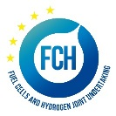

All Intellectual Property Rights, know-how and information provided by and/or arising from this document, such as designs, documentation, as well as preparatory material in that regard, is and shall remain the exclusive property of the ANIONE Consortium and any of its members or its licensors. Nothing contained in this document shall give, or shall be construed as giving, any right, title, ownership, interest, license or any other right in or to any IP, know-how and information.

This project has received funding from the FCH JU 2 / European Union’s Horizon 2020 research and innovation programme under grant agreement No 875024. The information and views set out in this publication does not necessarily reflect the official opinion of the European Commission. Neither the European Union institutions and bodies nor any person acting on their behalf, may be held responsible for the use which may be made of the information contained therein.

**Publishable summary**

Deliverable D1.1 concerns the Project Management Plan (PMP) for the ANIONE project. The PMP details management bodies, documents, and procedures which are described in the Description of the Action (DoA), Grant Agreement, and Consortium Agreement. It also includes the Quality Assurance protocol to be followed by the project partners to ensure a high quality of the project reports as well as the timely delivery of all project results to the FCH JU.

Contents

1 Project Management Plan 5

1.1 Work Plan and WP structure 5

1.2 Management Structure and Consortium Bodies 8

1.2.1 Project Management Team 8

1.2.2 Steering Committee 9

1.2.3 Work Package Leaders and Task Leaders 10

1.2.4 Innovation and Exploitation Management 10

1.2.5 Stakeholder Group (SG) 11

1.2.6 Mission Innovation (IC8 - Hydrogen Innovation Challenge) activities 11

1.3 Management Procedures and progress monitoring 11

1.3.1 Mett 12

1.3.2 Internal project monitoring 12

1.3.3 EU-fin 13

1.4 Change Management 13

1.4.1 Changes in Budget 13

1.4.2 Changes in personnel 14

1.4.3 Changes in technical content and timing 14

1.5 Communication, confidentiality and IP ownership 14

1.5.1 Decision and voting rules 15

1.5.2 IPR 15

1.5.3 Transfer of results 15

1.5.4 Dissemination of results 15

1.5.5 Acknowledgment of FCH JU funding 16

1.5.6 Early information of planned dissemination 16

2 Quality Assurance 17

2.1 Review Process for project deliverables and reports 17

2.2 Quality assurance procedure 17

2.2.1 Quality management responsibilities 17

2.2.2 General quality management procedure 18

2.2.3 General quality criteria 19

2.3 Approval process of Milestones 20

3 Risk management plan 22

3.1 Risk Analysis 22

3.2 Critical Risks and risk mitigation 23

3.3 Role of the partners and the coordinator in risk management 24

4 Risk Register 25

5 Acknowledgement 26

**Table of Figures**

Figure 1‑1. ANIONE Work Package Structure 5

Figure 1‑2. ANIONE Management Structure 8

Figure 1‑3. Mett interface 12

Figure 1‑4 EU-fin login 13

# Project Management Plan

This deliverable (D1.1) concerns the Project Management Plan (PMP) for the ANIONE project carried out in Work Package 1. This WP concerns the management and coordination of the project. In addition to D1.1, WP1 includes the annual data reporting for the FCH Knowledge Management Tool (D1.2, planned at M18; D1.3, planned at M30; D1.4, planned at M36) consisting of i) quantitative project data in a structured format (template and platform provided by FCH 2 JU), ii) dedicated EU-survey questionnaire requested by the FCH 2 JU to collect complementary key qualitative and quantitative information on project’s objectives, activities, and achievements, iii) visual material related to project activities.

The Project management Plan is based on the Annex I to the Grant Agreement, the “Description of the Action” (DoA), and further agreements proposed by the management team and discussed during the project Kick-Off Meeting (22nd January 2020, Brussels). It is meant to be a clear, sharp, comprehensive, and easily accessible guideline for the ANIONE project.

## Work Plan and WP structure

Overall, the ANIONE strategy is implemented in eight work packages (WP) consisting of 1 management WP, 1 WP for dissemination, communication and exploitation, 1 WP for ethics requirements, and 5 technical WPs. The overall structure of the work plan is presented in Figure 1‑1 (WP8 not included).

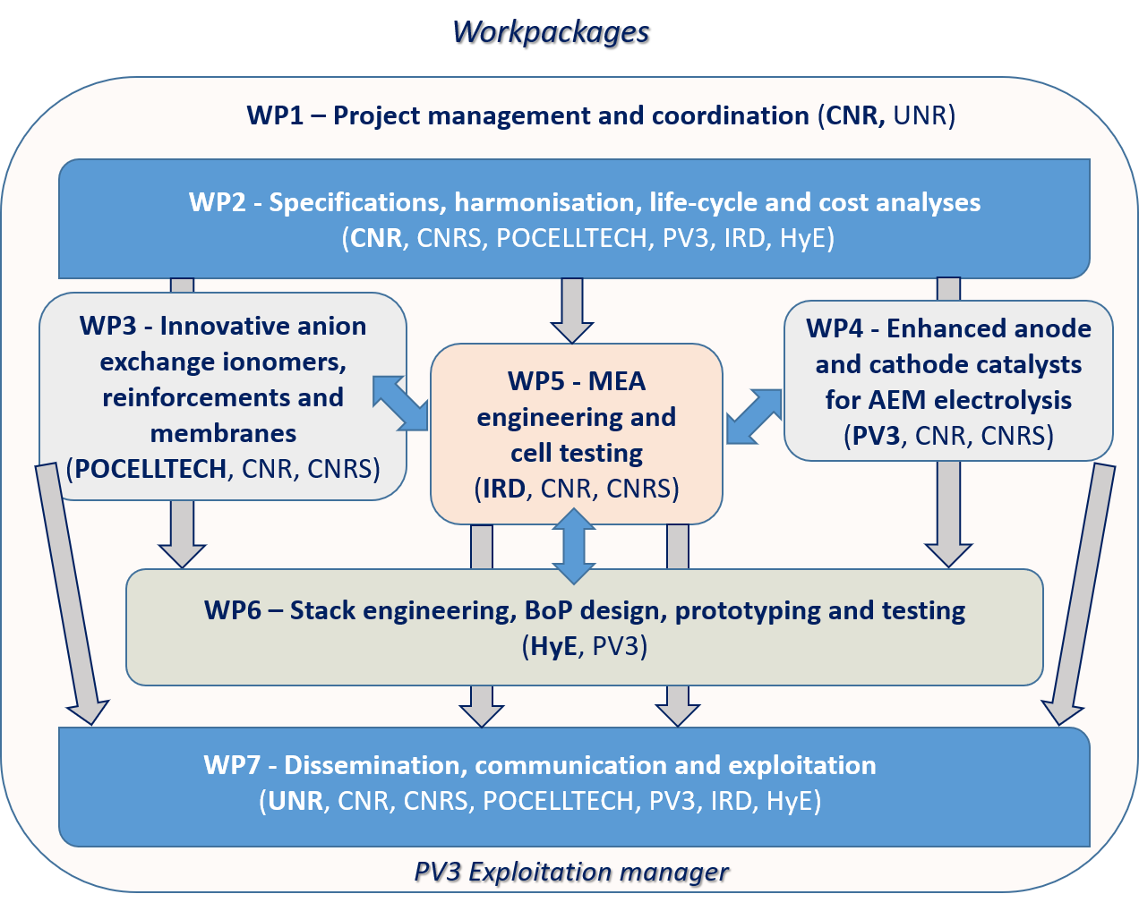

Figure 1‑1. ANIONE Work Package Structure

**WP1 – Project Management and Coordination** focuses on the effective execution of the ANIONE contract, the maintenance of the consortium agreement, the protection of IPR, and the technical coordination in order to achieve the project objectives.

**WP2 – Specifications, harmonisation, life cycle and cost analyses** deals with the specifications, characterisation, and test protocols for components of AEM electrolysis technology in synergy with the Harmonised Testing Procedures developed by JRC. Life cycle and cost analyses are also addressed.

**WP3 – Innovative anion exchange ionomers, reinforcements and membranes** is dedicated to the development of innovative perfluorinated anionic ionomers and membranes. Membrane engineering is addressed to improve conductivity and durability, decrease gas crossover, and expand the operation temperature.

**WP4 – Enhanced anode and cathode catalysts for AEM electrolysis** focuses on the development of nanostructured electrocatalysts based on non-critical raw materials, including both electrocatalysts for

electrolysis and recombination catalyst integrated in the MEA.

**WP5 – MEA engineering and cell testing** deals with the development of highly efficient Membrane-Electrode Assemblies and the scaling-up of the MEA active area to full-scale cells.

**WP6 – Stack engineering, BoP design, prototyping and testing** addresses the stack engineering and testing in terms of performance, durability and dynamic behaviour in a wide temperature range and under high differential pressure operation. A specific balance of plant (BoP) will be designed to test the AEM stack.

**WP7 – Dissemination, communication and exploitation** aim to establish an appropriate and effective communication of the project achievements and to pave the way to exploitation of the ANIONE project results.

**WP8 – Ethics requirements** set out the requirements that the project must comply with.

This document is meant to report further details related to the Work Breakdown Structure (WBS), including schedule per task and responsible partners/list of linked deliverables. So far, no modification with respect to the original plan proposed in the DoA, have been necessary. Therefore, we refer to the Annex I - DoA for further details.

If necessary, this Project Management Plan will be updated, and the necessary modification/decision will be reported and explained. We report below the detailed Gantt chant including timing for each task. For sake of simplicity, WP8 dealing with ethics requirements is not shown in the Gantt chart. The duration of WP8 – Ethics Requirements, covers the entire project period, i.e., 36 months (from M1 to M36).

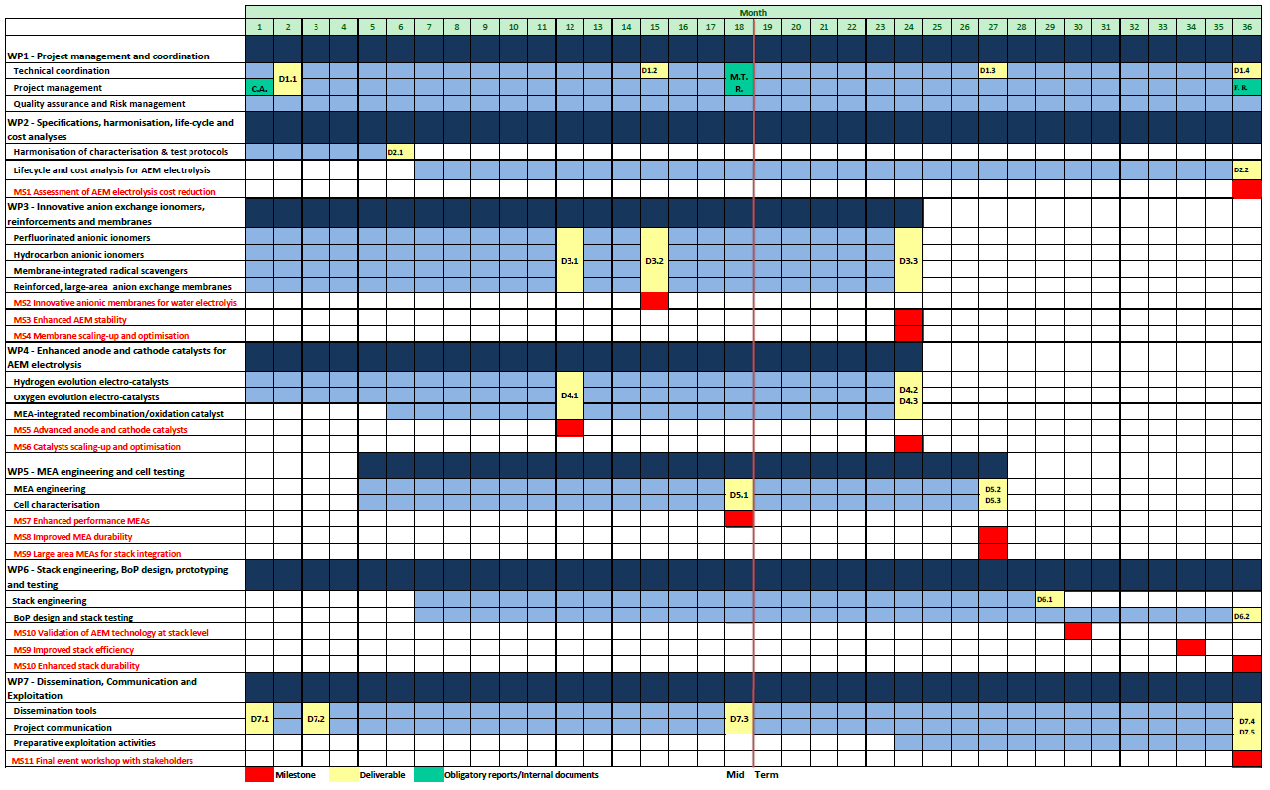

## Management Structure and Consortium Bodies

The management structure and the different consortium bodies are shown in Figure 1‑2.

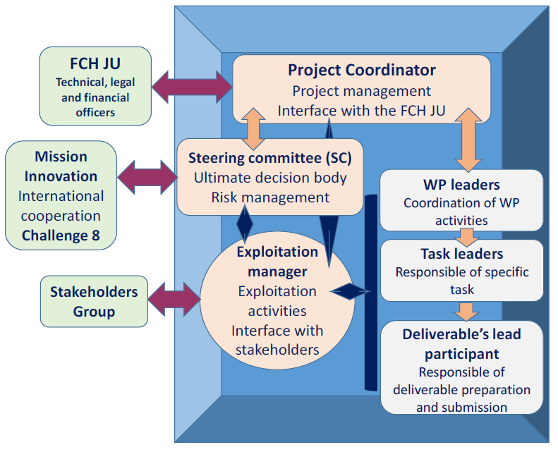

Figure 1‑2. ANIONE Management Structure

### Project Management Team

**Project Coordinator**

The Project Coordinator’s most important task is to ensure *completion of the work* *in time, within budget, and to a high quality*. The Coordinator is the *primus inter pares* and as such responsible for the overall project management, including coordination of the scientific and technical work plan, innovation management and preparative exploitation activities (supported by the exploitation manager). Of course, all partners have their responsibility to perform the tasks they are assigned to *in time, within budget, and to a high quality*. The Project Coordinator is also the consortium interface with the FCH JU.

The **Coordinator** of **ANIONE** is Dr. Antonino Salvatore Aricò (CNR-ITAE).

The following tasks are carried out by the Project Coordinator:

* Effective coordination of the various financial, technical and research activities.
* Maintaining contact with the FCH JU (project, legal and financial officers).
* Providing overviews of the work progress to the FCH JU (project officer).
* Preparing and attending scheduled review meetings with the project officer.
* Notifying the project officer of developments that may require amendments of the Grant Agreement.
* Chairing Steering Committee meetings and preparation of minutes.
* Review and approval of deliverables and material to be disseminated.
* Timely submission of the periodic reports.

A **project management support team** (represented by **UNR**) will support the consortium, Project Coordinator, Steering Committee, and Work Package Leaders with managerial, organisational and secretarial duties, administration and archiving work, such as:

* Support the consortium and Project Coordinator in the daily management of the project.
* Act as contact point for all partners and maintaining a high level of communication within the consortium.
* Organising and documenting project meetings including distributing documents before and after meetings.
* Managing deliverables and administrative documents, e.g. financial plans, (progress) reports etc.
* Producing and updating overviews of consortium expenses and deviations and keeping track of financial transactions between the Steering Committee and the consortium.
* Coordinate the preparation of the periodic management reports and the final report.

Collect, check and send to the FCH JU the required cost statements, based on the scheduled plan using the systems as provided by the FCH JU.

### Steering Committee

The Steering Committee (SC) will discuss and decide on overall project management, strategic management issues and contract amendments. It consists of one representative from each partner and will be established at the commencement of the project. The SC is the ultimate decisional body within the consortium.

The following tasks will be carried out by the SC:

* Monitoring and control of the technical progress in the work packages, project schedule and deliverables.
* Assuring cooperation and integration between the work packages.
* Regular risk analysis and preparation of contingency plans, if required.
* Conducting periodic progress meetings.
* Cooperation with Mission Innovation parties and related projects.

The names of the appointed SC are listed in the table below.

|  |  |  |
| --- | --- | --- |
| Steering Committee Members | | |
| Partner | **Name** | **Email Address** |
| CNR-ITAE | Antonino Salvatore Aricò (Chair) | antoninosalvatore.arico@cnr.it |
| CNRS | Deborah Jones | deborah.jones@umontpellier.fr |
| POCELLTECH | Ervin Tal-Gutelmacher | Ervin.Tal-Gutelmacher@pocelltech.com |
| PV3 | Nicholas van Dijk | nick.vandijk@pv3technologies.com |
| IRD | Laila Grahl-Madsen | lgm@irdfuelcells.com |
| HYDROGENICS | Wouter Schutyser | wschutyser@hydrogenics.com |
| UNR | Anna Molinari | a.Molinari@uniresearch.com |

#### Meeting schedule for the SC

The SC will meet at least every 6 months, but additional meetings will be arranged upon request of one of the partners (can be teleconferences). In addition, web-based progress meetings between the SC and WP Leaders will be conducted on a bi-monthly basis. Three meetings with the FCH JU Officer (Kick-off Meeting, M18, M36) are also planned.

The upcoming project meetings for the first 6 months have been discussed at the Kick-off meeting. The next meeting is planned for June 2020, Messina (exact dates to be determined). During each SC meeting dates and locations will be proposed for following meetings (decision to be taken approx. 9/12 months before a meeting takes place).

### Work Package Leaders and Task Leaders

The Work Package Leaders will coordinate the activities related to their WPs. Work Package Leaders deal with the technical developments, overall coherence, and technical implementation of the project output.

Each work package leader has the following tasks:

* Maintaining monthly contact with the task leaders and coordination of the activities in the work package.
* Ensuring completion of work package activities and deliverables on time, within budget and of high quality.
* (In)formal reporting on work package progress, quality and risk status to the coordinator and SC.
* Reviewing and approval of all formal work package deliverables.
* Managing of risks within the work package.

The T**ask Leaders** hold similar responsibilities as the WP Leaders but at task level.

The names of the appointed WP leaders are listed in the table below:

|  |  |  |
| --- | --- | --- |
| Work Package Leaders | | |
| WP Number | **Lead Beneficiary** | **Name** |
| WP1 | CNR-ITAE | Antonino Salvatore Aricò |
| WP2 | CNR-ITAE | Antonino Salvatore Aricò |
| WP3 | POCELLTECH | Ervin Tal-Gutelmacher |
| WP4 | PV3 | Simon Jones |
| WP5 | IRD | Laila Grahl-Madsen |
| WP6 | HYE | Wouter Schutyser |
| WP7 | UNR | Anna Molinari |
| WP8 | CNR-ITAE | Antonino Salvatore Aricò |

### Innovation and Exploitation Management

Innovation management is a process, which requires an understanding of both the market and the technical possibilities, with an aim to successfully implement appropriate creative ideas. With good innovation management it should allow a consortium to respond quickly and thoroughly to both internal and external opportunities.

The Exploitation Manager will:

* Manage all activities related to innovation, from market needs to market deployment.
* Monitor and follow up the technological developments during the project.
* Manage key aspects regarding patents, licenses, royalties and dissemination of the intellectual property arising from the project.
* Play a key role in developing the exploitation strategy and co-ordinate negotiations between the Consortium and external parties regarding specific exploitation aspects.

The role of Exploitation Manager is assigned to Dr. Nicholas van Dijk (PV3) who has extensive competence at industrial level in the deployment of electrolysis and hydrogen technologies.

### Stakeholder Group (SG)

It is the aim to establish a Stakeholder Group composed of renowned authorities and experts in the areas of electrolysis, renewable power sources, and grid balancing, as well as key representatives from policymakers and industry. The purpose of the SG is to advise and help guide the process of defining the recommendations for implementation of the results developed within the ANIONE project: Thanks to their expertise, professional knowledge and bird’s eye view, the members of the Stakeholder Group will play an important part in contributing to the success of the project, helping to provide full commitment to the recommendations developed. The purpose of this group is to:

* Increase the probability of wide market acceptance of the materials and processes developed and with that a better market penetration.
* Enable early market uptake by enlarging the industry interest through discussions on selected project results.
* Advancing in possible obstacles by challenging the project on relevant safety, health and other issues which need to be answered and might not be considered from the beginning.
* Propose solutions for high level issues which might occur during the project regarding the long-term implementation of these technologies.

Possible members of this group will be suggested by the project partners at the beginning of the project (to be listed in the project dissemination database, part of D7.2, planned for M3). The SG will be informed about the project activities through flyers and newsletters containing links to the project website. In addition, specific dissemination events, including meetings between the SG and the SC, will be organised for the engagement of stakeholders.

### Mission Innovation (IC8 - Hydrogen Innovation Challenge) activities

To ensure international collaboration (outside of Europe) and to ensure the ANIONE project is at the cutting edge of innovation, the consortium will collaborate with experts in both Canada and the US in the sister companies of HYE and IRD. Experts from these companies will act as scientific and technical advisory group providing substantial technical advice and support for the implementation of specific activities carried out in the project. The proposed collaboration will ensure that relevant innovations from North America can be brought into the ANIONE project while facilitating exploitation of the outputs from ANIONE globally. The advisory group will be invited to participate in web meetings with the project consortium specifically organised to strengthen the international cooperation.

## Management Procedures and progress monitoring

The organisational structure composed of a Project Coordinator (CNR-ITAE) assisted by the project management support team (UNR) and a SC as the ultimate decision-making body in the project has proven its appropriateness and adequacy in numerous EU/FCH JU funded projects. The management method and procedures applied by partner UNR for planning, monitoring and control of the progress of the research are derived from the methods and procedures used by multinationals for managing large research and development programmes.

### Mett

The management tool [Mett](https://uniresearch.mett.nl/h2020+projects/anione/default.aspx) will be used as platform for the ANIONE project and will facilitate the communication among partners, the exchange of documents, and the monitoring of the status of project deliverables and milestones. An impression of the Mett interface is presented in Figure 1‑3. Special pages, with different functionalities, are dedicated to the different aspects of the project (document upload and exchange, video and photos’, contact list and consortium members).

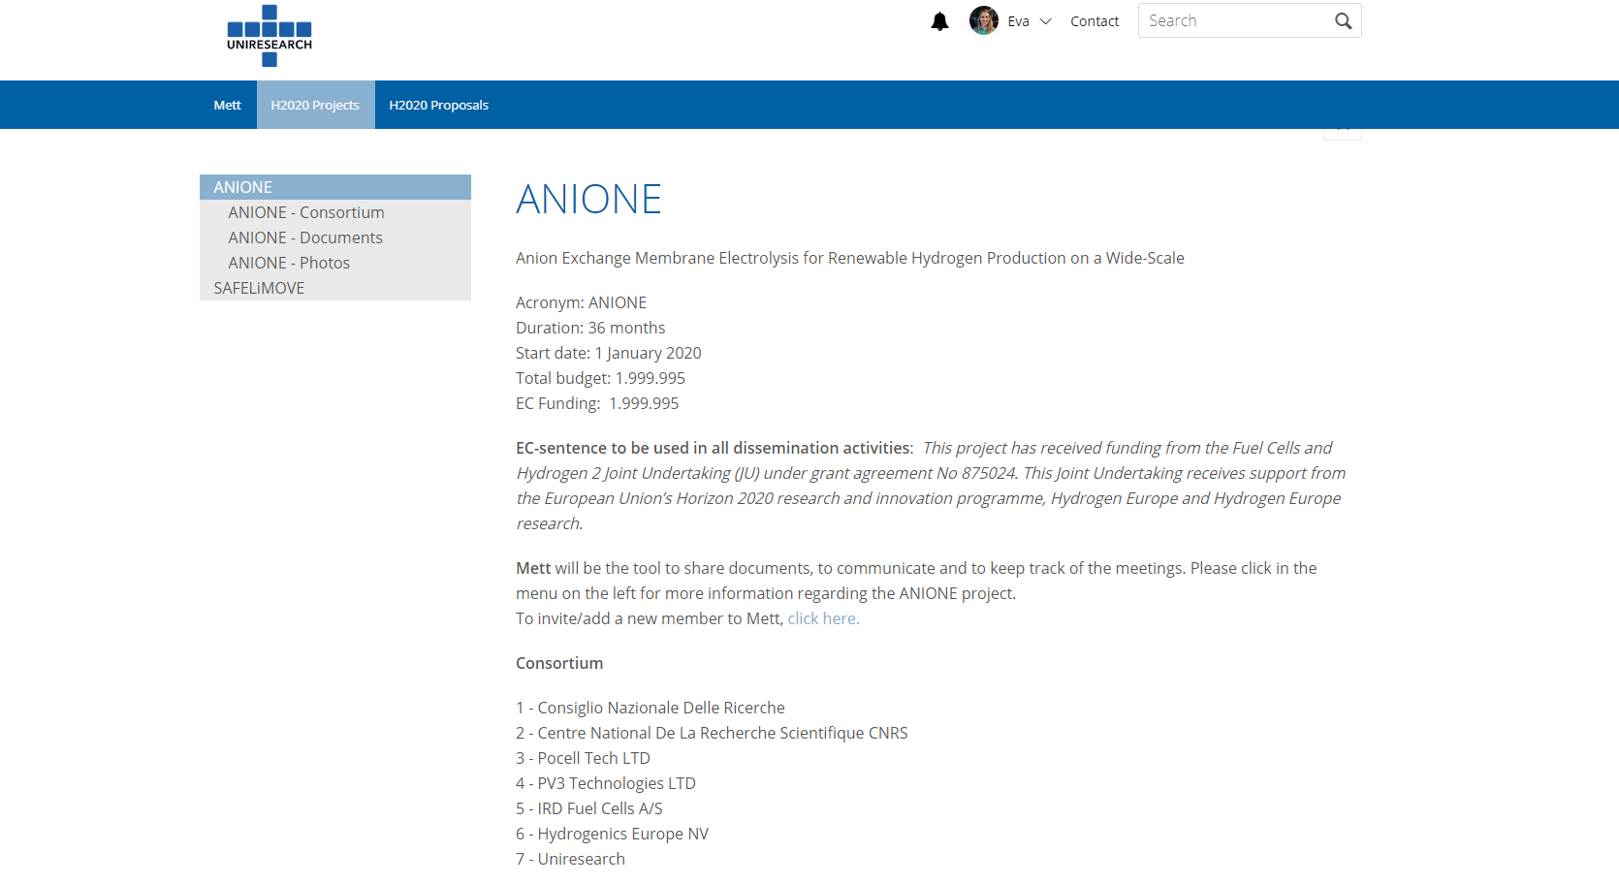

Figure 1‑3. Mett interface

### Internal project monitoring

At the end of every 6-month period, all partners will be requested to supply a management summary for internal project monitoring. This summary will consist of a technical report and an overview of expenses. The idea is to set up and maintain an ‘early-warning’ system (for possible technical and financial risks) via clear, simple and transparent procedures. In particular:

* Technical report: a simple .doc template will be provided by UNR, each partner will have to report on the activities undertaken during the specific period:
  + possible deviation from the DoA;
  + participation at meetings;
  + contribution to milestones/deliverables;
  + risks/problems encountered, or which may be encountered in near future; and
  + attention points.
* Financial report: via EU-fin (next sub-section): a simple overview (per WP) of the costs and PMs spent in the specific period, including short clarification. Deviation from Annex I with respect to the planned budget should also be reported.

### EU-fin

An e-mail is sent every 6 months with the link to the project reporting tool “EU-fin”. All the project partners will be asked to report on project costs via this tool. At the beginning of the project, a financial planning will be prepared in EU-fin (by UNR). Here, the total project costs for each period will be divided among the different WPs (according to the budget file prepared during the proposal preparation) and categories. A screenshot of the EU-fin system login window is shown in Figure 1‑4.

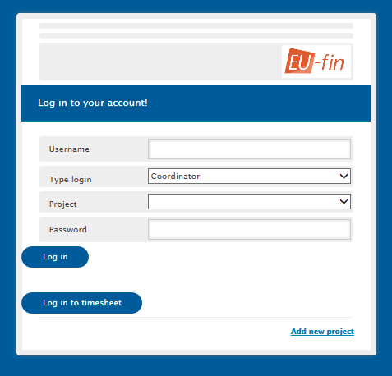

Figure 1‑4 EU-fin login

The EU-fin tool allows the project manager and Coordinator to automatically generate cost reports comparing the actual expenses versus the budget per beneficiary, WP, activity, etc. Other functionalities include creating charts for comparing deliverables planned vs. actual, budget planned vs. budget spent, etc. The information in EU-fin will be used as input for the official periodic reports (after M18, M36).

## Change Management

In a collaborative project, involving 7 partners (from 7 different EU and associated countries) and 3 years planning, changes may happen. This is quite normal but there should not be a surprise at the end of an official reporting period (or of the project). Therefore, the project management team and the entire consortium is committed to maintain an open and transparent communication system. Nevertheless the ‘Rules of the Game’ are clearly reported below.

### Changes in Budget

Each partner is requested to:

* Report immediately, as soon as the possibility of a budget modification is considered, to the coordinator.
* Provide the financial report every 6 months and clearly report on the expenditures and financial planning.

The Project Coordinator together with the project management team will evaluate the situation, propose scenarios and possible solutions, and inform accordingly the project officer for further discussion and alignment.

Below a list of the most common situations which may arise:

* Budget shift at partner level (only one partner involved, the total costs are not changing): some budget needs to be shifted from one WP to another or from one category to another (ex. from ‘travel’ to ‘other direct costs’) 🡪 in principle no amendment to the Grant Agreement will be necessary but this should be discussed with the project officer and the Commission. In any case, convincing justification for the budget shift should be provided.
* Budget shift between different partners 🡪 this may request an amendment of the Grant Agreement and it should be carefully analysed by the SC and – finally – by the Commission. Supporting documents need to be provided.

### Changes in personnel

A project contact list is available on Mett and maintained updated by UNR with inputs from all partners. It is normal that new personnel/PhD students/collaborators join or leave the project team within three years’ time. However, changes will still need to be communicated to the management team (this project is dealing with confidential research information and in case someone leaves the team it is important to remove his/her access to the project document database):

* Changes at SC level need to be presented and discussed during the SC meetings.
* In case of change of the Project Coordinator, an Amendment to the Grant Agreement will be required.
* Partners are requested to immediately report any changes to the management team.

### Changes in technical content and timing

Each change related to the technical content and timing needs to be reported to the project officer (via the Project Coordinator).

Minor re-planning and re-alignment of the activities may be implemented but in case of changes in the scope/objectives of a specific WP an Amendment to the Grant Agreement will be necessary.

Partners are requested to immediately report possible changes to specific tasks to the WP leader who will evaluate the situation and inform the management team.

## Communication, confidentiality and IP ownership

Internal communication will be stimulated as much as possible by the management team and the SC members. Frequent teleconferences and meetings will be organised among partners.

The partners concluded a Consortium Agreement (CA), in which all relevant issues necessary for the proper execution of the project are described in detail. Below a summary of a few articles related to decisions, communication and confidentiality.

### Decision and voting rules

*Article 6.3.3 of the CA - Voting rules and quorum*

* 6.3.3.1 The Steering Committee shall not deliberate and decide validly unless two-thirds (2/3) of its Members are present or represented (quorum).
* 6.3.3.2 Each Member shall have one vote.
* 6.3.3.3 Defaulting Parties may not vote.
* 6.3.3.4 Decisions shall be taken by a majority of two-thirds (2/3) of the votes cast.

### IPR

*Article 8.0 of the CA – Ownership of Results*

Results are owned by the Party that generates them. Each Party shall cooperate in order to avoid that patent rights embodying any of their own Results jeopardise the patent protection of any other Party’s Results.

*Article 8.1 of the CA – Joint Ownership*

Each of the joint owners shall be entitled to use for Internal Use their jointly owned Results on a royalty-free basis, and without requiring the prior consent of the other joint owner(s).

Each of the joint owners shall be entitled to use for Use Commercially their jointly owned

Results and to grant non-exclusive licenses to third parties, without any right to sub-license, subject to the following conditions:

* at least 45 days prior notice must be given to the other joint owner(s), and
* fair and reasonable compensation must be provided to the other joint owner(s).

With respect to any jointly owned Results, the relevant joint owners further agree that they shall, within a reasonable period of time following creation of any such Results, enter into good faith discussions in order to settle a joint ownership agreement defining the jointly owned Results protection and management conditions, including the division of related costs. The joint ownership agreement should be signed before any Commercial Use. The provision of the joint ownership agreement cannot be in contradiction with the provisions of this Consortium Agreement.

### Transfer of results

*Article 8.2 of the CA*

Each Party may transfer ownership of its own Results following the procedures of the Grant Agreement Article 30.

### Dissemination of results

*Article 8.3.1.1 of the CA*

During the Project and for a period of 1 year after the end of the Project, the dissemination of own Results by one or several Parties including but not restricted to publications and presentations, shall be governed by the procedure of Article 29.1 of the Grant Agreement subject to the following provisions.

Prior notice of any planned publication shall be given to the other Parties at least 45 calendar days before the submission. Any objection to the planned publication shall be made in accordance with the Grant Agreement in writing to the Coordinator and to the Party or Parties proposing the dissemination within 30 calendar days after receipt of the notice. If no objection is made within the time limit stated above, the publication is permitted.

### Acknowledgment of FCH JU funding

Article 29.4 of the GA: The correct acknowledgment sentence is reported on the FCH JU web site:

<https://www.fch.europa.eu/page/fchju-projects-communication-dissemination#Acknowledging> EU funding

For scientific publications:

“The financial support from the ANIONE EU FCH JU project is acknowledged. This project has received funding from Fuel Cells and Hydrogen 2 Joint Undertaking under grant agreement No 875024. This

Joint Undertaking receives support from the European Union's Horizon 2020 research and innovation programme and Hydrogen Europe and Hydrogen Europe Research”

For communications activities:

“This project has received funding from the Fuel Cells and Hydrogen 2 Joint Undertaking (JU) under grant agreement No 875024. This Joint Undertaking receives support from the European Union’s Horizon 2020 research and innovation programme, Hydrogen Europe and Hydrogen Europe research”

For patents:

“The project leading to this application has received funding from the Fuel Cells and Hydrogen 2 Joint Undertaking (JU) under grant agreement No 875024. This Joint Undertaking receives support from the European Union’s Horizon 2020 research and innovation programme, Hydrogen Europe and Hydrogen Europe research”

For standardisation activities:

“Results incorporated in this standard received funding from the Fuel Cells and Hydrogen 2 Joint Undertaking (JU) under grant agreement No 875024. This Joint Undertaking receives support from the European Union’s Horizon 2020 research and innovation programme, Hydrogen Europe and Hydrogen Europe research”

In addition, the emblem of the JU and European Commission should be displayed. The emblems are shown here:

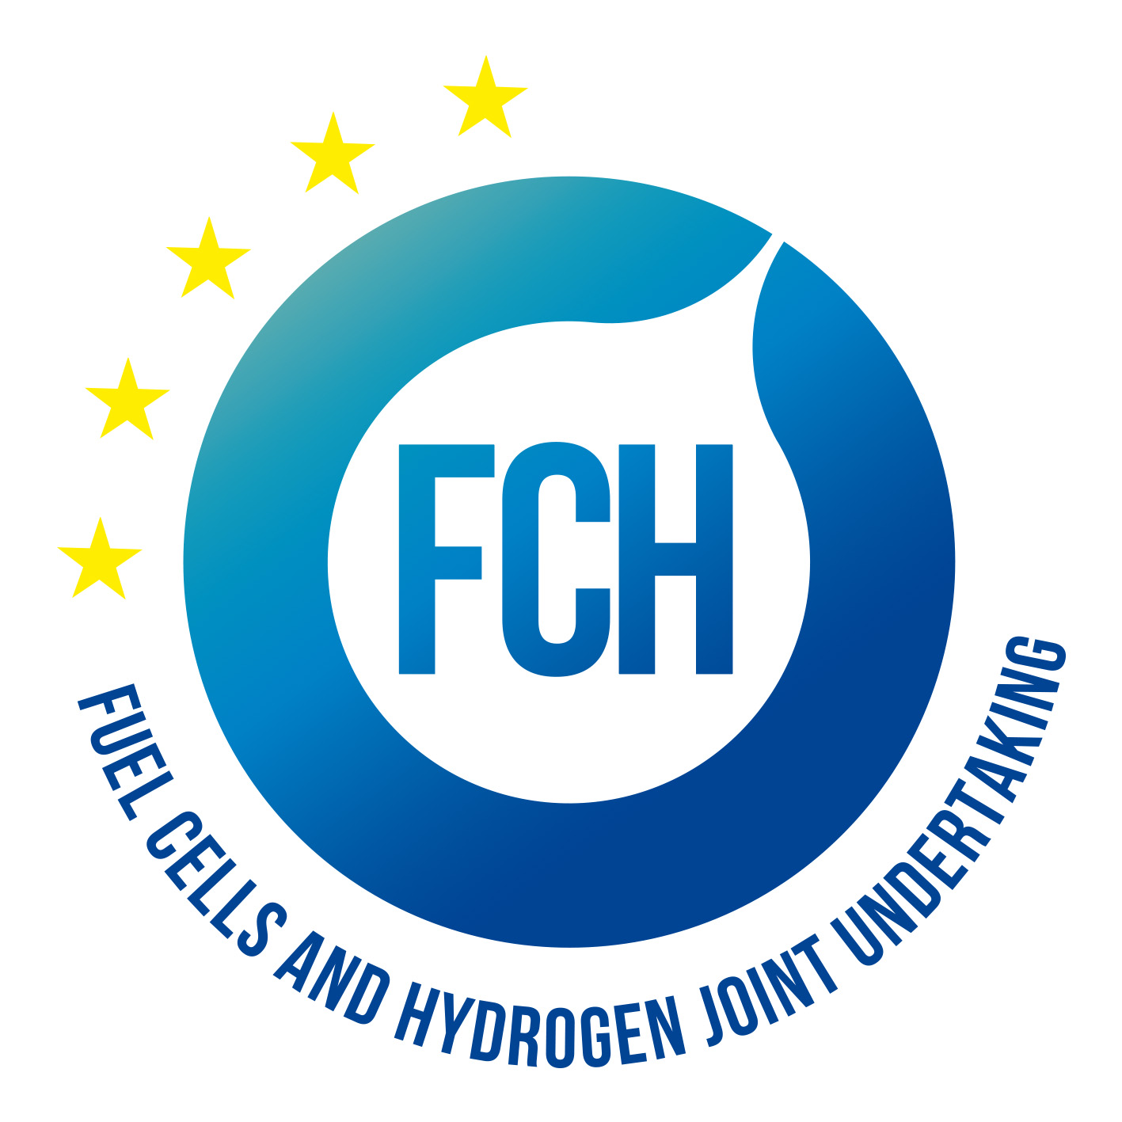

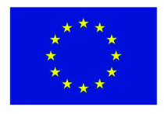

### Early information of planned dissemination

Please note:

* Dissemination activities must be planned well in advance to allow for proper quality review and security assessment.
* All partners need to be informed well in advance (30 days prior) to formal publication (apart from the formal ANIONE deliverables). This holds for publications in journals, presentations at conferences and contributions to proceedings, and the like.

# Quality Assurance

## Review Process for project deliverables and reports

The term “Deliverables” refers to the formal ANIONE project deliverables as described in the Grant Agreement No. 875024; the term “Reports” refers not only to the compulsory reports for the Commission but – more generally - also to other publications and exposures of ANIONE activities to third parties.

Also content on the project website can be considered a report; with the notion that all information presented on the website has to be PUBLIC, the website host is responsible for quality and sanity checks on information that is to be published on the ANIONE website.

For confidential deliverable(s) a short publishable summary can be offered on the website.

The sequel concerns formal ANIONE deliverables and scientific publications and presentations concerning ANIONE developments. An overview of all formal ANIONE deliverables is presented in Annex I of the Grant Agreement, part A, table 1.3.2.

An overview of all other ANIONE exhibitions and presentations will be included in the ANIONE Dissemination Database. This database will be regularly updated with initiatives from the consortium and/or individual partners that intend to deliver ANIONE-related publications, presentations and similar. (Updates of) This plan will be discussed and agreed upon at ANIONE Steering Committee meetings.

All deliverables must undergo a quality assessment. The rules for quality assessment are laid out in next sections.

## Quality assurance procedure

To ensure their quality, all ANIONE deliverables will be reviewed internally before delivery to the Commission or to publishing bodies.

### Quality management responsibilities

The Exploitation Manager Dr. Nicholas van Dijk (PV3) together with the Project Coordinator Dr. Antonino Salvatore Aricò (CNR-ITAE) fulfil the role of overall Quality Manager. They supervise the overall assessment of project deliverables and are also responsible for timely delivery and uploading of project products to the EU portal and for informing the Project Officer. This is especially important in case of delays in delivery dates of formal deliverables.

Each Work Package Leader is quality manager for his/her own work package and for the deliverables developed within concerned work package. The WP Leader may assign internal reviewers to review a deliverable draft, preferably a staff member working in that work package who is not one of the deliverable authors. Alternatively, the reviewers will be the WP leader and the Coordinator.

### General quality management procedure

The quality management procedure recognizes the following timeline and steps to submit the deliverable in time:

|  |  |  |
| --- | --- | --- |
| **SubmissionDate** | **Action** | **Action by** |
| **D- XX** | Check on timely planning and prepare for supporting actions as necessary | WP Leader with Authors |
| **D-28** | Suggest Quality Reviewers and inform Coordinator (if applicable). Alternatively, the role of Quality Reviewer will automatically be asigned to the WP leader and the Coordinator. | Lead beneficiary |
| **D-21** | Present final draft of deliverable for quality review to Reviewers | Main Author |
| **D-10** | In case of serious modifications following from first review, revisit the review procedure in order to take appropriate measures as necessary | WPL, Authors and Reviewers |
| **D-5** | Finalise deliverable and present to WP leader | Main Author |
| **D-3** | Present final version to project coordinator | WP Leader |
| **D** | Submit deliverable to the Commission | Project Coordinator |

All deliverables must show that they have followed the effective quality management by indicating persons responsible for the quality review.

1. Due date (D) is the day at which a deliverable has to be forwarded externally, be it to the project officer or other bodies. Formal due dates for ANIONE deliverables are the last day of the month specified in the ANIONE deliverables table (Table 1.3.2 of Annex 1 (part A)).
2. The author(s) of the deliverable shall use the latest deliverable template (can be found on the ANIONE Mett platform, section ‘Templates and Manuals’) for creating the deliverable.
3. The WP Leader takes the initiative to contact the SC members in advance if he/she fears that a part of the deliverable is at risk of non-completion.
4. The lead beneficiary responsible for a deliverable suggests reviewer(s) for the deliverable four weeks before the deliverables’ due date. The reviewer is independent from the authors and is ideally from at least one other ANIONE consortium partner, preferably one of the WP participants. If no reviewers are assigned, the WP leader and Coordinator automatically become reviewers.
5. The internal review shall be completed no later than one week after the review request.
6. The reviewer uses a standard review form (reported in section 2.2.3 of this document) to document his/her review findings. The review form is maintained throughout the reviewing procedure until submission of the deliverable. The review form will be stored on the ANIONE project platform for archive purposes.
7. The reviewer reviews the deliverable and sends his/her completed comments to the WP Leader and to the authors of the deliverable. The possible results of the review process are:
   1. ACCEPT: The deliverable is acceptable in its current form and the ANIONE coordinator should submit it to the Commission.
   2. ACCEPT w. REVISION: The deliverable is in principle acceptable. However, some minor changes are needed. The author(s) should revise the deliverable. No further WP internal reviewing is required.
   3. REVISE: The deliverable is not acceptable in its current form. The author(s) proceed to implement required improvements.
8. The author(s) revise the deliverable according to the review result within a maximum of five days after receiving the request for quality improvement and inform the WP Leader which will request a new review, preferably by the same reviewer.
9. The WP Leader checks the review and ensures that the requested improvements are implemented by the author(s).
10. When the deliverable is accepted, the WP Leader informs the Project Management Team.
11. The Project Management Team checks the deliverable and the review form. He/She may issue a request for further improvement to the author(s) and the WP Leader. This procedure makes it highly likely that the two-fold improved deliverable is ready for submission. If not, the author(s) must implement the final corrections as requested immediately.
12. Once the review and approval procedure is completed, the Project Coordinator submits the deliverable to the Commission in electronic form (PDF) via the SyGMa portal. The Project Management Team stores the PDF of submitted deliverables on the ANIONE Mett platform (section Documents / Deliverables/ Submitted to EC Deliverables / Dx.x).
13. The final version of the deliverable must be submitted to the FCH JU before the due date. If this is not possible for any reason the project Coordinator must be informed well in advance of the due date. To ensure deliverables will be met, reviewing and revising must be performed as early and as fast as possible in case multiple review-revise cycles are necessary.

### General quality criteria

This subsection provides an overview of the quality criteria that should be applied to ensure the quality of the deliverables.

The following questions should be answered by all reviewers (WP Leader, peer reviewer(s), Project Coordinator) as part of the Quality Assurance Procedure. Questions answered with NO should be elaborated. The author will then make an updated version of the Deliverable. When all reviewers have answered all questions with YES, only then can the Deliverable be submitted to the EC.

|  |  |  |  |
| --- | --- | --- | --- |
| Question | WP Leader | Peer reviewer(s) | Project Coordinator |
|  | NAME | NAME | NAME |
| 1. Do you accept this Deliverable as it is? | Yes / No (elaborate) | Yes / No (elaborate) | Yes / No (elaborate) |
| 1. Are all required actions from the DoA performed and reported in the Deliverable? | Yes / No (elaborate) | Yes / No (elaborate) | Yes / No (elaborate) |
| 1. Are all interactive outputs clearly defined for the related Tasks? | Yes / No (elaborate) | Yes / No (elaborate) | Yes / No (elaborate) |
| 1. Is the Deliverable complete ? - omissions / all required chapters / argumentation | Yes / No (elaborate) | Yes / No (elaborate) | Yes / No (elaborate) |
| 1. Is the technical quality sufficient?   - inputs and assumptions correct - data, calculations and motivations correct - outputs and conclusions correct | Yes / No (elaborate) | Yes / No (elaborate) | Yes / No (elaborate) |
| 1. Are the tasks/WP/project objectives clearly addressed in the Deliverable? | Yes / No (elaborate) | Yes / No (elaborate) | Yes / No (elaborate) |
| 1. Is created and potential IP identified and are protection measures in place? | Yes / No (elaborate) | Yes / No (elaborate) | Yes / No (elaborate) |
| 1. Is the Risk Procedure followed and reported? | Yes / No (elaborate) | Yes / No (elaborate) | Yes / No (elaborate) |
| 1. Is the reporting quality sufficient?  - clear language - argumentation - consistency - structure - use of templates, etc | Yes / No (elaborate) | Yes / No (elaborate) | Yes / No (elaborate) |
| 1. Is the Deliverable formatted according to the project template? | Yes / No (elaborate) | Yes / No (elaborate) | Yes / No (elaborate) |
| 1. Is the Deliverable ready? | Yes / No (elaborate) | Yes / No (elaborate) | Yes / No (elaborate) |

## 

## Approval process of Milestones

WP Leaders are responsible for the achievement of WP related milestones. WP Leaders report to the Steering Committee if they think a milestone has been achieved and the means of verification as reported in SyGMa should be met. It will then be discussed, after which the Management team can report to the EC.

The ANIONE project Milestones are listed in the table below.

|  |  |  |  |  |  |
| --- | --- | --- | --- | --- | --- |
| Milestone number | Milestone name | Related WP | Lead Beneficiary | Est. Del. Date | Means of verification |
| MS01 | Assessment of cost reduction for ANIONE technology through a technoeconomic analysis | WP2 | CNR-ITAE | 31 Dec 2022 | Projected capital costs < 0.750 M€/kg H2/day for systems > 1 MW |
| MS02 | Innovative AEM electrolysis membranes for operation in a wide range of temperature and pressure | WP3 | CNRS | 31 Mar 2021 | Thin (≤ 30 μm) fibre reinforced membranes containing specific additives for operation up to 90 °C and 30 bar, with hydroxide conductivity ≥50 mS cm-1 and area specific resistance ≤70 mOhm cm2 and low gas cross over (< 1 vol. % H2 in the O2 stream at the anode) |
| MS03 | Enhanced electrochemical and mechanical stability for the anionic exchange membrane | WP3 | CNR-ITAE | 31 Dec 2021 | Area specific resistance (ASR) increase lower than 5 % in 2,000 h electrolysis operation. Mechanical elongation at break >100%; modulus ~ 15 MPa. |
| MS04 | Membrane scaling-up and optimisation | WP3 | CNR-ITAE | 31 Dec 2021 | Provision of large-area membranes (active area ≥100 cm2) meeting specifications. |
| MS05 | Advanced nanostructured anode and cathode catalysts for AEM electrolysis | WP4 | CNR-ITAE | 31 Dec 2020 | Reduced oxygen and hydrogen evolution overpotentials under AEM electrolysis conditions (< 150 mV IR-free at 1 A cm-2) and low degradation rate (<5% increase in overpotential in a 2000 h durability test at 1 A cm-2) |
| MS06 | Catalysts scaling-up and optimisation | WP4 | PV3 | 31 Dec 2021 | Provision of large-batch (>100 g) catalysts meeting specifications |
| MS07 | Enhanced performance for engineered MEAs | WP5 | IRD | 30 Jun 2021 | Performance of 1 Acm-2 at ECell < 1.8 V under pressure. Faradaic efficiency > 99%. |
| MS08 | Improved MEA electrochemical durability | WP5 | CNR-ITAE | 31 Mar 2022 | Durability > 3,000 hours cumulative (2000 h steady state, 1000 h cycled operation) with targeted degradation rate lower than 5 μV/h at a fixed current density of 1 Acm-2 and less than 10 μV/h under cycled (0.2 – 1 A cm-2) operation. |
| MS09 | Large area engineered MEAs for stack integration | WP5 | IRD | 31 Mar 2022 | Provision of large area MEAs (>100 cm2 active area) for stack assembling. |
| MS10 | Advanced cost effective AEM electrolysis stack | WP6 | HYE | 30 Jun 2022 | AEM stack prototype of ~ 2 kW capacity (10-cells) with ≥100 cm2 active area, operating at a current density ≥ 1 Acm-2 with an average cell potential < 1.8-2 V and hydrogen production rate > 0.4 Nm3/h. |
| MS11 | Improved stack efficiency | WP6 | HYE | 31 Oct 2022 | Decreased energy consumption < 50 kWh/kg for the AEM electrolysis stack with an enhanced stack efficiency of about 80% vs. HHV. |
| MS12 | Enhanced durability PEM electrolysis stack | WP6 | HYE | 31 Dec 2022 | Assessment of stack durability in time studies of at least 2000 h test at 1 A cm-2 showing efficiency loss < 3 %/year. |
| MS13 | Final event workshop | WP7 | UNR | 31 Dec 2022 | Workshop organisation |

# 

# Risk management plan

As part of the overall management plan for the ANIONE project, this document describes the risk management plan. It identifies conditions that may put the project at risk and provides guidance for managing these. It also provides methods and establishes roles and responsibilities of all participants in the risk management process.

## Risk Analysis

The project risk management plan is an internal document for the ANIONE consortium. It describes the project risks and the possible actions to be taken to prevent or mitigate delays and other disruptions in the execution of the project.

A preliminary risks analysis and proposed mitigation measures are presented in the Description of Action (detailed in Annex 1, Part A of the Grant Agreement, table 1.3.5). In this document the consortium further details the risk scale, contingency plan and partner’s responsibility.

This Risk Management Plan describes, via the tables presented in the different chapters, the risk management approach to be followed within the ANIONE project.

The approach is based on the steps which together form the “circle” of risk management:

* 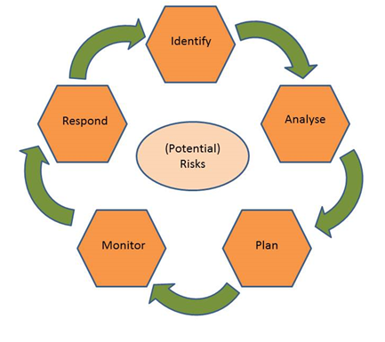Identify 🡪 In this step, risks are identified, alongside the moments at which they could occur and the specific symptoms of the risks.
* Analyse 🡪 Here, the risk is analysed further, looking also into the potential effects and consequences of the risk.
* Plan 🡪 In this step, plans are developed for management of the specific risk, as well as contingency plans.
* Monitor 🡪 The actual status of the risk is monitored, using e.g. the risk symptoms as identified in the first step.
* Respond 🡪 The specific risk management plan is put into action, when the monitoring step has shown the need for this. Actions are taken to prevent the risk from happening full force, or to avoid undesired consequences of the risk.

These steps, including roles of partners, are described in the following sections. In risk management, the WP Leaders and the Technical Coordinator will cooperate to be able to tackle imminent risks efficiently and timely.

The risk management circle formed by the five steps outlined above will continuously be applied to potential project risks during the lifetime of the project.

## Critical Risks and risk mitigation

In view of the highly innovative character of the proposed research, several risks are identified that may occur during the implementation of the ANIONE project. The important risks are summarized in the table below.

|  |  |  |  |
| --- | --- | --- | --- |
| No | Description of risk | Related WP | Proposed risk-mitigation measures |
| 1 | Achieving high conductivity and stability (chemical, thermal and mechanical) for the thin reinforced anionic membranes. | WP3 | This is mitigated by having two different routes for membrane development that have already provided good indication in terms of hydroxide conductivity and electrochemical stability |
| 2 | Obtaining high surface area, active non-CRM electrocatalysts with good stability in the alkaline environment. | WP4 | This is mitigated by having different routes for both anode and cathode electrocatalysts development that have shown promising electrochemical activity and stability |
| 3 | Demonstrating the capability of advanced membrane-electrode assemblies and related components to operate in a wider operating temperature and pressure ranges. | WP3, WP4, WP5 | This is mitigated by having different routes for components developing that have already given good indication of proof of concept in terms of wider temperature and pressure ranges and a new strategy for crossover management. |
| 4 | Gas cross-over management for thin anionic membranes in the presence of high differential pressure. | WP3, WP4, WP5 | Proper mitigation strategies are adopted e.g., membrane and MEA engineering to include a recombination catalyst integrated in the membrane and in the anode and membrane reinforcement increasing the tortuosity path for gas permeation. |
| 5 | Achieve the challenging performance, efficiency and stability targets with large-area MEAs. | WP3, WP4 | This is mitigated by the fact that some of these targets have been almost approached in previous projects under certain conditions and will be demonstrated here in proper scale |
| 6 | Scaling-up of membrane-electrode assemblies and related components to proper levels for assessing them in a stack of appropriate capacity. | WP3,  WP4, WP5 | Producing several batches of core-components and resizing the number of cells in the stack are specific options to mitigate this risk. Scaling-up activities on similar components have been planned in other projects and the lesson learned from the previous experience can be transferred to this project. |
| 7 | Improving stack design by implementing cost-effective steel bipolar plates and innovative flow-field free architecture. | WP6 | Baseline stack architecture and bipolar plates can be used in the first phase in combination with the innovative MEAs and advanced components to validate the perspective to operate in a wide range of temperature and pressure |
| 8 | Implementation of the innovative solutions for AEM electrolysis, into a 2 kW stack operating at high differential pressure | WP6 | This is mitigated by the fact that the partner involved in electrolyser manufacturing (HYE) has proper competences on producing electrolysis units of much larger size. The electrolyser stack size can be eventually modulated to accomplish the targeted electrical power and hydrogen production rate. |
| 9 | Validation of the advanced electrolysis stack as proof-of- concept of the new technology in durability and dynamic studies | WP6 | This is mitigated by the fact that the partner involved in electrolyser development (HYE) has proper competences on testing electrolysis stacks of much larger size and on developing related BoP. |
| 10 | Demonstrate the achievement of challenging cost targets for the AEM electrolysis technology | WP6, WP7 | This is mitigated by having specific strategies for components development e.g. non-CRM catalysts, steel plates, stack design simplicity, material use minimisation, e.g. thin membranes and catalyst layers, increase of current density (inversely related to CAPEX), and enhancing stability to ensure only 1 stack replacement during a 20-years electrolyser life-span. |

## Role of the partners and the coordinator in risk management

The monitoring of these risks, and the reporting of new, as yet unidentified risks, will be a task of everyone involved in ANIONE. In the end, it is the responsibility of the Steering Committee to assess the possible occurrence of the risks and to decide on the mitigation measures or, eventually, a modification of the work plan.

During the execution of the ANIONE project, frequent Steering Committee meetings will be held to monitor progress, stimulate interactions between respective work packages, provide feedback and exchange lessons learned, and to respect timely delivery of intermediate results, project deliverables and milestones.

The prevention of problems, avoidance of deviations from the project work plan, and mitigation of any risk arising as well as enhancement of the project success is an important task of project management in general.

The management work plan and the common internet platform “Mett”, will spell out roles and responsibilities for proper execution of the ANIONE project and will distinguish between:

* Persons responsible for deliverables: who will identify risk, develop mitigation strategies and contingency plans for their tasks and monitor risk. They report potential risk factors to their Work Package Leader.
* Work package leaders: who will consolidate risks and develop mitigation strategies and contingency plans on WP level. They report potential risk factors to the Project Manager and other WP Leaders.
* Project Management Team: who is responsible for the risk management of the whole project. He/she identifies risks, develops mitigation strategies and contingency plans, monitors risks and reports risk status in the periodic progress reports to the EU, including planned contingency measures.

In the end, all partners are responsible for dealing with the risk factors and actions as sketched in the contingency plan.

# Risk Register

At this stage no risks linked to D1.1 have been identified.

|  |  |  |  |  |
| --- | --- | --- | --- | --- |
| Risk No. | What is the risk | Probability of risk occurrence1 | Effect of risk1 | Solutions to overcome the risk |
| WP1 | n/a |  |  |  |

1) Probability risk will occur: 1 = high, 2 = medium, 3 = Low

# Acknowledgement

The author(s) would like to thank the partners in the project for their valuable comments on previous drafts and for performing the review.

**Project partners:**

|  |  |  |
| --- | --- | --- |
| # | Partner | Partner Full Name |
| 1 | CNR-ITAE | CONSIGLIO NAZIONALE DELLE RICERCHE |
| 2 | CNRS | CENTRE NATIONAL DE LA RECHERCHE SCIENTIFIQUE |
| 2.1 | UM | UNIVERSITE DE MONTPELLIER |
| 3 | POCELLTECH | POCELL TECH LTD |
| 4 | PV3 | PV3 TECHNOLOGIES LTD |
| 5 | IRD | IRD FUEL CELLS A/S |
| 6 | HYDROGENICS | HYDROGENICS EUROPE NV |
| 7 | UNR | UNIRESEARCH BV |

|  |  |  |
| --- | --- | --- |
|  | *This project has received funding from the Fuel Cells and Hydrogen 2 Joint Undertaking (JU) under grant agreement No 875024. This Joint Undertaking receives support from the European Union’s Horizon 2020 research and innovation programme, Hydrogen Europe and Hydrogen Europe research.* | http://elastic.studioh2o.nl/image.php/userdata/image/ec_1.gif?width=150&height=150&image=/userdata/image/ec_1.gif |